Lesson 17: Writing Inverse Functions to Solve Problems
Let’s use inverse functions to solve problems.

17.1: Water in a Tank
A tank contained some water. The function $w$ represents the relationship between $t$, time in minutes, and the amount of water in the tank in liters. The equation $w(t)=80−2.5t$ defines this function.
- Discuss with a partner:
  - How is the water in the tank changing? Be as specific as possible.
  - What does $w(t)$ represent? Is $w(t)$ the input or the output of this function?
- Sketch a graph of the function. Be sure to label the axes.
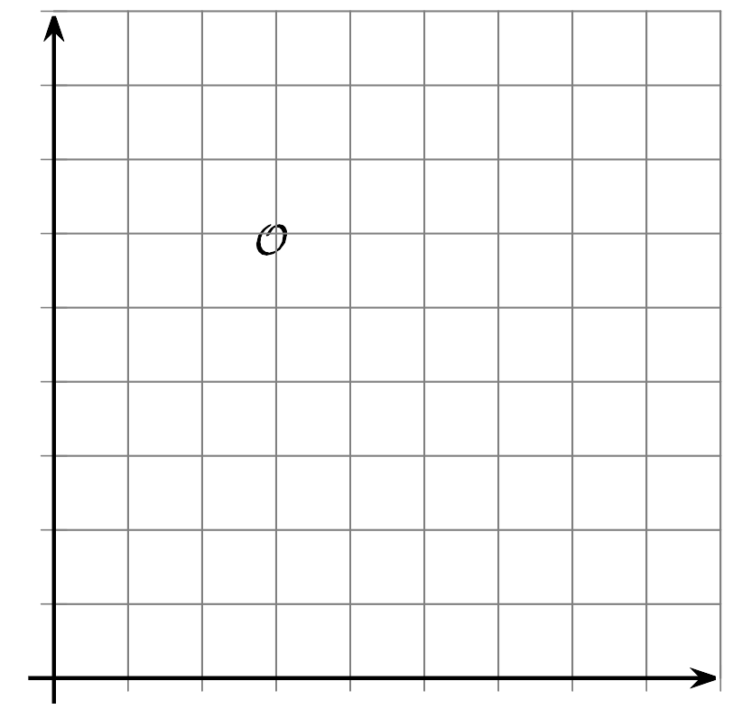

17.2: Another Look at the Tank
A tank contained 80 liters of water. The function $w$ represents the relationship between $t$, time in minutes, and the amount of water in the tank in liters. The equation $w(t)=80−2.5t$ defines this function.
- How much water will be in the tank after 13 minutes?
- How many minutes will it take until the tank has 5 liters of water?
- In this situation, what information can we gain from the inverse of function $w$?
- Find the inverse of function $w$. Be prepared to explain or show your reasoning.
- How would the graph of the inverse function of $w$ compare to the graph of $w$? Describe or sketch your prediction.

17.3: Phones in Homes
In 2004, less than 5% of the homes in the U.S. relied only on a cell phone. Since then, the percentage of homes that used only cell phones have increased.
Here are the percentages of homes with only cell phones from 2004 to 2009.
years since 2004 | percentages
0 | 4.4
1 | 6.7
2 | 9.6
3 | 13.6
4 | 17.5
5 | 22.7
​​​​​​
- Suppose a linear function, $P$, gives us the percentage of homes with only cell phones as a function of years since 2004, $t$.
- Fit a line on the scatter plot to represent this function and write an equation that could define the function. Use function notation.
- Use your equation to find the value of $P(6)$. Then, explain what it means in this situation.
- Use your equation to solve $P(t)=30$ for $t$. What does the solution represent?
- Suppose we want to know when the percentage of homes with only cell phones would reach 50%, 75%, or 100% (assuming that the trend continues and the function stays valid). What equation could be written to help us find those percentages? Show your reasoning.

Are you ready for more?
How well do you think your model will work to predict the percentage of homes with only a cell phone in future years, for example, a decade or two decades from now? Explain your reasoning.

Lesson 17 Summary
The water in a rain barrel is being drained and used to water a garden. Function $v$ gives the volume of water remaining in the barrel, in gallons, $t$ minutes after it started being drained. This equation represents the function:
$v(t)=60−2.25t$
From the equation and description, we can reason that there were 60 gallons of water in the rain barrel, and that it was being drained at a constant rate of 2.25 gallons per minute.
This equation is handy for finding out the amount of water left in the barrel after some number of minutes. In other words, it helps us find the output, $v(t)$, when we know the input, $t$.
Suppose we want to know how long it would take before the barrel has 20 gallons of water remaining, or how long it would take to empty the barrel. Let's find the inverse of function $v$ so that the volume of water is the input and time is the output.
Even though the equation is in function notation, we can still solve for $t$ as we had done before:
$\begin{matrix}v(t) & =60−2.25t \\ v(t)+2.25t & =60 \\ 2.25t & =60−v(t) \\ t & =\frac{60−v(t)}{2.25}\end{matrix}$
This equation now shows $t$ as the output and $v(t)$ as the input. We can easily find or estimate the time when the barrel will have 20 gallons remaining or when it will be empty by substituting 20 or 0 for $v(t)$, and then evaluating $\frac{60−20}{2.25}$ or $\frac{60−0}{2.25}$, respectively.
© CC BY 2019 by Illustrative Mathematics®

