Unit 4 Lesson 4: Using Function Notation to Describe Rules (Part 1)

1 Notice and Wonder: Two Functions (Warm up)

Student Task Statement
What do you notice? What do you wonder?
$x$ | $f(x)=10−2x$
1 | 8
1.5 | 7
5 | 0
-2 | 14
$x$ | $g(x)=x^{3}$
-2 | -8
0 | 0
1 | 1
3 | 27

2 Four Functions

Images for Launch

Student Task Statement
Here are descriptions and equations that represent four functions.
$f(x)=3x−7$
$g(x)=3(x−7)$
$h(x)=\frac{x}{3}−7$
$k(x)=\frac{x−7}{3}$
A. To get the output, subtract 7 from the input, then divide the result by 3.
B. To get the output, subtract 7 from the input, then multiply the result by 3.
C. To get the output, multiply the input by 3, then subtract 7 from the result.
D. To get the output, divide the input by 3, and then subtract 7 from the result.
- Match each equation with a verbal description that represents the same function. Record your results.
- For one of the functions, when the input is 6, the output is -3. Which is that function: $f,g$, $h$, or $k$? Explain how you know.
- Which function value—$f(x),g(x),h(x)$, or $k(x)$—is the greatest when the input is 0? What about when the input is 10?

3 Rules for Area and Perimeter

Student Task Statement
- A square that has a side length of 9 cm has an area of 81 cm². The relationship between the side length and the area of the square is a function.
  - Complete the table with the area for each given side length.
  - Then, write a rule for a function, $A$, that gives the area of the square in cm² when the side length is $s$ cm. Use function notation.
- side length (cm) | - area (cm²)
  - 1
  - 2
  - 4
  - 6
  - $s$
  - What does $A(2)$ represent in this situation? What is its value?
  - On the coordinate plane, sketch a graph of this function.
- A roll of paper that is 3 feet wide can be cut to any length.
  - If we cut a length of 2.5 feet, what is the perimeter of the paper?
  - 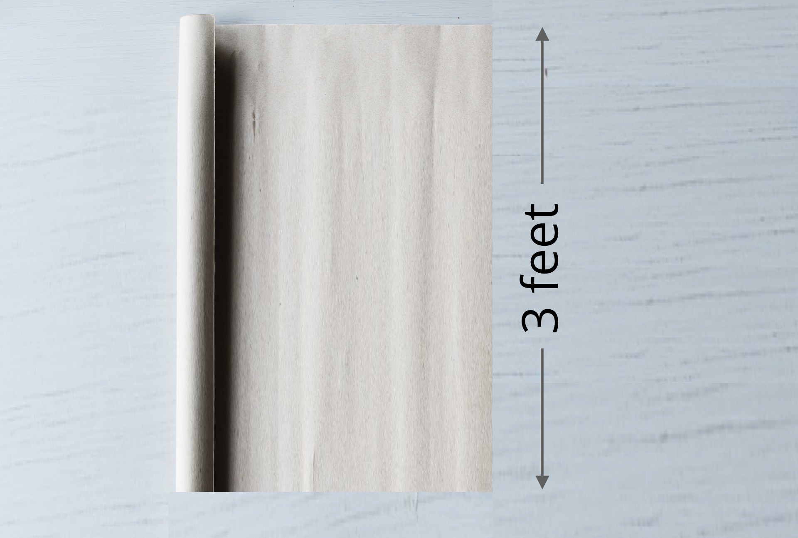
  - Complete the table with the perimeter for each given side length.
  - Then, write a rule for a function, $P$, that gives the perimeter of the paper in feet when the side length in feet is $ℓ$. Use function notation.
- side length (feet) | - perimeter (feet)
  - 1
  - 2
  - 6.3
  - 11
  - $ℓ$
  - What does $P(11)$ represent in this situation? What is its value?
  - On the coordinate plane, sketch a graph of this function.
© CC BY 2019 by Illustrative Mathematics®

