Unit 1 Lesson 3: Add 1 or 2

WU How Many Do You See: Dot Cubes (Warm up)

Student Task Statement
How many do you see?
How do you see them?
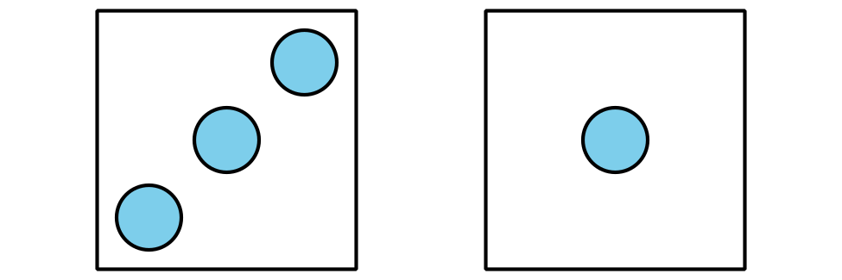
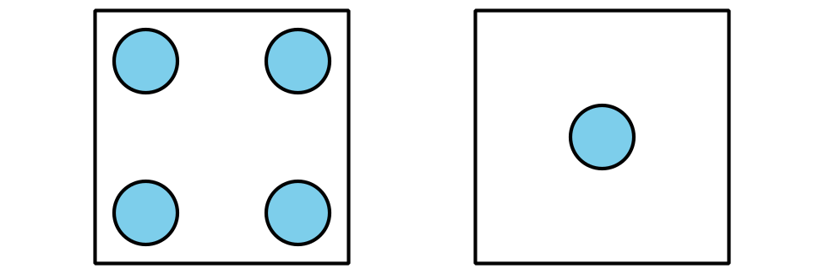
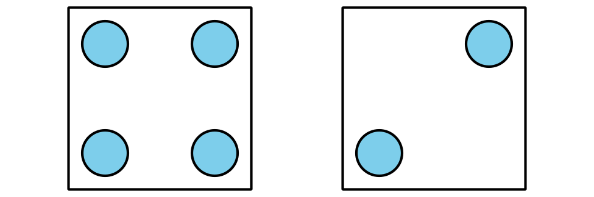
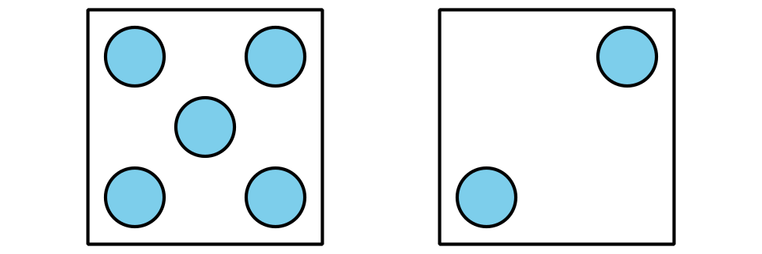

1 Introduce Five in a Row: Addition and Subtraction, Add 1 or 2

Student Task Statement

2 Centers: Choice Time

Student Task Statement
Choose a center.
Counting Collections
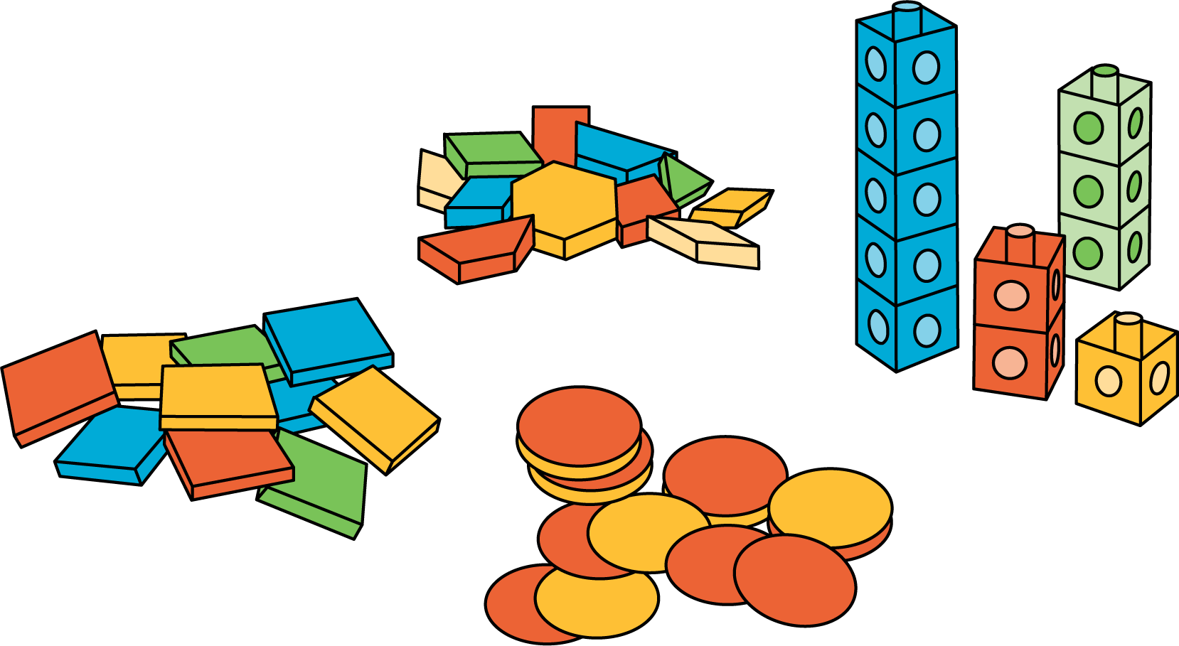
Number Race
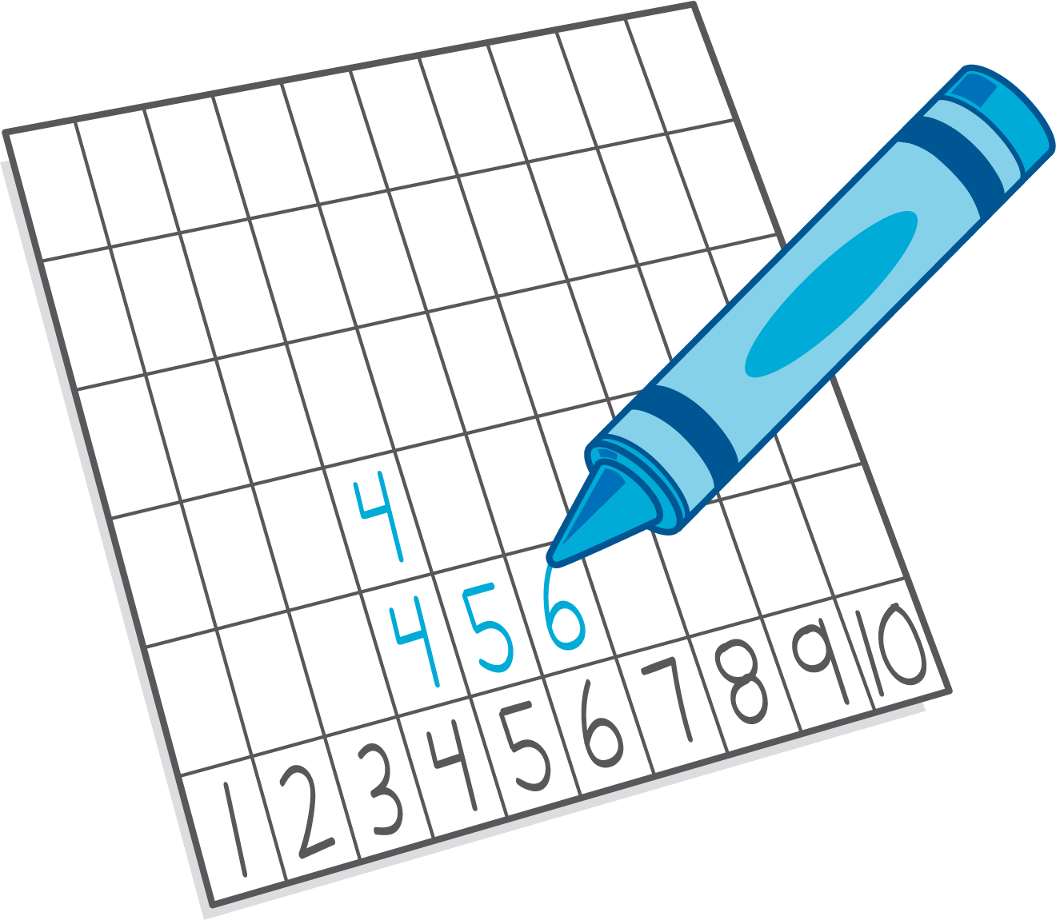
Check it Off
Five in a Row: Addition and Subtraction
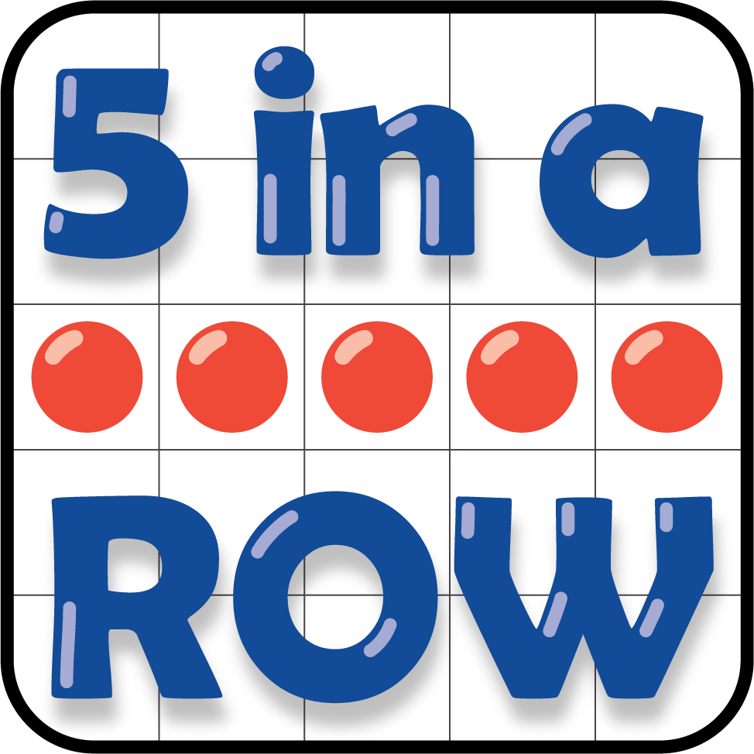
© CC BY 2021 Illustrative Mathematics®

