Unit 6 Lesson 19: More Money Problems

WU Number Talk: Use Ten to Add Within 100 (Warm up)

Student Task Statement
Find the value of each expression mentally.
- $18+32$
- $28+32$
- $28+34$
- $38+35$

1 Shop with Friends

Student Task Statement
Write the letter next to the story problem it represents.
A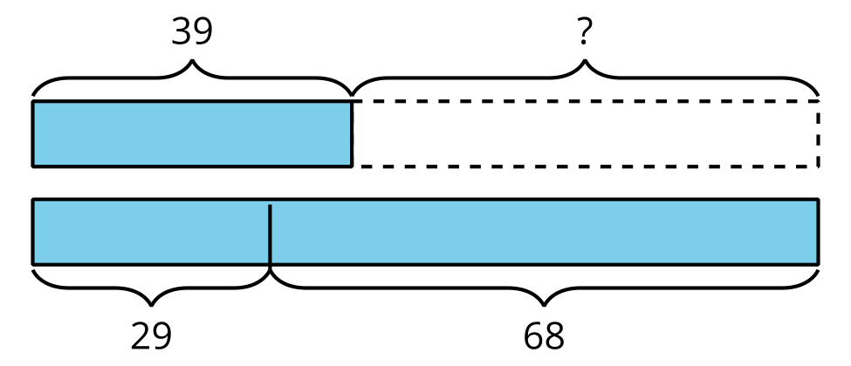
B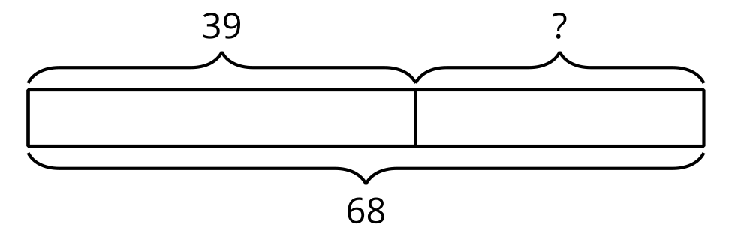
C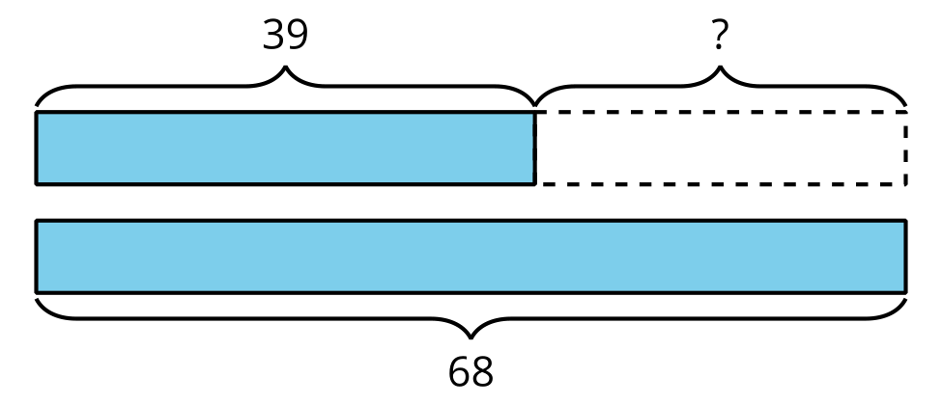
D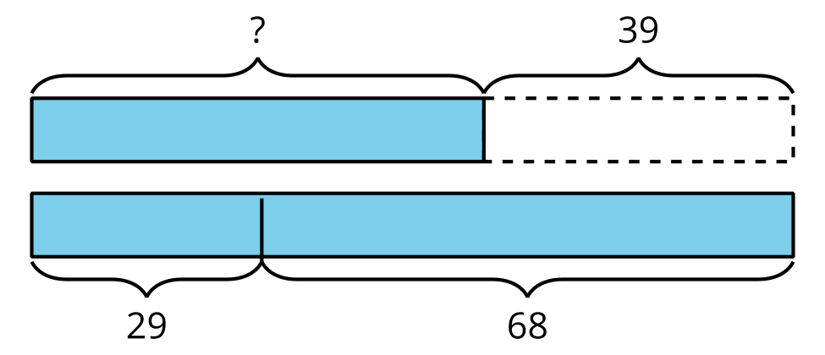
- A basketball costs $39 less than a soccer ball and football combined.
- The soccer ball costs $29 and the football costs $68.
- How many dollars does the basketball cost? _____
- Jada is saving to buy a gift for her dad. The gift costs $68. So far she has $39.
- How much more does she need? _____
- A pair of pants costs $39.
- A shirt costs $29 and a pair of shoes cost $68.
- How many more dollars do the shirt and shoes cost than the pants? _____
- Diego has $39. His mom gave him some money for his birthday. Now he has $68.
- How much money did he get for his birthday? _____

2 Money Among Friends

Student Task Statement
For each problem, show your thinking. Write your final answer using the $. Use a diagram if it helps.
- Mai has $27, Elena has $48, and Jada has $16. How much money do they have altogether?
- Tyler has $45, Andre has $36, and Noah has $28. How much less money does Tyler have than Andre and Noah combined?
- Lin has $19. Together, Lin and Han have $45. Then Han gets $17 more. How much money does Han have now?

Images for Activity Synthesis
© CC BY 2021 Illustrative Mathematics®

