Lesson 4: Attributes of Rectangles, Rhombuses, and Squares
- Let’s find out what makes rectangles, rhombuses, and squares what they are.

Warm-up: Which One Doesn’t Belong: More Attributes
Which one doesn’t belong?
A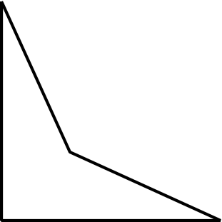
B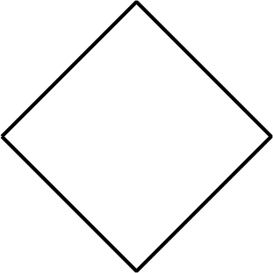
C
D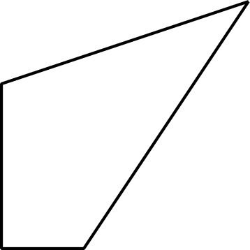

4.1: What Makes These Shapes So?
- These are right triangles.
- 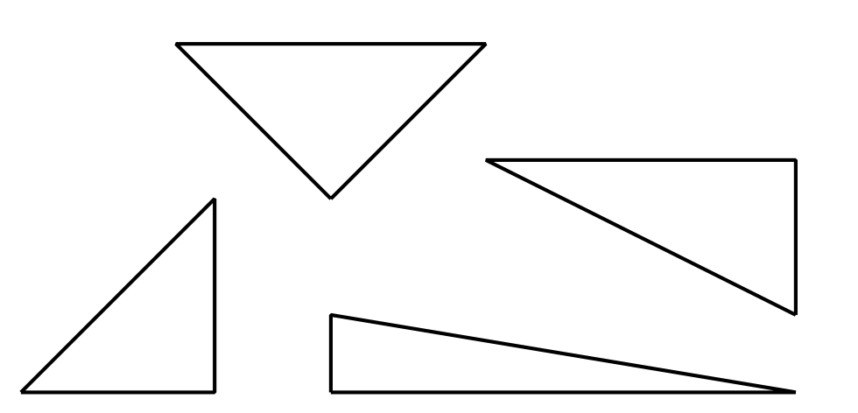
- These are not right triangles.
- 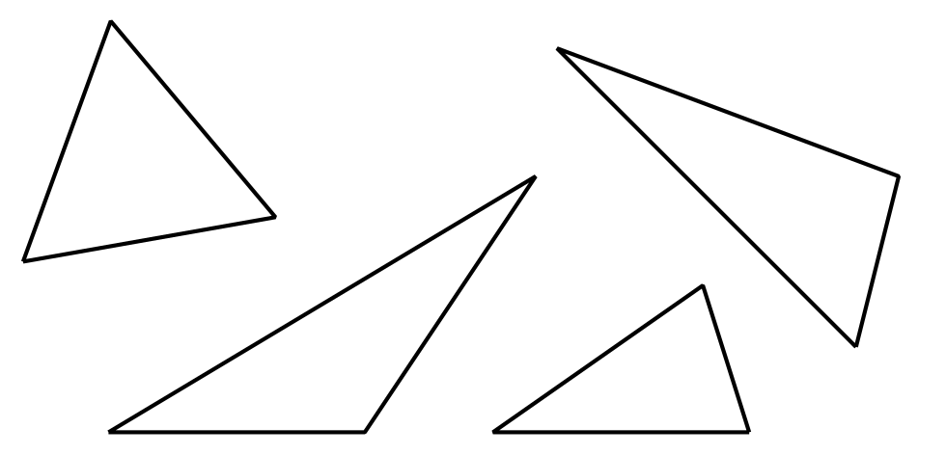
  - Which of the following are right triangles? Circle them.
  - 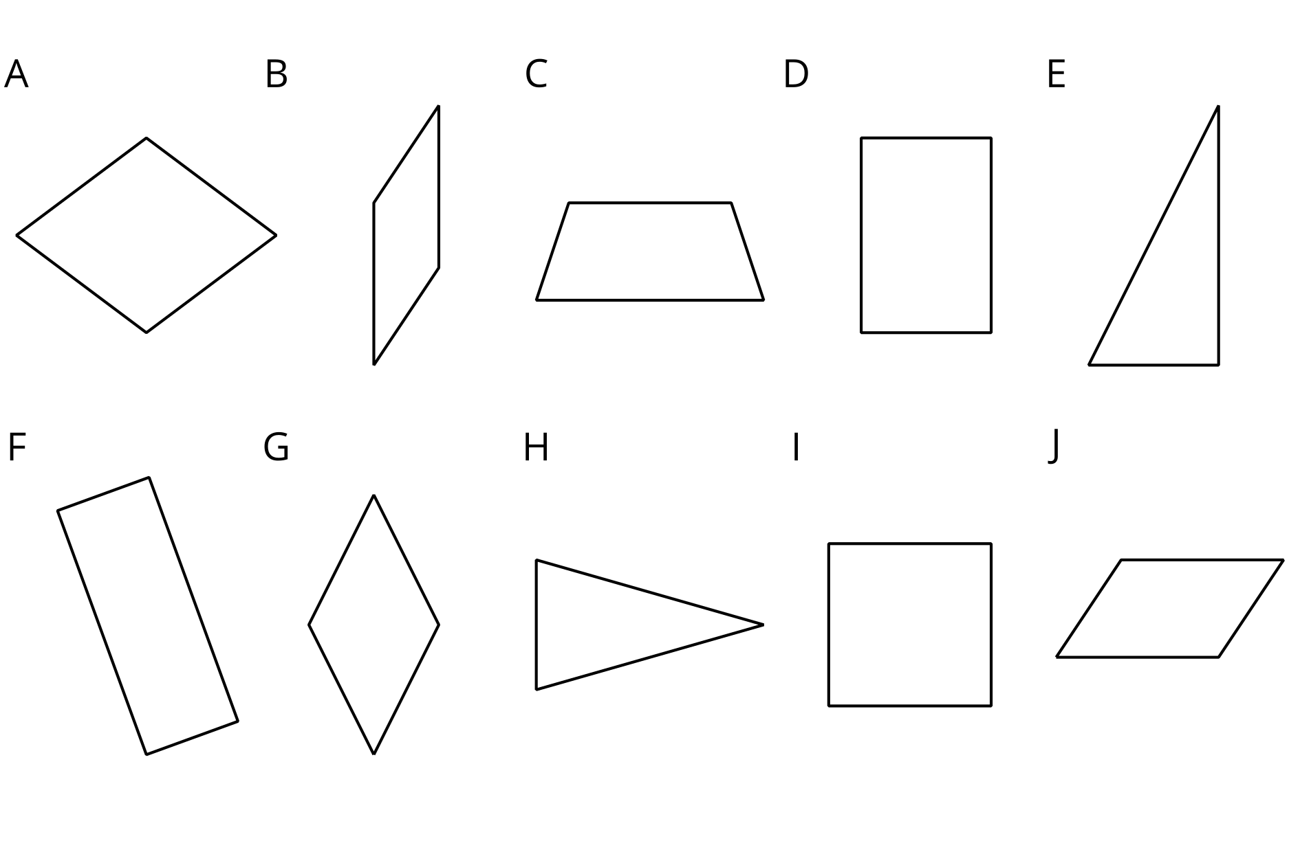
  - What makes a shape a right triangle?
- These are rectangles.
- 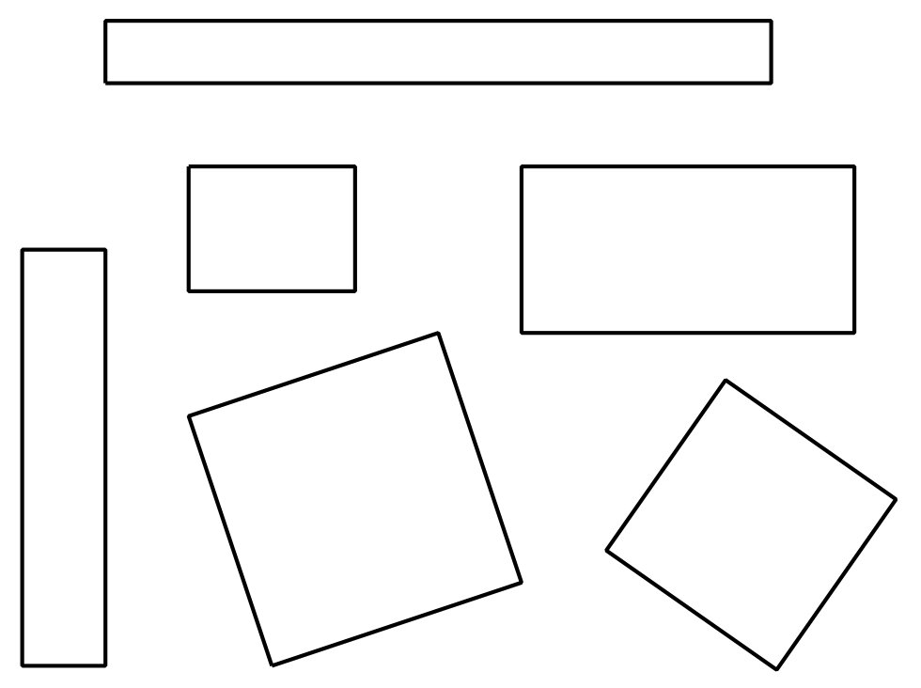
- These are not rectangles.
- 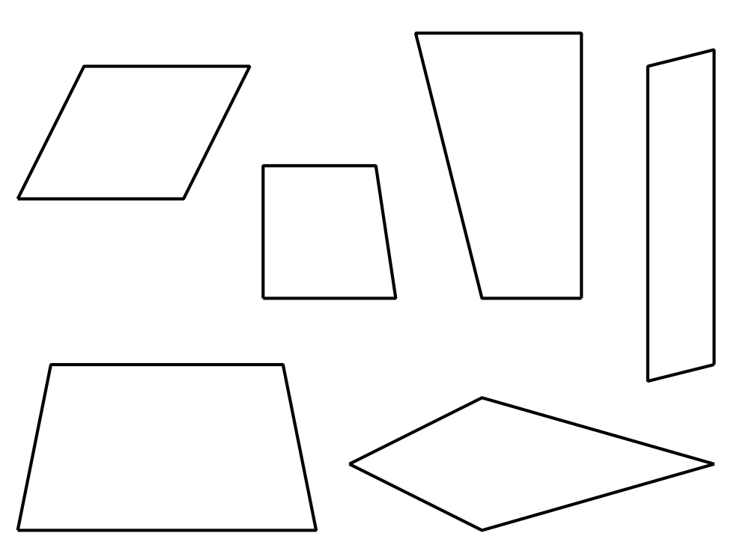
  - Which of the following are rectangles? Circle them.
  - What makes a shape a rectangle?
- These are rhombuses.
- 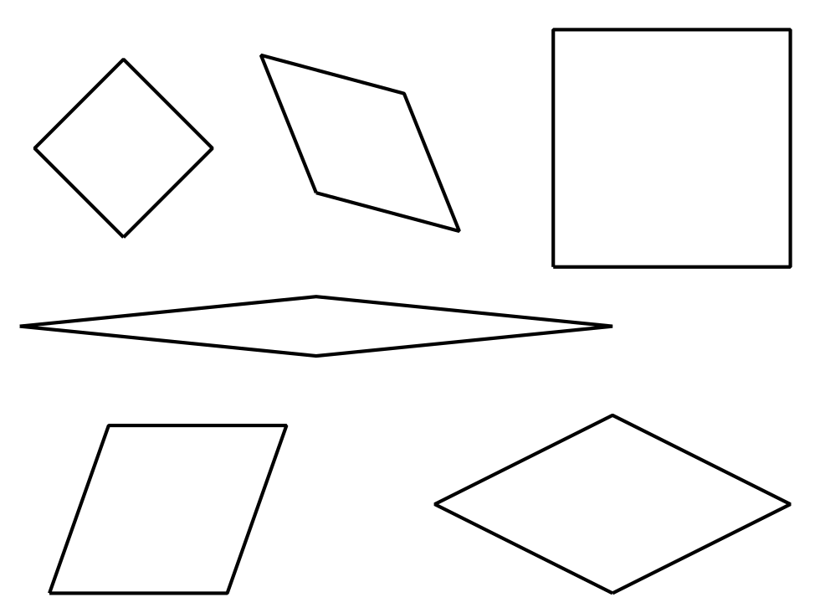
- These are not rhombuses.
- 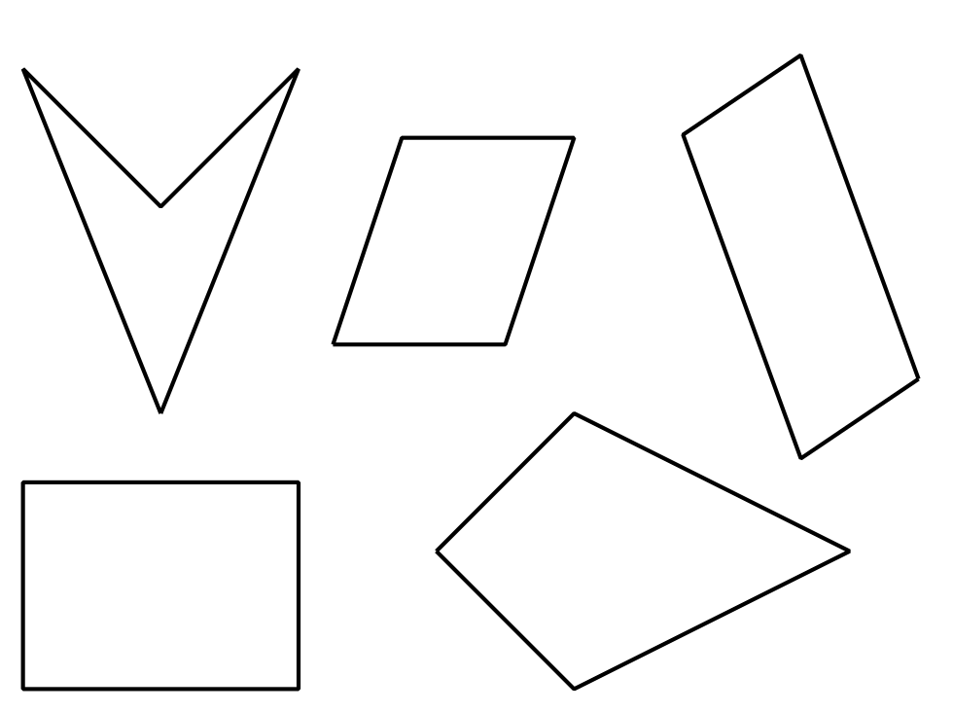
  - Which of the following are rhombuses? Circle them.
  - What makes a shape a rhombus?
- These are squares.
- 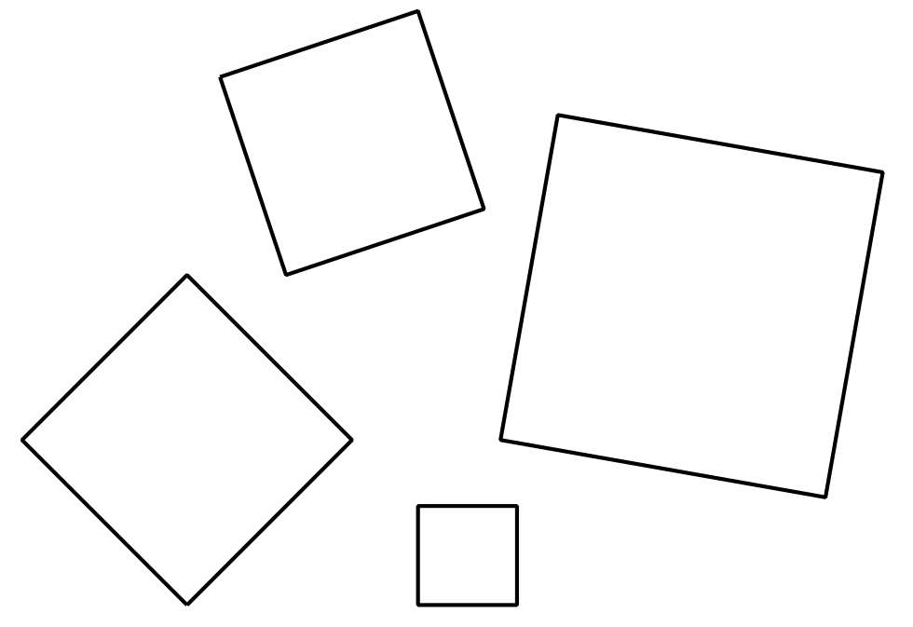
- These are not squares.
- 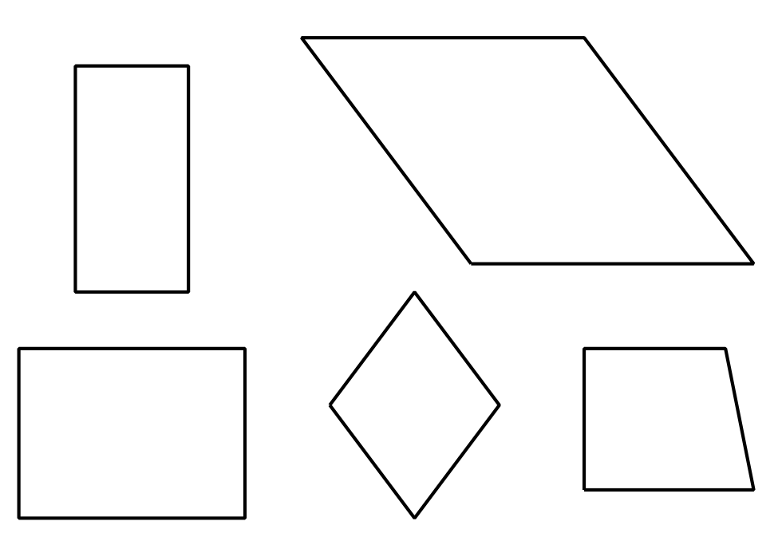
  - Which of the following are squares? Circle them.
  - What makes a shape a square?
© CC BY 2021 Illustrative Mathematics®

