Lesson 24: Relate Counting to Addition and Subtraction

Standards Alignments
Addressing | 1.NBT.A.1, 1.OA.B.4, 1.OA.C.5, 1.OA.C.6, 1.OA.D.8

Teacher-facing Learning Goals
- Analyze and use counting on and taking away as methods to subtract.

Student-facing Learning Goals
- Let’s subtract by counting on or taking away.
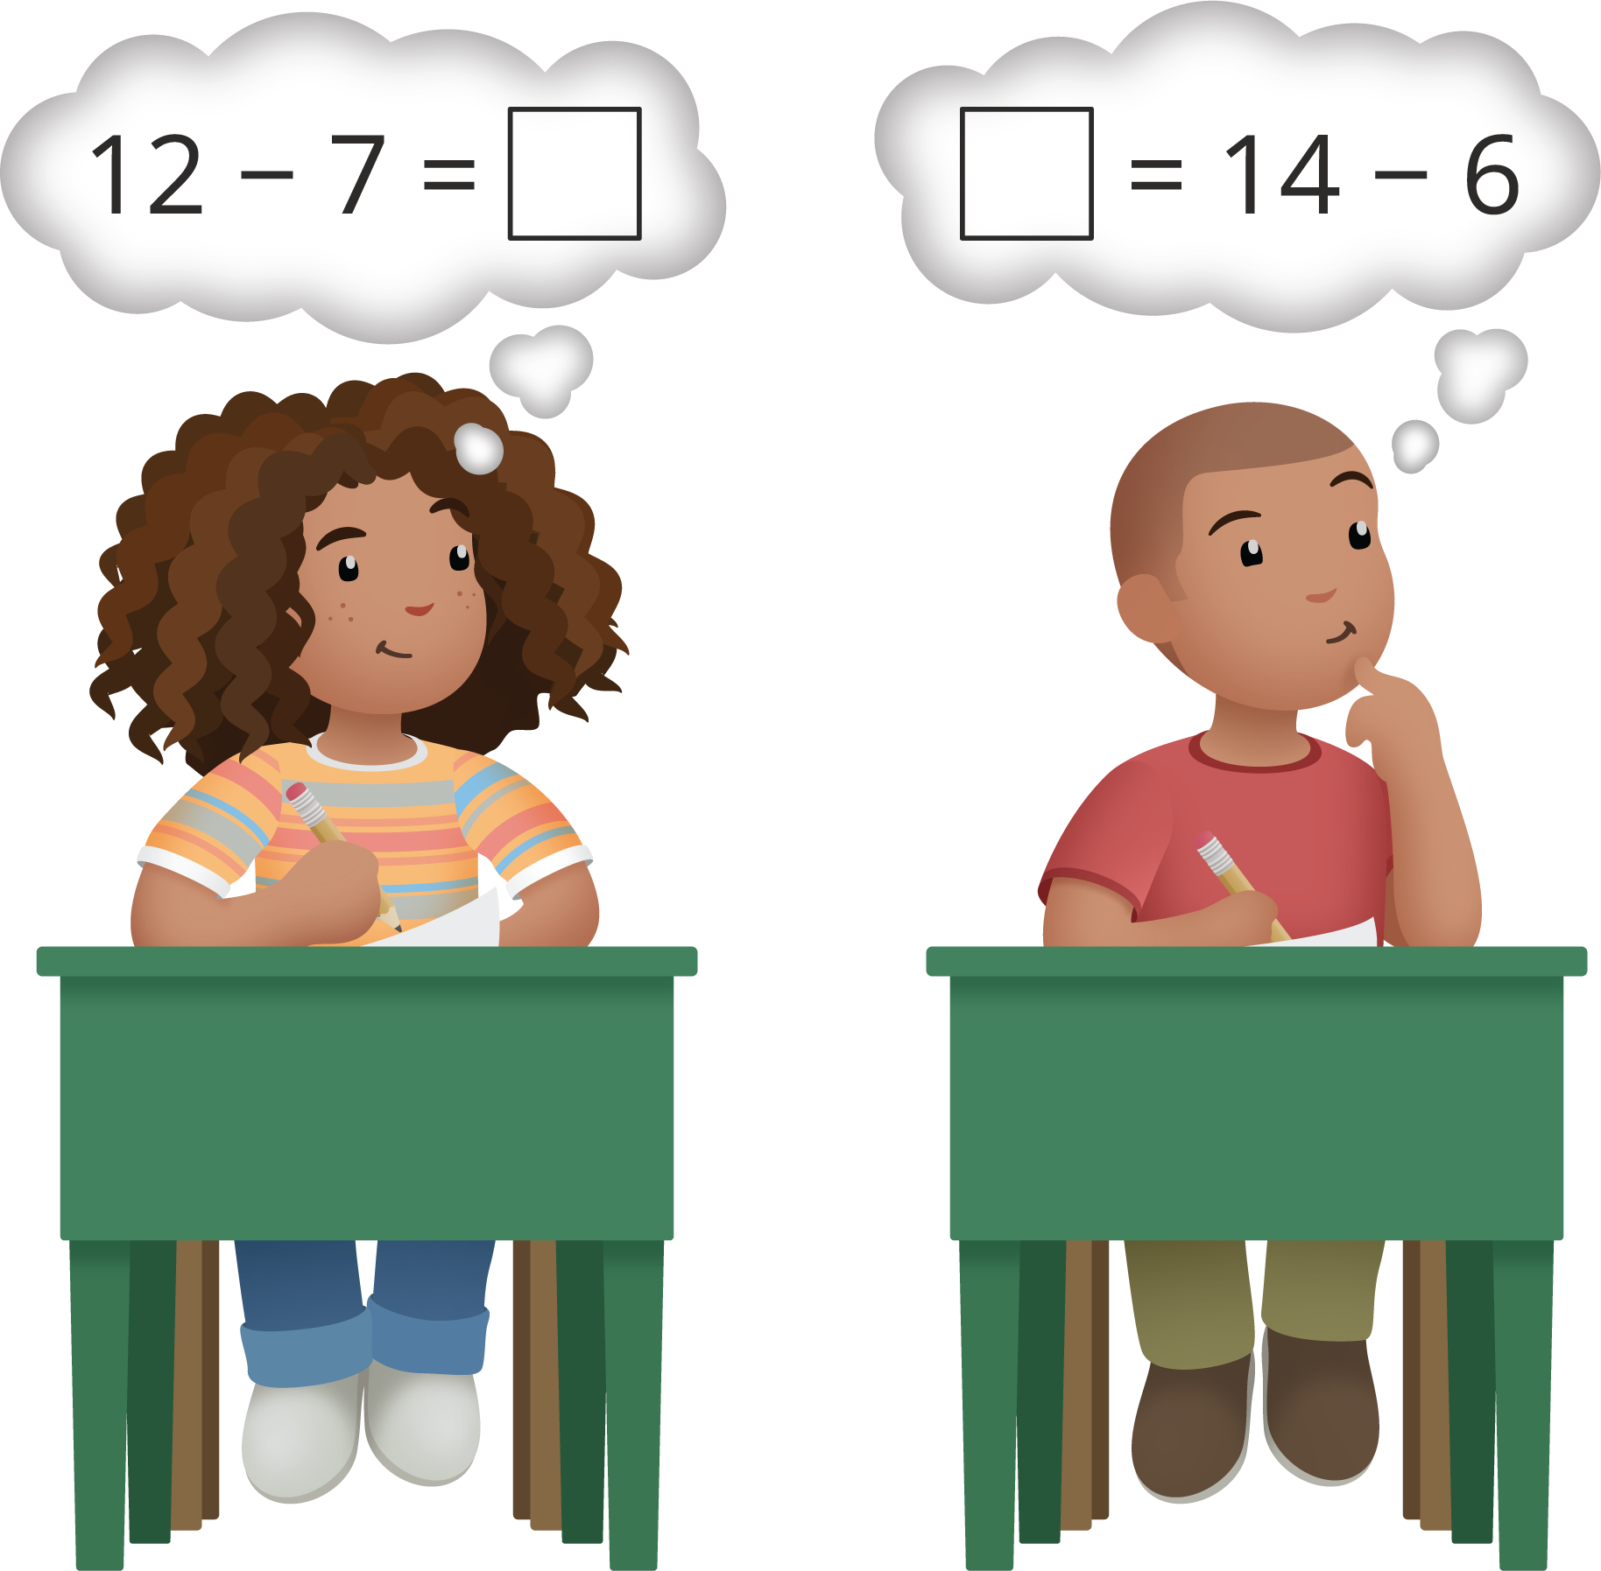

Lesson Purpose
The purpose of this lesson is for students to analyze and use counting on and taking away methods to subtract within 20.
In a previous unit, as well as a previous section in this unit, students related addition to subtraction and thought about how knowing their addition facts to 10 could help them find differences.
The work of this lesson builds on students understanding of the relationship between addition and subtraction. In the first activity, students analyze two different methods for solving the same subtraction problem, then they try each method with new problems. In the second activity, students find the value of the difference in subtraction equations and find the value in missing addend equations.

Access for:

Students with Disabilities
- Engagement (Activity 2)

English Learners
- MLR7 (Activity 2)

Instructional Routines
Choral Count (Warm-up), MLR8 Discussion Supports (Activity 1)

Materials to Gather
- Connecting cubes or two-color counters: Activity 1, Activity 2
- Double 10-frames: Activity 1, Activity 2

Lesson Timeline
Warm-up | 10 min
Activity 1 | 20 min
Activity 2 | 20 min
Lesson Synthesis | 10 min

Teacher Reflection Question
With which math ideas from today’s lesson did students grapple most? Did this surprise you or was this what you expected?

Cool-down
(to be completed at the end of the lesson) 0min
Unit 3, Section D Checkpoint

Standards Alignments
Addressing | 1.OA.C.6

Student-facing Task Statement
Lesson observations:

Student Responses
- Take away to find the difference.
- Count on to find the difference.
- Make 10 to find the difference.
- Know certain differences.
- Use addition facts to find the difference.

