Unit 1 Lesson 4: More Work with 1 and 2

WU Number Talk: Add 1 or 2 (Warm up)

Student Task Statement
Find the value of each expression mentally.
- $6+1$
- $6+2$
- $8+1$
- $8+2$

1 Introduce Five in a Row: Addition and Subtraction, Subtract 1 or 2

Student Task Statement

2 Centers: Choice Time

Student Task Statement
Choose a center.
Counting Collections
Number Race
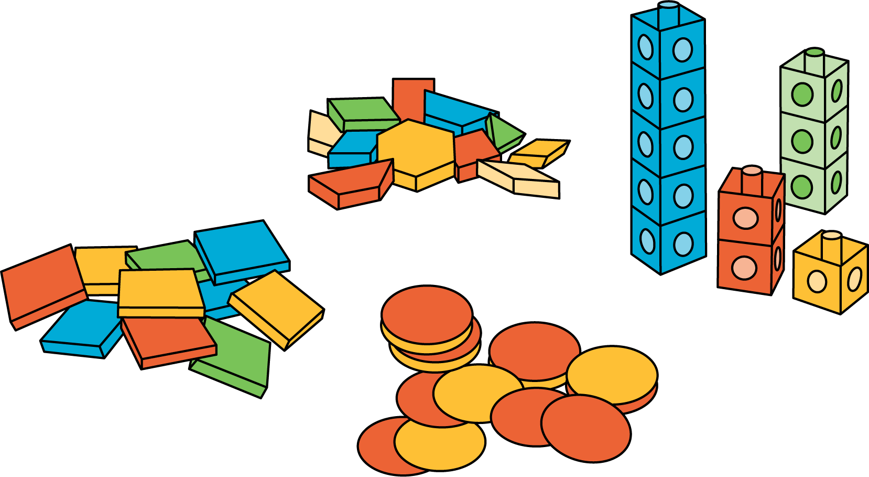
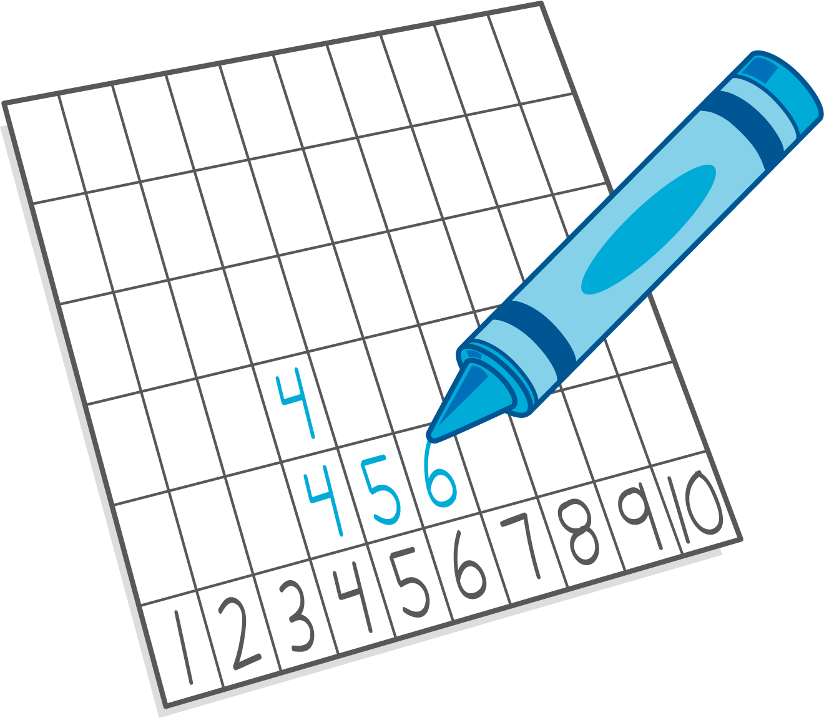
Check it Off
Five in a Row: Addition and Subtraction
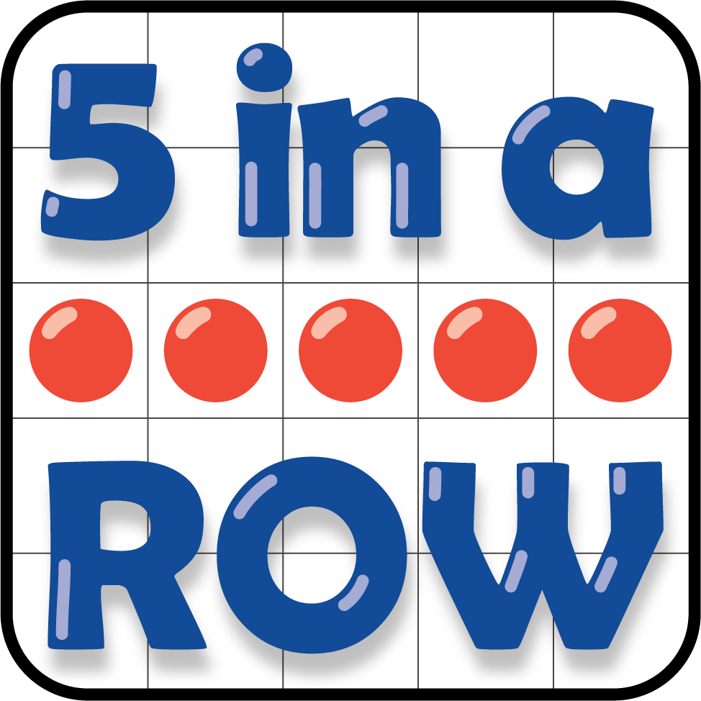
© CC BY 2021 Illustrative Mathematics®

