Lesson 5: Attributes of Other Quadrilaterals
- Let’s describe and draw shapes in specific groups.

Warm-up: Number Talk: Divide by 7
Find the value of each expression mentally.
- $70÷7$
- $77÷7$
- $63÷7$
- $56÷7$

5.1: All the Ways
Select all the ways you could describe each shape. Be prepared to explain your reasoning.
1
- triangle
- quadrilateral
- square
- rhombus
- rectangle
2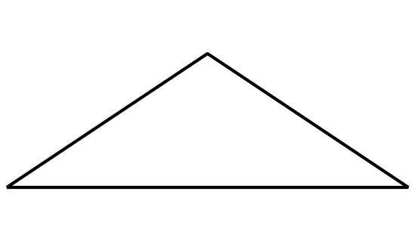
- triangle
- quadrilateral
- hexagon
- rhombus
- rectangle
- square
3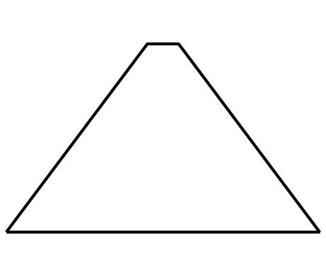
- triangle
- quadrilateral
- pentagon
- rhombus
- rectangle
- square
4
- triangle
- quadrilateral
- hexagon
- rhombus
- rectangle
- square
5
- hexagon
- quadrilateral
- triangle
- square
- rectangle
- rhombus
6
- hexagon
- quadrilateral
- triangle
- rhombus
- rectangle
- square

5.2: Draw One That’s Not . . .
- Draw a quadrilateral that isn’t a square.
- Draw a quadrilateral that isn’t a rhombus.
- Draw a quadrilateral that isn’t a rectangle.
- Draw as many quadrilaterals as you can that aren’t rhombuses, rectangles, or squares.

Section Summary
Section Summary
In this section, we learned to sort shapes based on attributes such the number of sides, side lengths, and whether angles were right angles. We also sorted quadrilaterals and triangles into more specific groups.
We learned that a shape can be named based on its attributes. For example:
- If a triangle has a right angle, then it is a right triangle.
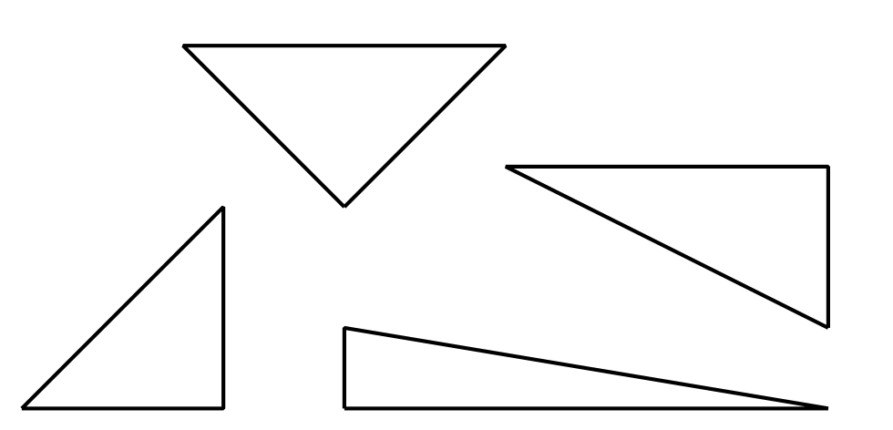
- If a quadrilateral has 2 pairs of sides that are the same length and 4 right angles, then it is a rectangle.
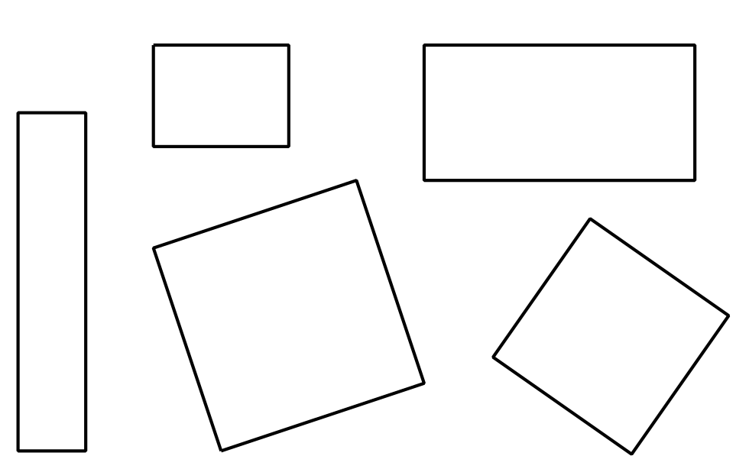
- If a quadrilateral has sides that are all the same length, then it is a rhombus.
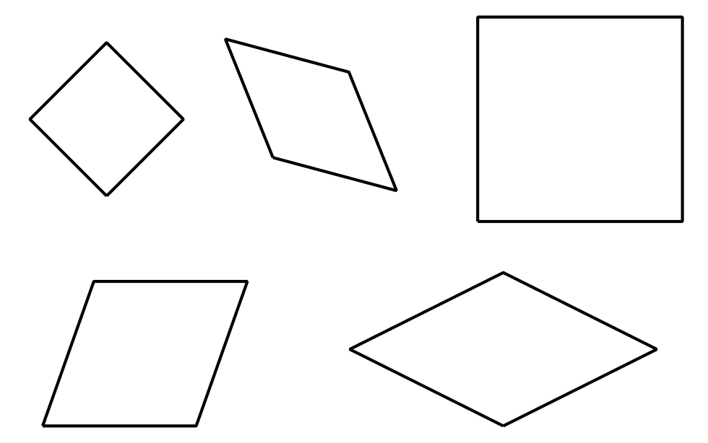
- If a quadrilateral has sides that are all the same length and 4 right angles, then it is a square.
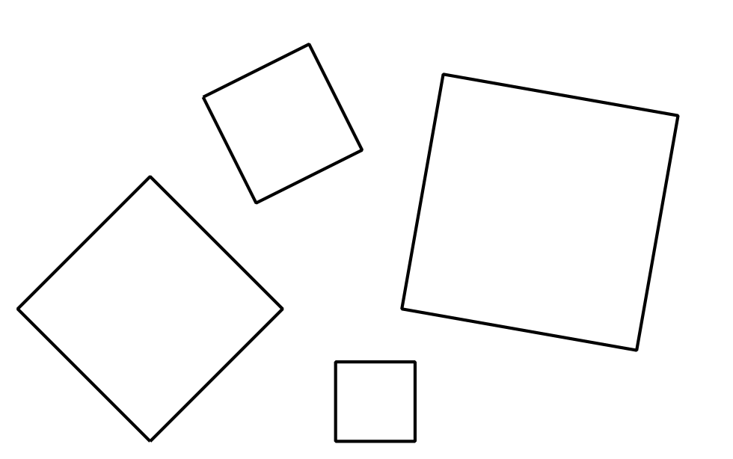
© CC BY 2021 Illustrative Mathematics®

