Lesson 13: It’s Time to Learn About Clocks

Standards Alignments
Addressing | 1.MD.B.3

Teacher-facing Learning Goals
- Tell and write time in hours.
- Understand time as a unit of measurement.

Student-facing Learning Goals
- Let’s tell and write times from a clock.

Lesson Purpose
The purpose of this lesson is for students to tell and write time in hours.
In previous sections, students learned about linear measurement. In this lesson, they formally learn about measuring time. It is likely that students will have experiences working with time outside of school, but they may have limited familiarity with clock faces.
In this lesson, students learn about time as a unit of measurement and show time in hours. Students begin by considering clocks that only have hour hands to help them attend to the short hand representing the hour. Students learn that when times are read as “___ o’clock” or shown as __:00 the minute hand points to the 12. Students write times in the digital format (__:__), show times on analog clocks, and relate times to activities they do during the school day.

Access for:

Students with Disabilities
- Action and Expression (Activity 3)

English Learners
- MLR8 (Activity 1)

Instructional Routines
Notice and Wonder (Warm-up)

Materials to Gather
- Materials from a previous activity: Activity 2
- Scissors: Activity 1

Materials to Copy
- Clock Cards Hour (groups of 1): Activity 1

Lesson Timeline
Warm-up | 10 min
Activity 1 | 15 min
Activity 2 | 10 min
Activity 3 | 10 min
Lesson Synthesis | 10 min
Cool-down | 5 min

Teacher Reflection Question
How does the measure of time relate to measuring length? How can you help students visualize the abstract concept of time?

Cool-down
(to be completed at the end of the lesson) 5min
Show the Time

Standards Alignments
Addressing | 1.MD.B.3

Student-facing Task Statement
- Circle the 3 clocks that show 5 o’clock.
- 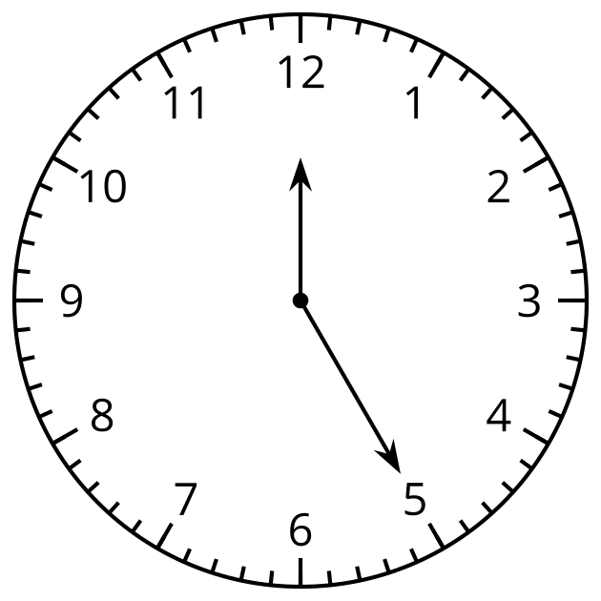
- 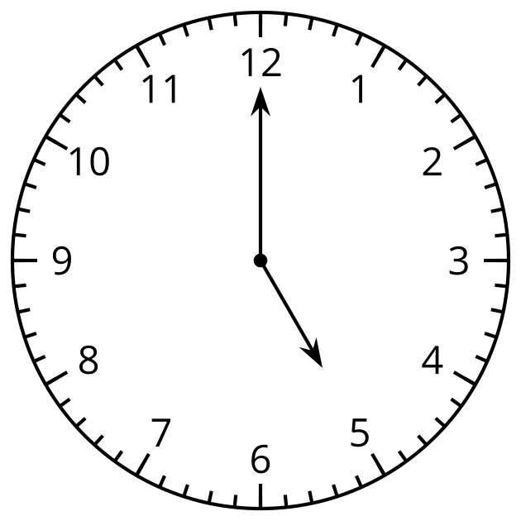
- 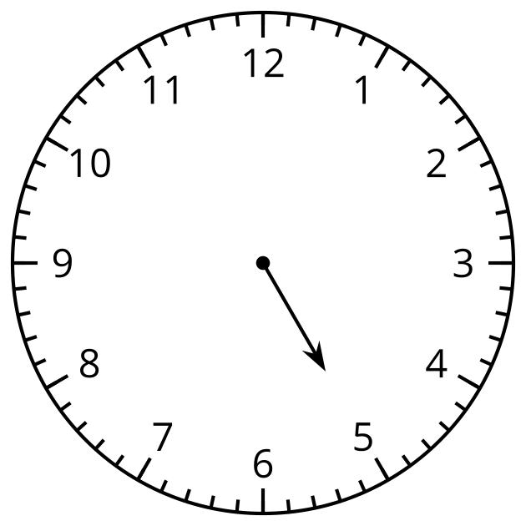
- 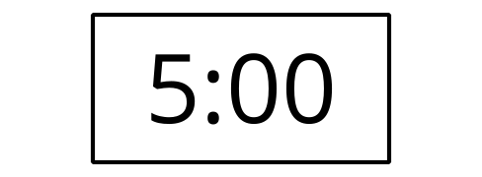
- 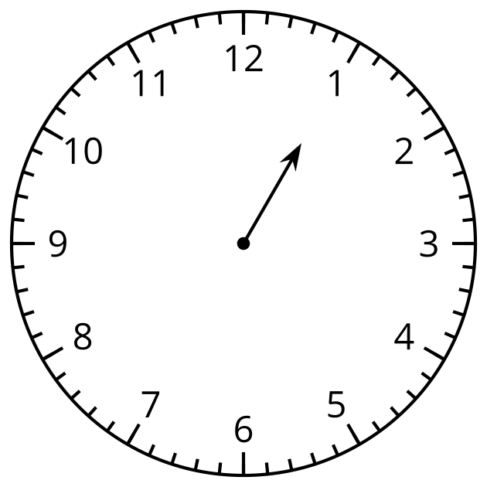
- 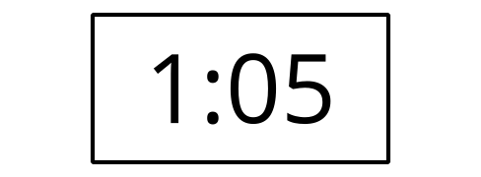
- Show 6 o’clock on both clocks.
- 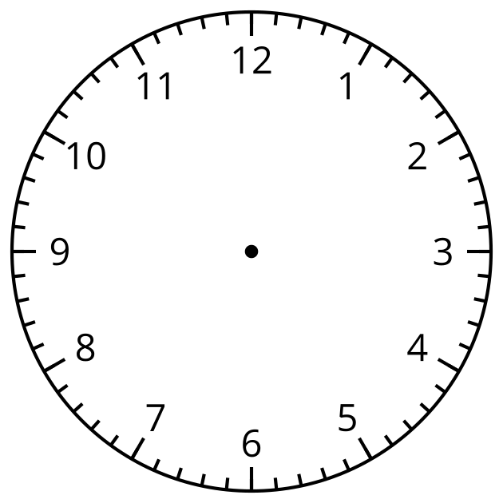

Student Responses
- Students circle the 3 clocks showing 5:00.
- 6:00, the hour hand points to the 6 and the minute hand points to the 12.

