Unit 1 Lesson 5: Explore Addition and Subtraction

WU Number Talk: Subtract 1 or 2 (Warm up)

Student Task Statement
Find the value of each expression mentally.
- $6−1$
- $6−2$
- $8−1$
- $8−2$

1 Introduce Check it Off, Subtract within 10

Student Task Statement

2 Centers: Choice Time

Student Task Statement
Choose a center.
Counting Collections
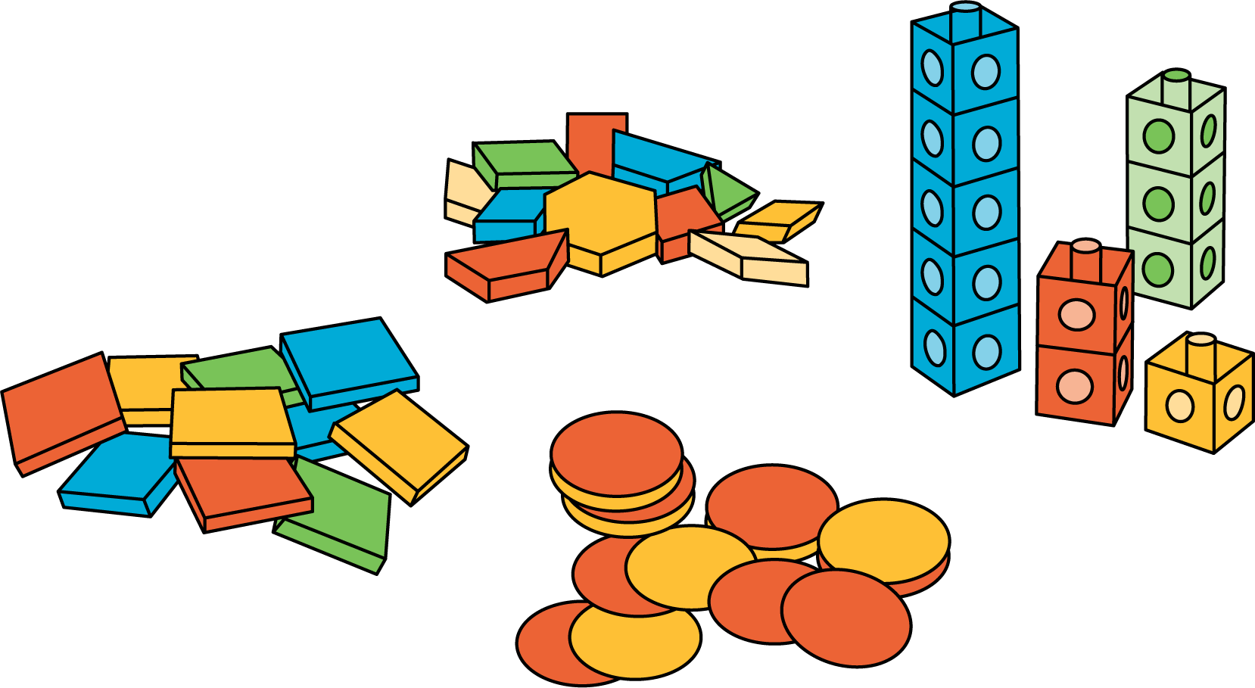
Number Race
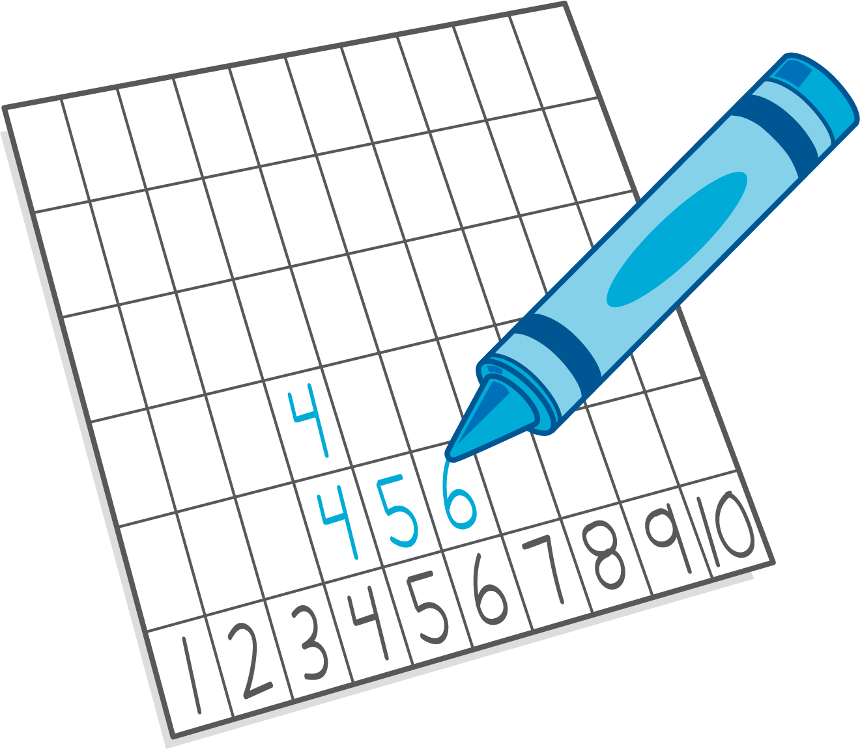
Check it Off
Five in a Row: Addition and Subtraction
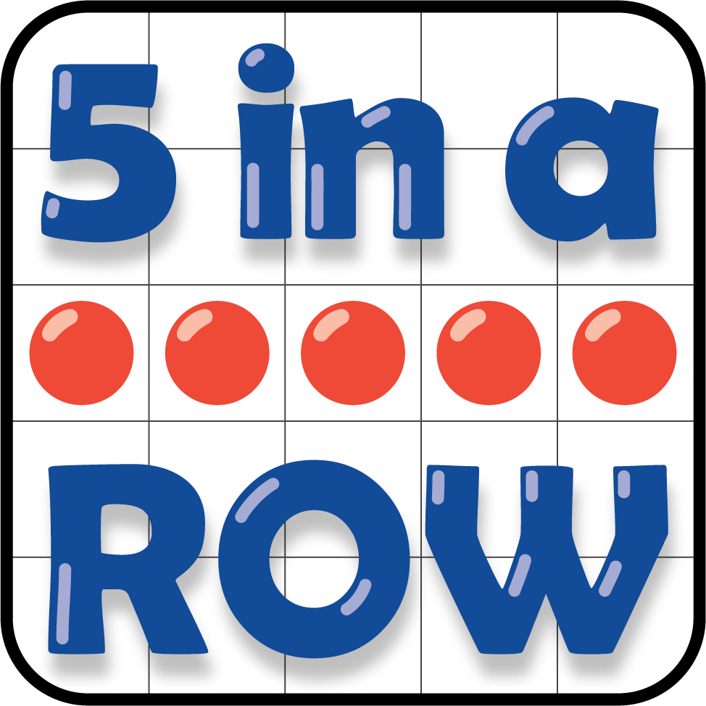
© CC BY 2021 Illustrative Mathematics®

