Unit 6 Lesson 21: Pattern Block Puzzles

WU Notice and Wonder: Pattern Block Bees (Warm up)

Student Task Statement
What do you notice? What do you wonder?
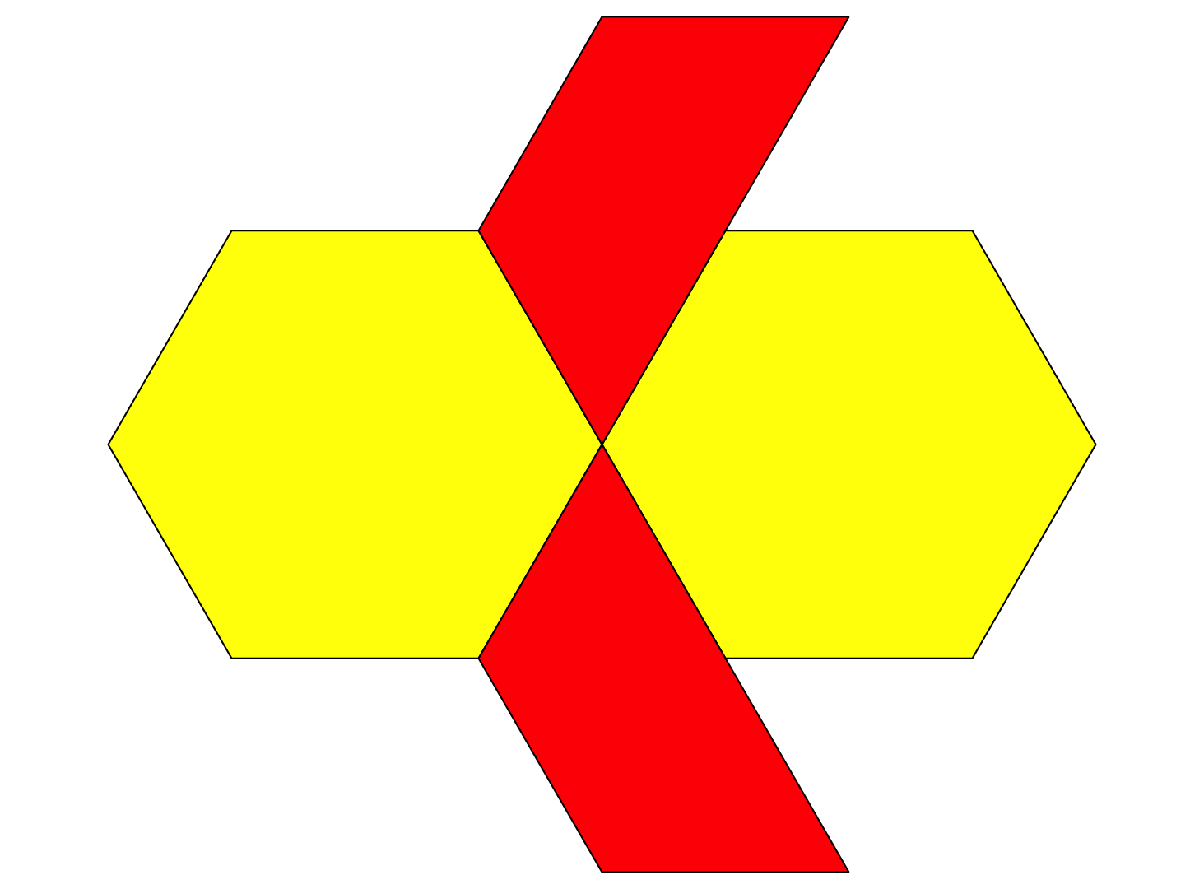
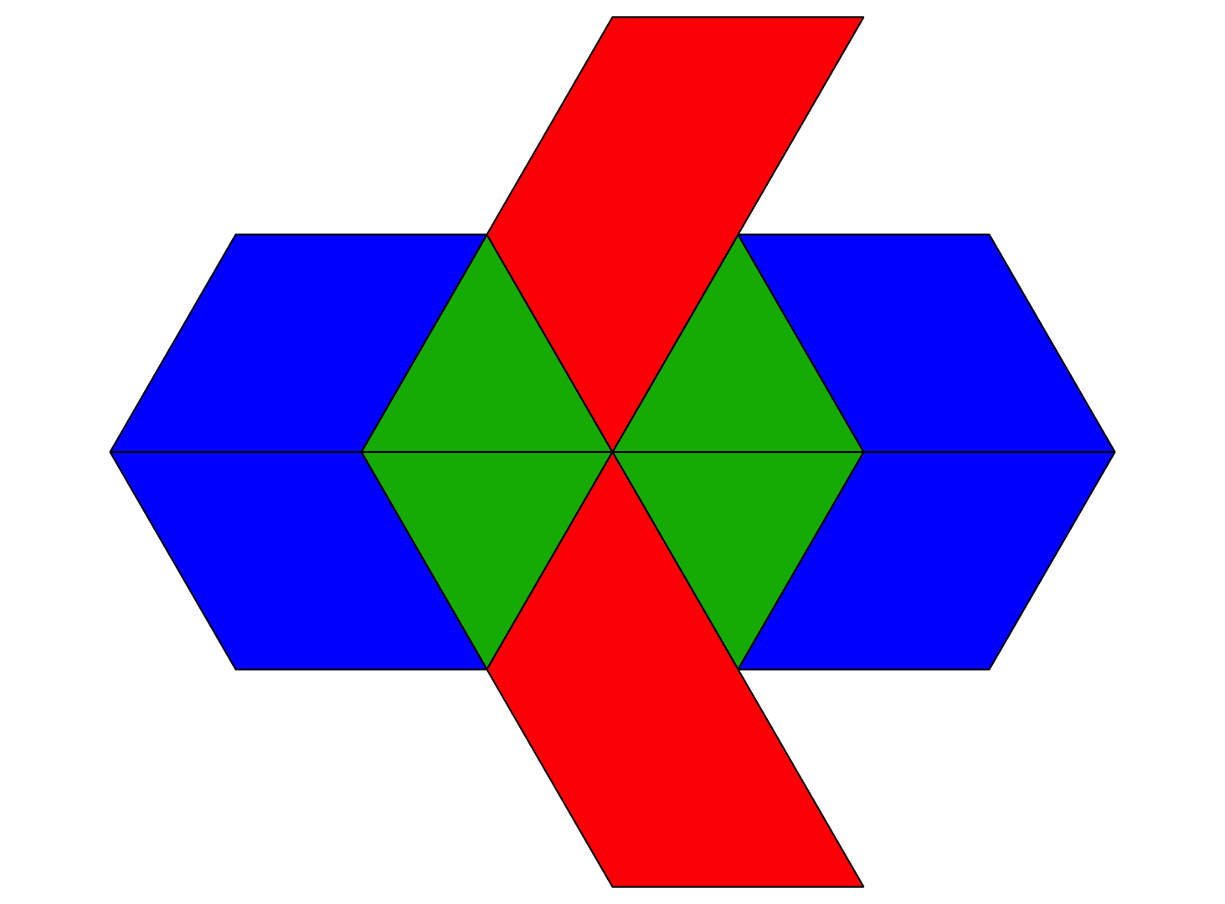

1 Pattern Block Puzzles

Student Task Statement
- Make a puzzle using 4 pattern blocks. Use at least 1 hexagon.
- Trace each pattern block on the blank puzzle paper.
- Trade the puzzle paper with another person in your group.
- Use the pattern blocks to show two different ways to make your partner’s puzzle. Sketch the two ways.
- Puzzle 1
- Puzzle 2
- Share one thing you notice about the puzzles.

2 The Pattern Block Store

Student Task Statement
shape | cost
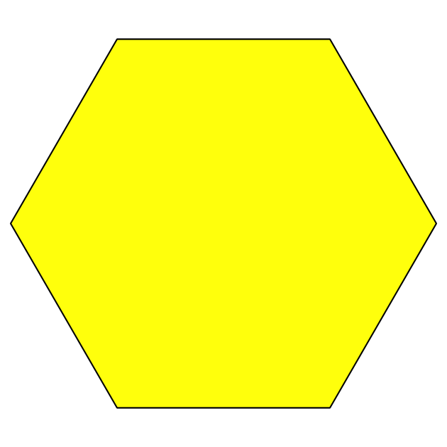
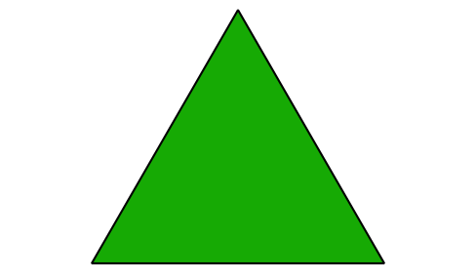
How much would the two puzzles you sketched cost at the Pattern Block Store? Show or explain your reasoning.
- Puzzle 1:
- Puzzle 2:
© CC BY 2021 Illustrative Mathematics®

