Lesson 6: Distance Around Shapes
- Let’s find the distance around shapes.

Warm-up: Notice and Wonder: Paper Clips & Shapes
What do you notice? What do you wonder?
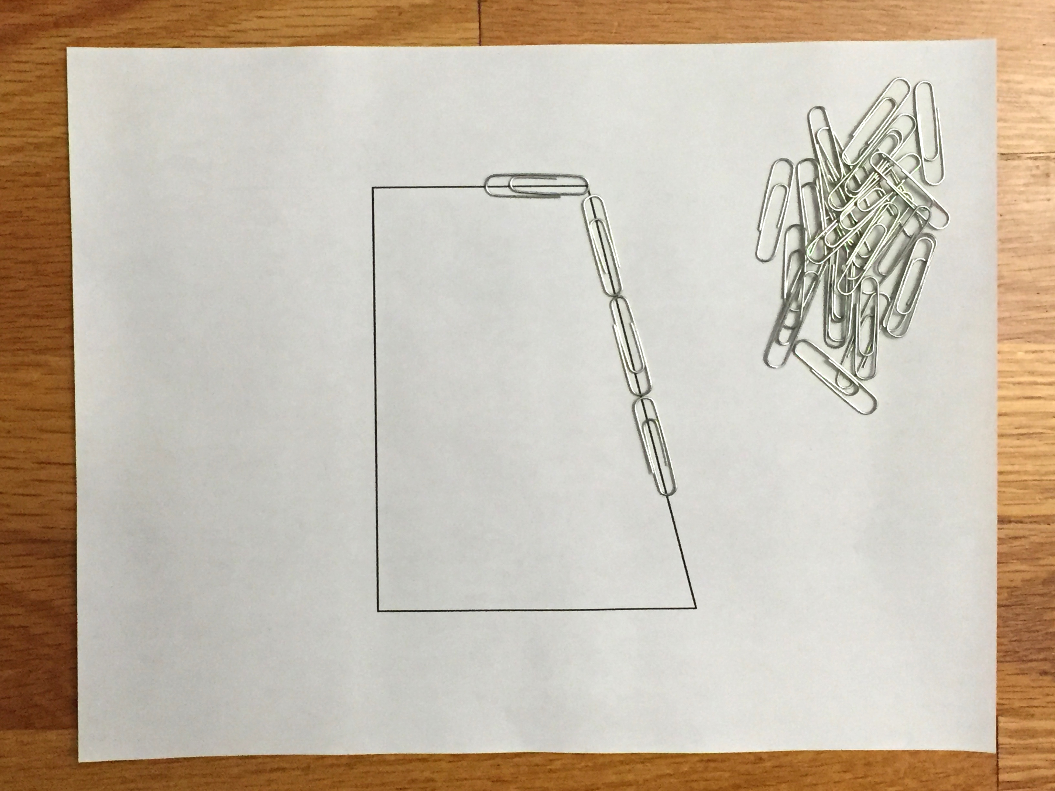

6.1: What Does It Take to Build the Shapes?
Your teacher will give you four shapes on paper and some paper clips.
Work with your group to find out which shape takes the most paper clips to build. Explain or show how you know. Record your findings here. Draw sketches if they are helpful.
A
B
C
D

6.2: Distance Around
Find the perimeter of each shape. Explain or show your reasoning.
A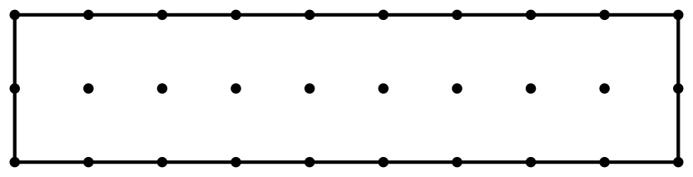
B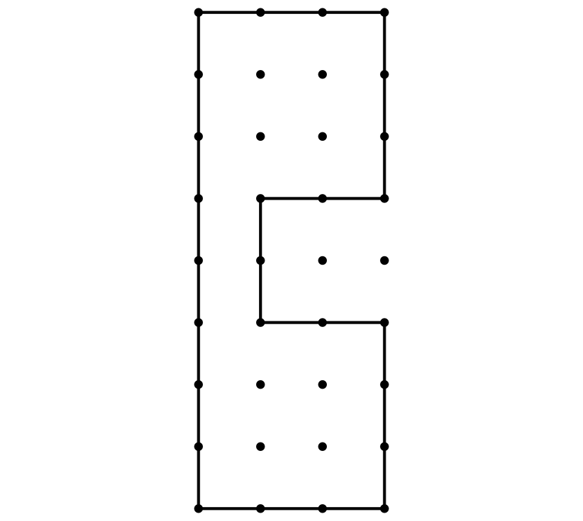
C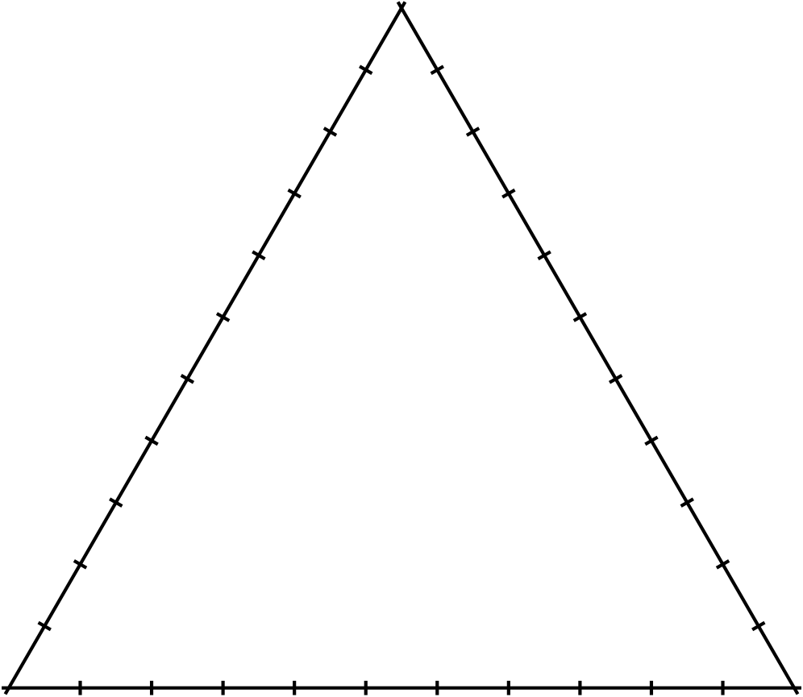
D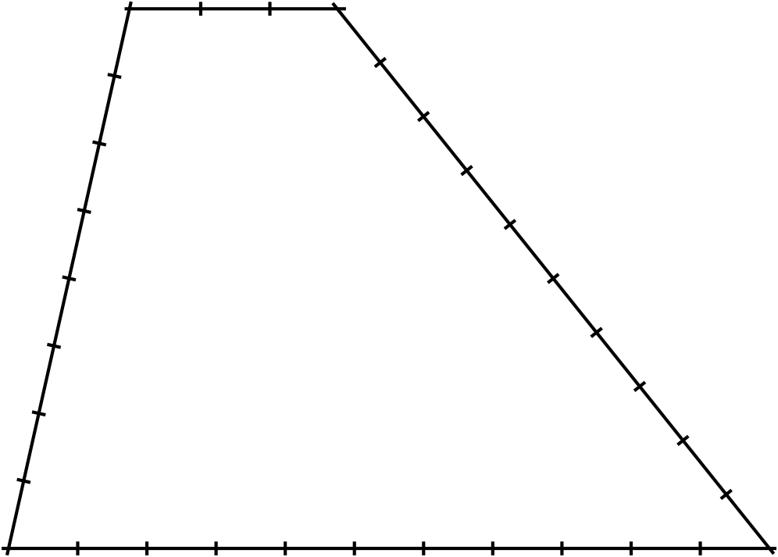
E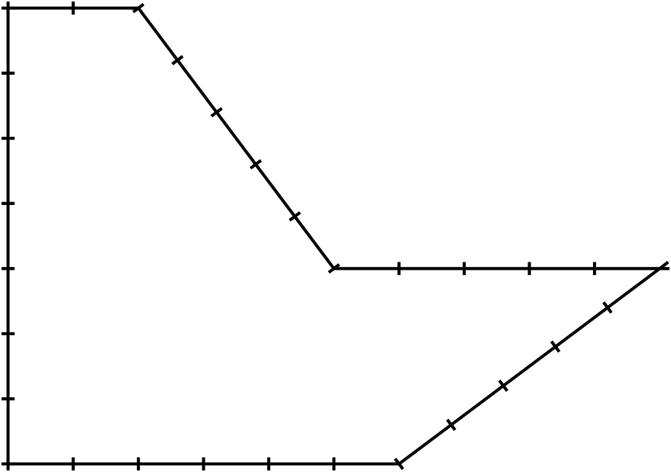
© CC BY 2021 Illustrative Mathematics®

