Unit 4 Lesson 1: Count 2 Groups of Objects

WU Which One Doesn’t Belong: Groups (Warm up)

Student Task Statement
Which one doesn’t belong?
A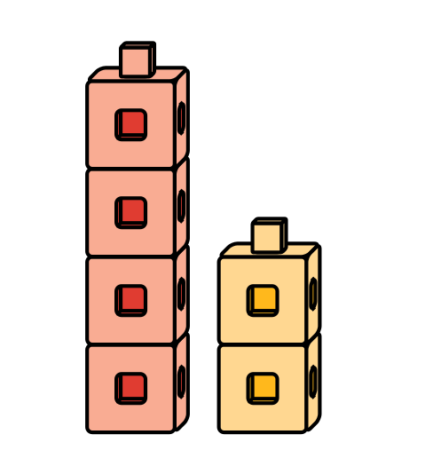
B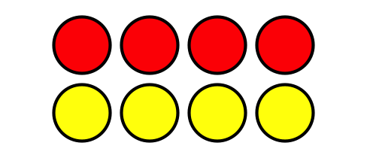
C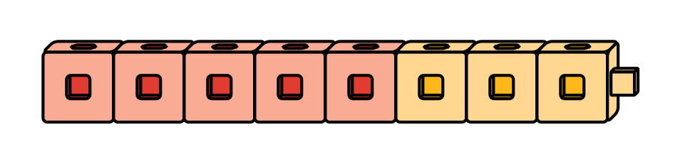
D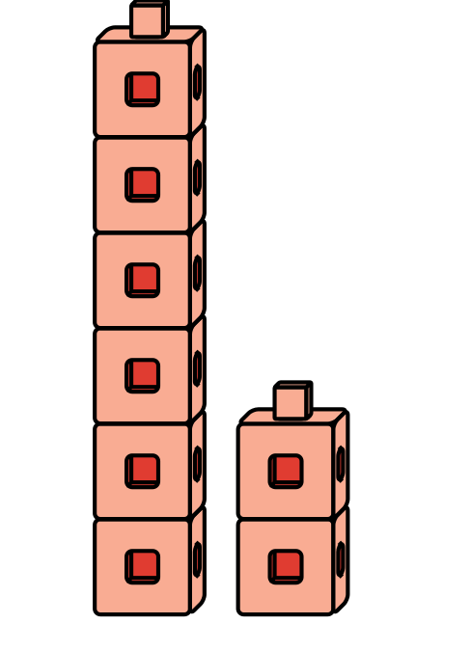

1 Put Together Pattern Blocks

Student Task Statement
How many pattern blocks do you have?
I have
pattern blocks.

2 Put Together Connecting Cubes

Student Task Statement
How many cubes do you and your partner have together?
We have
cubes.
We have
cubes.

3 Centers: Choice Time

Student Task Statement
Choose a center.
Math Libs
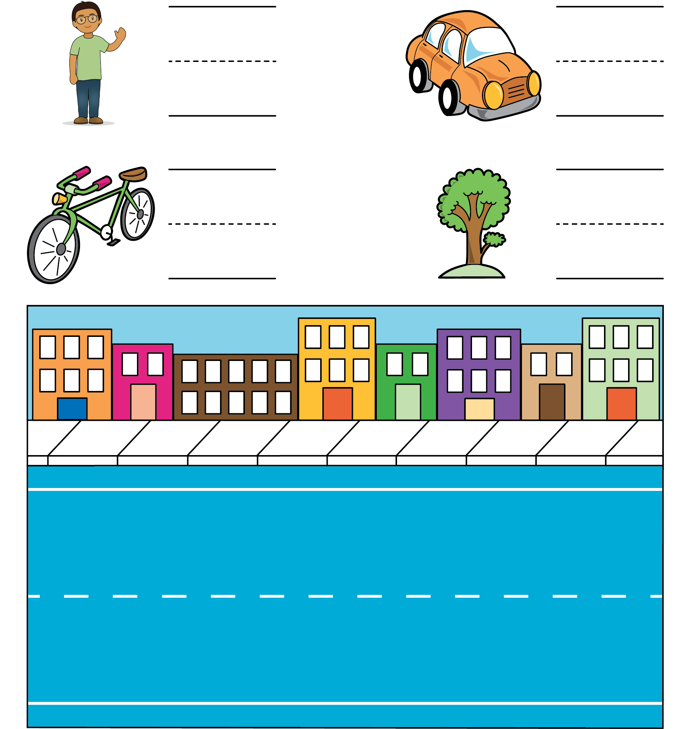
Match Mine
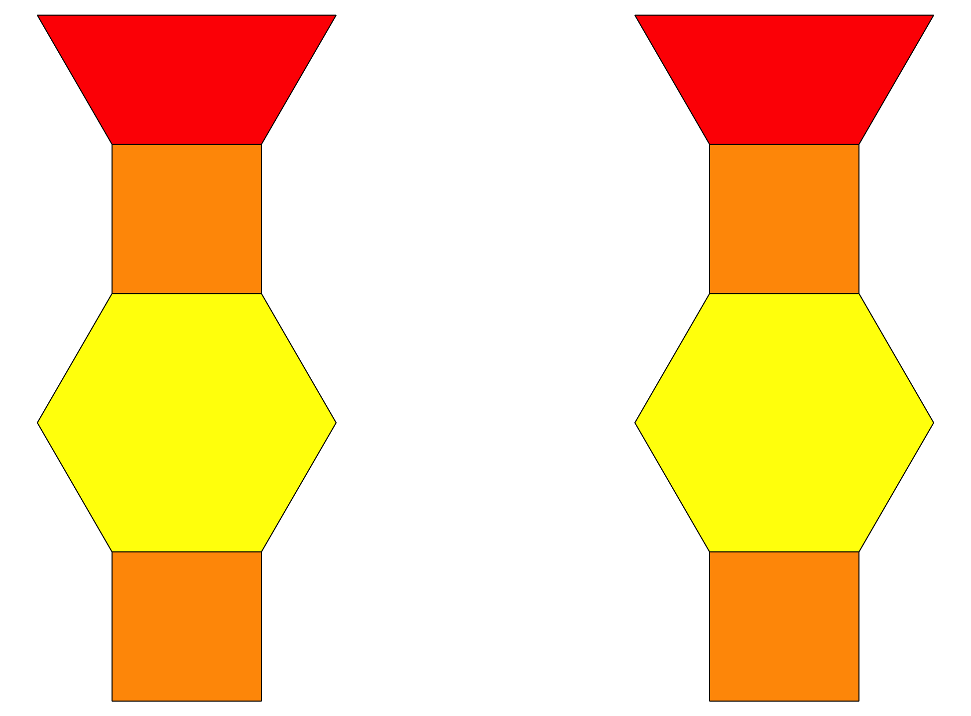
© CC BY 2021 Illustrative Mathematics®

