Unit 7 Lesson 12 Cumulative Practice Problems
  - Select all the prisms.
  - For each prism, shade one of its bases.
  - 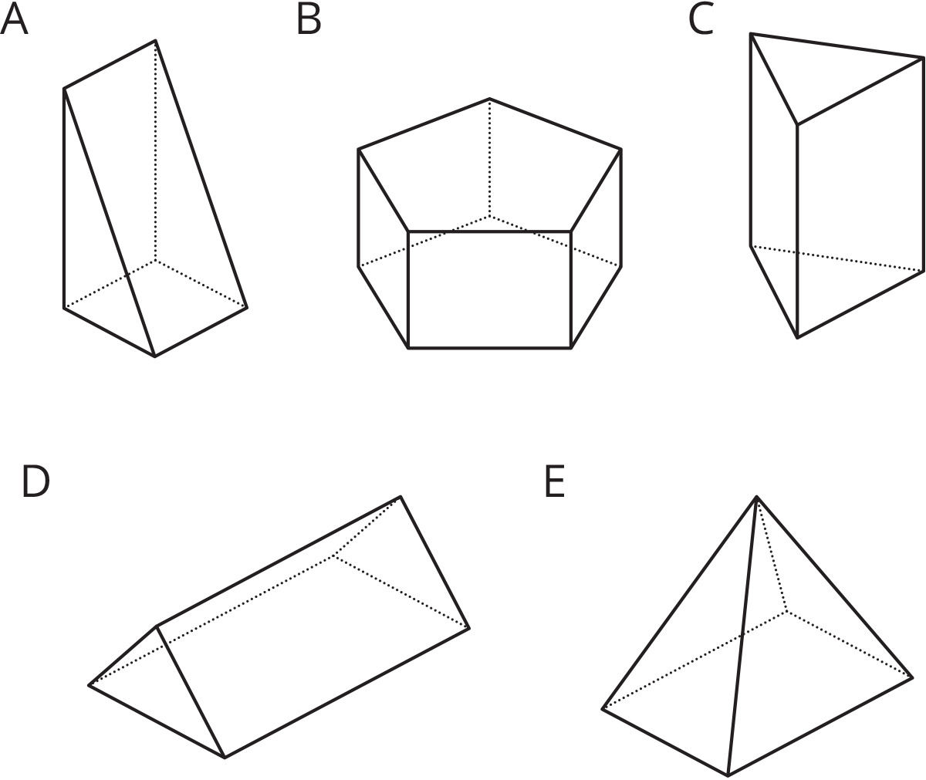
- The volume of both of these trapezoidal prisms is 24 cubic units. Their heights are 6 and 8 units, as labeled. What is the area of a trapezoidal base of each prism?
- 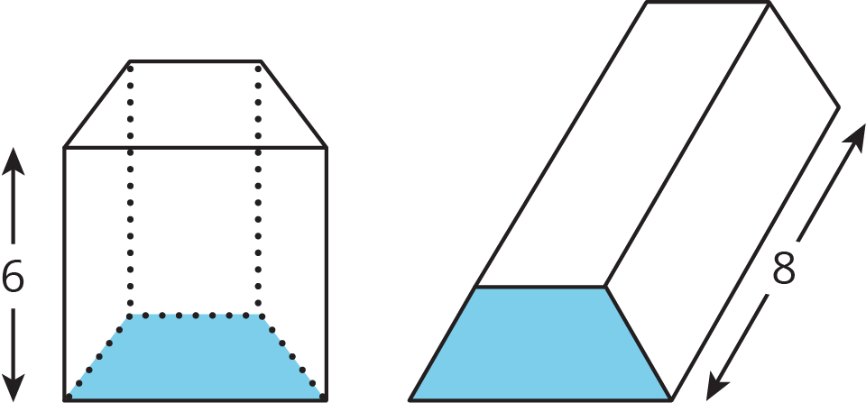

- Two angles are complementary. One has a measure of 19 degrees. What is the measure of the other?
- (From Unit 7, Lesson 2.)
- Two angles are supplementary. One has a measure that is twice as large as the other. Find the two angle measures.
- (From Unit 7, Lesson 2.)
- Match each expression in the first list with an equivalent expression from the second list.
  - $7(x+2)−x+3$
  - $6x+3+4x+5$
  - $\frac{\text{-}2}{5}x−7+\frac{3}{5}x−3$
  - $8x−5+4−9$
  - $24x+36$
  - $\frac{1}{5}x−10$
  - $6x+17$
  - $2(5x+4)$
  - $12(2x+3)$
  - $8x+(\text{-}5)+4+(\text{-}9)$
- (From Unit 6, Lesson 22.)
- Clare paid 50% more for her notebook than Priya paid for hers. Priya paid $x$ for her notebook and Clare paid $y$ dollars for hers. Write an equation that represents the relationship between $y$ and $x$.
- (From Unit 4, Lesson 8.)
© CC BY Open Up Resources. Adaptations CC BY IM.

