Lesson 15 Practice Problems
- Solve: $\left\{\begin{matrix}y=6x \\ 4x+y=7\end{matrix}\right.$
- Solve: $\left\{\begin{matrix}y=3x \\ x=\text{-}2y+70\end{matrix}\right.$
- Which equation, together with $y=\text{-}1.5x+3$, makes a system with one solution?
  - $y=\text{-}1.5x+6$
  - $y=\text{-}1.5x$
  - $2y=\text{-}3x+6$
  - $2y+3x=6$
  - $y=\text{-}2x+3$
- The system $x−6y=4$, $3x−18y=4$ has no solution.
  - Change one constant or coefficient to make a new system with one solution.
  - Change one constant or coefficient to make a new system with an infinite number of solutions.
- Match each graph to its equation.
- 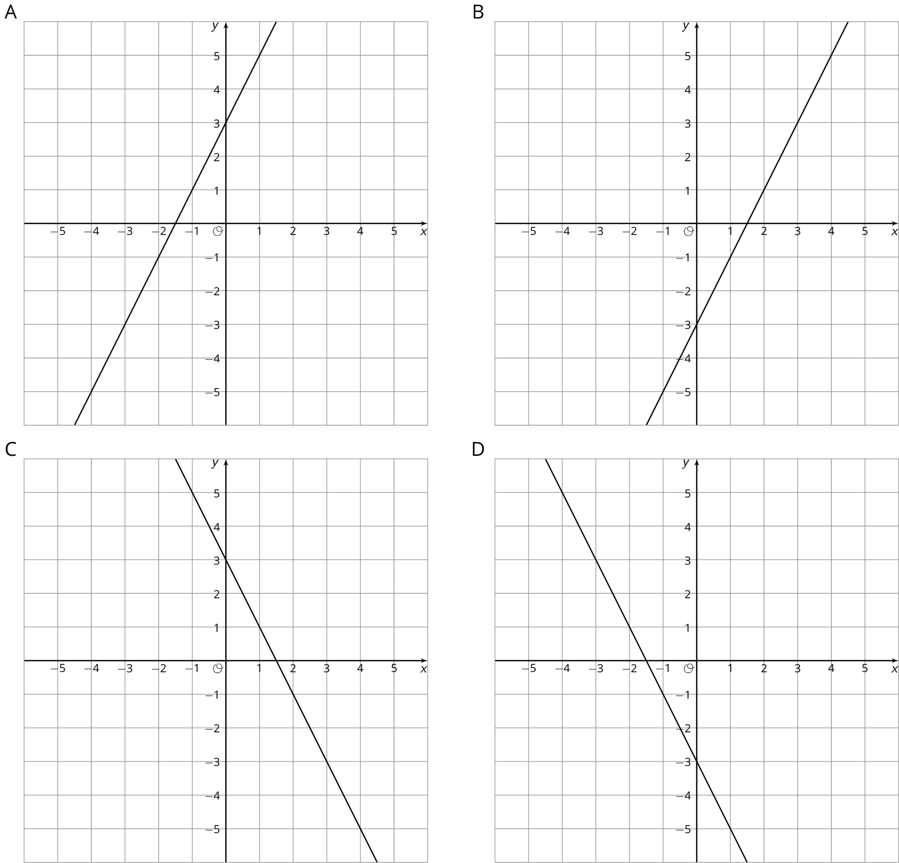
  - $y=2x+3$
  - $y=\text{-}2x+3$
  - $y=2x−3$
  - $y=\text{-}2x−3$
- (From Unit 5, Lesson 9.)
- Here are two points: $\left(\text{-}3,4\right)$, $\left(1,7\right)$. What is the slope of the line between them?
  - $\frac{4}{3}$
  - $\frac{3}{4}$
  - $\frac{1}{6}$
  - $\frac{2}{3}$
- (From Unit 5, Lesson 9.)
© CC BY Open Up Resources. Adaptations CC BY IM.

