Lesson 3 Practice Problems
- Each image shows a quadrilateral in a plane. The quadrilateral has been dilated using a center above the plane and a scale factor between 0 and 1. Match the dilation with the scale factor used.

- Dilation A

- Dilation B

- Dilation C
  - Dilation A
  - Dilation B
  - Dilation C
  - $\frac{1}{4}$
  - $\frac{1}{2}$
  - $\frac{3}{4}$
- The Pyramid of Khufu in Giza, Egypt was the world’s tallest free-standing structure for more than 3,500 years. Its original height was about 144 meters. Its base is approximately a square with a side length of 231 meters.
- The diagram shows a cross section created by dilating the base using the top of the pyramid as the center of dilation. The cross section is at a height of 96 meters.
  - What scale factor was used to create the cross section?
  - What are the dimensions of the cross section?
- The horizontal cross sections of this figure are dilations of the bottom rectangle using a point above the rectangle as a center. What scale factors of dilation are represented in the figure’s cross sections?
  - scale factors between $0$ and $\frac{1}{2}$
  - scale factors between $0$ and $1$
  - scale factors between $\frac{1}{4}$ and $\frac{3}{4}$
  - scale factors between $\frac{1}{2}$ and $1$
- Imagine an upright cone with its base resting on your horizontal desk. Match each plane with the image of the cross section formed by intersecting the plane with the cone.

- Figure 1

- Figure 2

- Figure 3
- 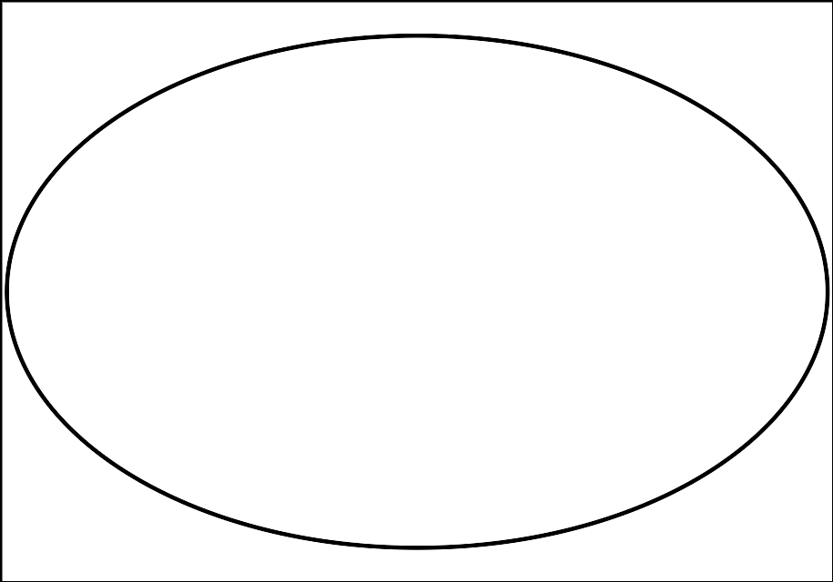
  - horizontal
  - vertical, through cone’s topmost point
  - diagonal
  - Figure 1
  - Figure 2
  - Figure 3
- (From Unit 5, Lesson 2.)
- What is the shape of the cross section formed by intersecting a cube with a vertical plane that passes through opposite edges of the cube? Explain how you know.
- (From Unit 5, Lesson 2.)
- Sketch the solid of rotation formed by rotating the given two-dimensional figure using the dashed vertical line as an axis of rotation.
- (From Unit 5, Lesson 1.)
- Technology required. A rope with a length of 4 meters is tied from a stake in the ground to the top of a tent. It forms a 20 degree angle with the ground. How tall is the tent?
- (From Unit 4, Lesson 7.)
- Technology required. What is the value of $y$?
- (From Unit 4, Lesson 6.)
© CC BY 2019 by Illustrative Mathematics®

