Unit 4 Lesson 7: Using Graphs to Find Average Rate of Change

1 Temperature Drop (Warm up)

Student Task Statement
Here are the recorded temperatures at three different times on a winter evening.
time | 4 p.m. | 6 p.m. | 10 p.m.
temperature | ${25}^{∘}F$ | ${17}^{∘}F$ | $8^{∘}F$
- Tyler says the temperature dropped faster between 4 p.m. and 6 p.m.
- Mai says the temperature dropped faster between 6 p.m. and 10 p.m.
Who do you agree with? Explain your reasoning.

2 Drop Some More

Images for Launch

Student Task Statement
The table and graphs show a more complete picture of the temperature changes on the same winter day. The function $T$ gives the temperature in degrees Fahrenheit, $h$ hours since noon.
$h$
$T(h)$
0
18
1
19
2
20
3
20
4
25
5
23
6
17
7
15
8
11
9
11
10
8
11
6
12
7
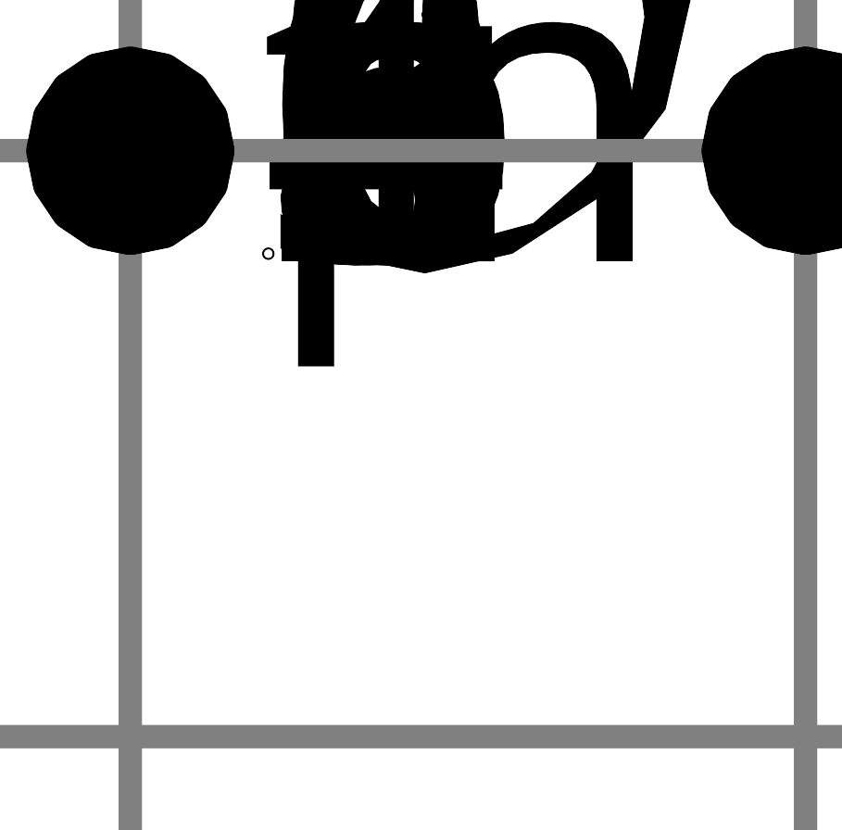
- Find the average rate of change for the following intervals. Explain or show your reasoning.
  - between noon and 1 p.m.
  - between noon and 4 p.m.
  - between noon and midnight
- Remember Mai and Tyler’s disagreement? Use average rate of change to show which time period—4 p.m. to 6 p.m. or 6 p.m. to 10 p.m.—experienced a faster temperature drop.

Activity Synthesis
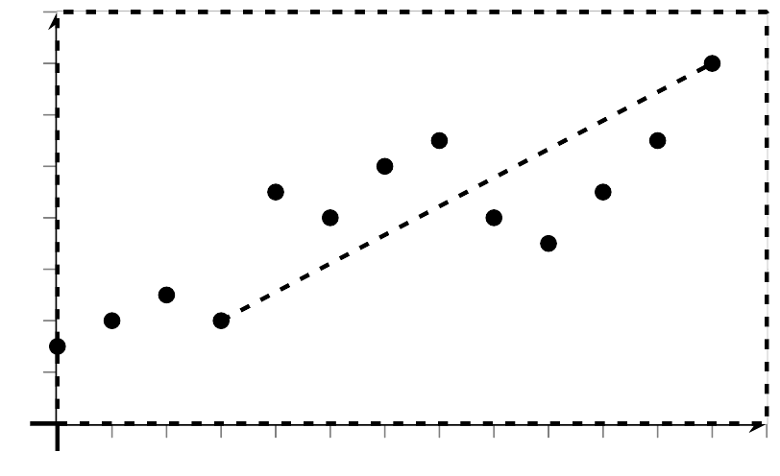

3 Populations of Two States

Student Task Statement
The graphs show the populations of California and Texas over time.
  - Estimate the average rate of change in the population in each state between 1970 and 2010. Show your reasoning.
  - In this situation, what does each rate of change mean?
- Which state’s population grew more quickly between 1900 and 2000? Show your reasoning.
© CC BY 2019 by Illustrative Mathematics®

