Unit 2 Lesson 17: Graphs of Rational Functions (Part 1)

1 Biking 10 Miles (Part 1) (Warm up)

Student Task Statement
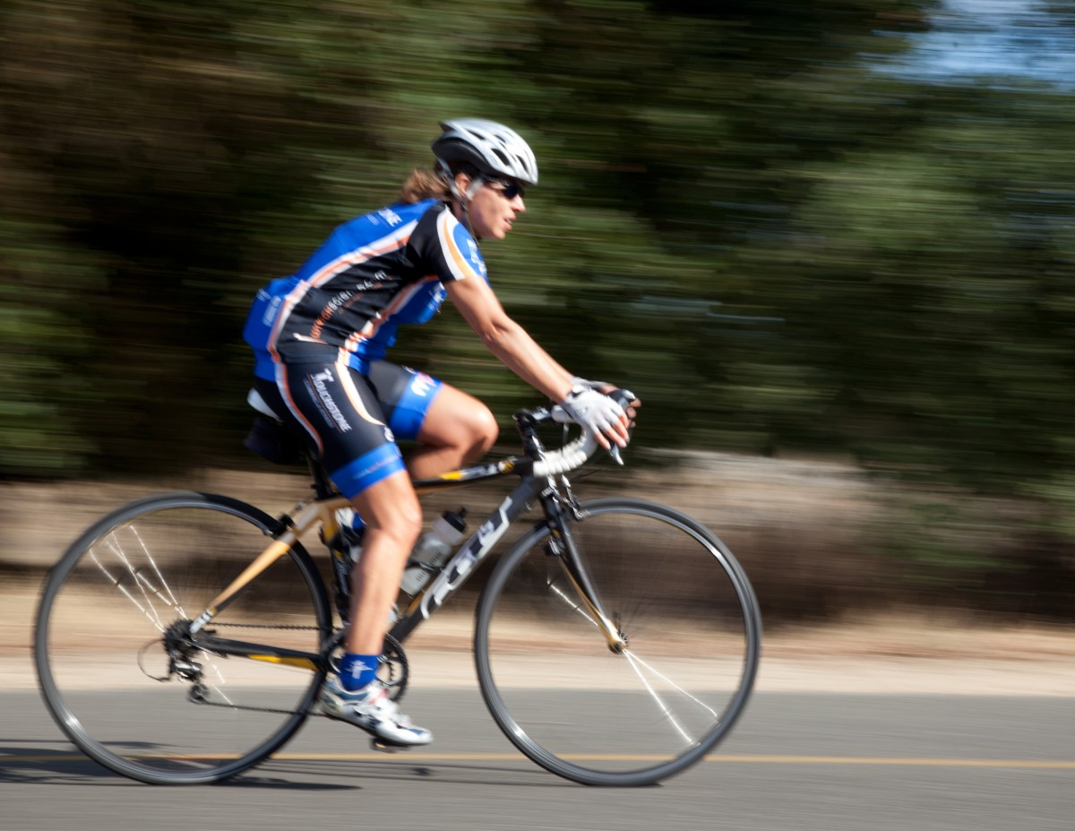
Kiran’s aunt plans to bike 10 miles.
- How long will it take if she bikes at an average rate of 8 miles per hour?
- How long will it take if she bikes at an average rate of $r$ miles per hour?
- Kiran wants to join his aunt, but he only has 45 minutes to exercise. What will their average rate need to be for him to finish on time?
- What will their average rate need to be if they have $t$ hours to exercise?

2 Biking 10 Miles (Part 2)

Student Task Statement
Kiran plans to bike 10 miles.
- Write an equation that gives his time $t$, in hours, as a function of his rate $r$, in miles per hour.
- Graph $y=t(r)$.
- What is the meaning of $t(8)$? Does this value make sense? Explain your reasoning.
- What is the meaning of $t(0)$? Does this value make sense? Explain your reasoning.
- As $r$ gets closer and closer to 0, what does the behavior of the function tell you about the situation?
- As $r$ gets larger and larger, what does the end behavior of the function tell you about the situation?

3 Card Sort: Graphs of Rational Functions

Images for Launch

Student Task Statement
Your teacher will give you a set of cards. Match each rational function with its graphical representation.

Images for Activity Synthesis

A

B

C

D

E

F

G

H

I
© CC BY 2019 by Illustrative Mathematics®

