Unit 1 Lesson 6: Center Day 1

WU Which One Doesn’t Belong: Math Tools (Warm up)

Student Task Statement
Which one doesn’t belong?
A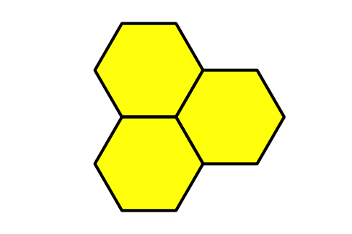
B
C
D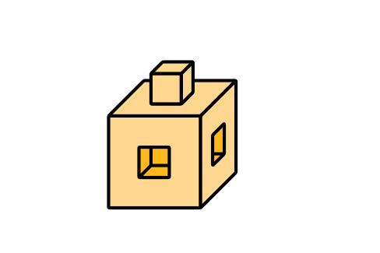

1 Revisit Find the Pair, Make 10

Student Task Statement

2 Centers: Choice Time

Student Task Statement
Choose a center.
Counting Collections
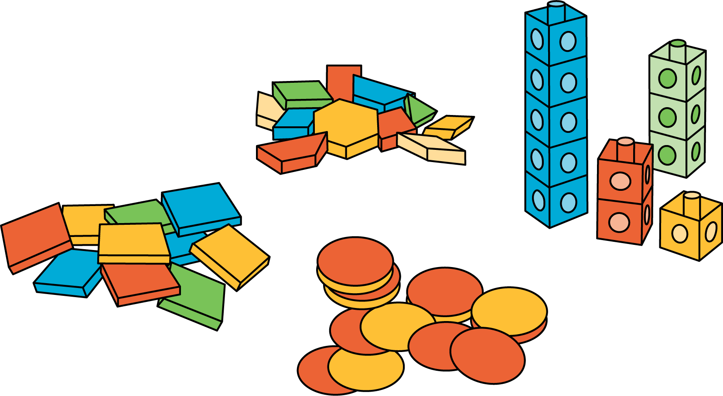
Number Race
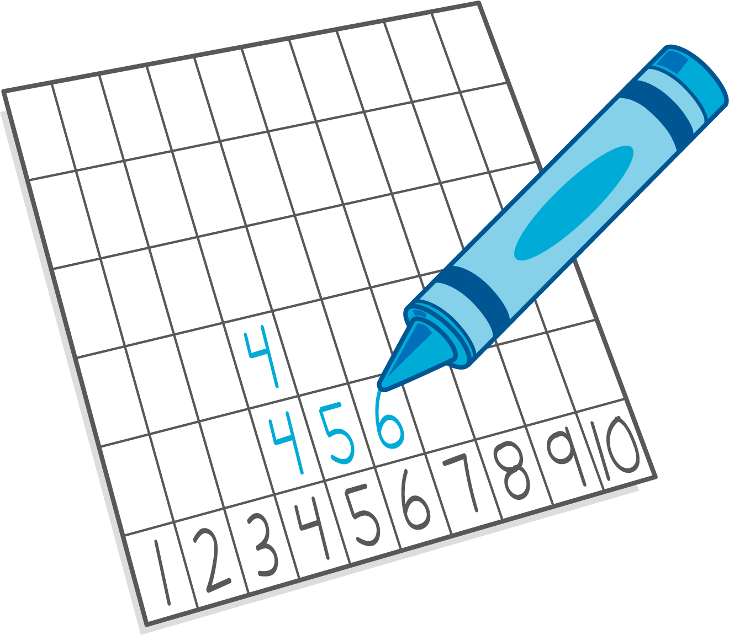
Check it Off
Five in a Row: Addition and Subtraction
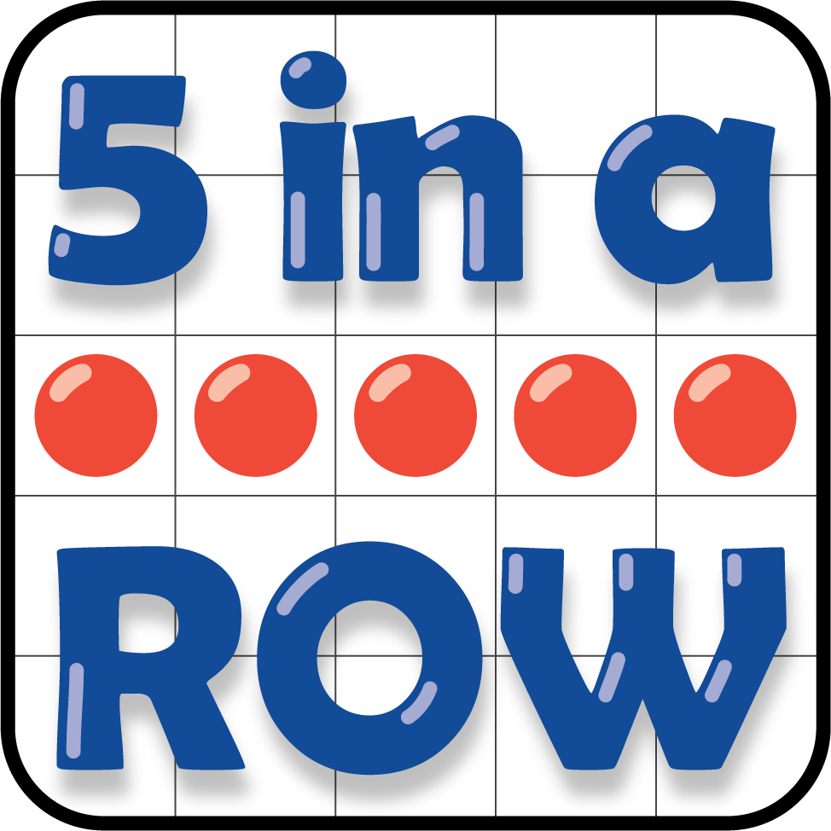
Find the Pair
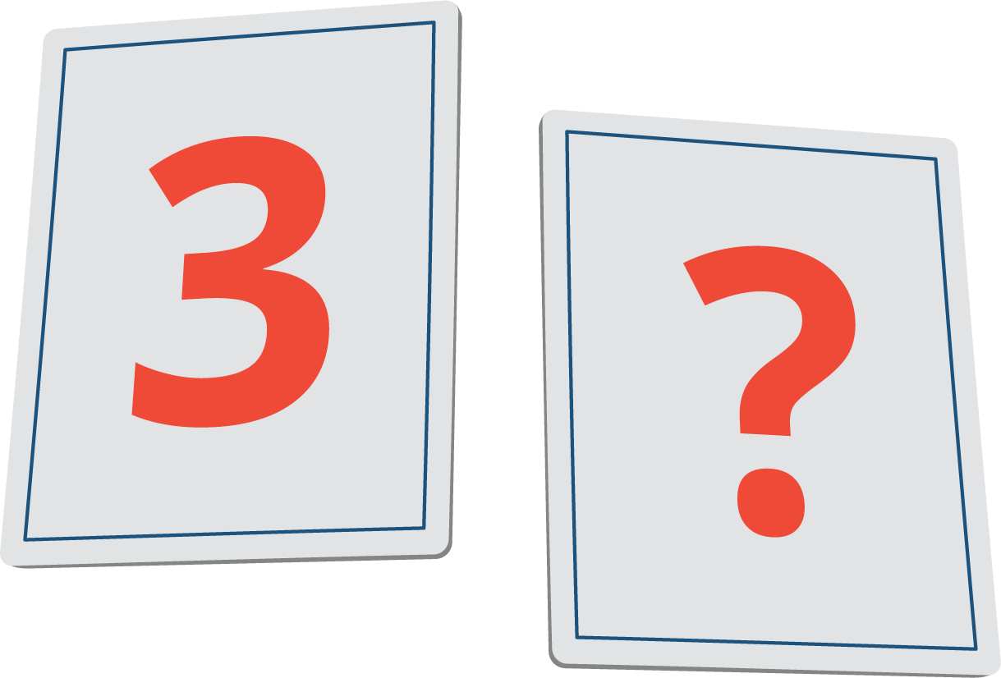
© CC BY 2021 Illustrative Mathematics®

