Lesson 7: Same Perimeter, Different Shapes
- Let’s learn about shapes with the same perimeter.

Warm-up: True or False: Sums of Four Numbers
Decide whether each statement is true or false. Be prepared to explain your reasoning.
- $123+75+123+75=100+100+70+70+5+5+3+3$
- $123+75+123+75=\left(2×123\right)+\left(2×75\right)$
- $123+75+123+75=208+208$
- $123+75+123+75=246+150$

7.1: All Kinds of Shapes
- Choose any 3 shapes and find the perimeter of each shape. Explain or show your reasoning.
- Find one shape that has the same perimeter as one of the shapes you chose earlier. Be prepared to explain your reasoning.
- 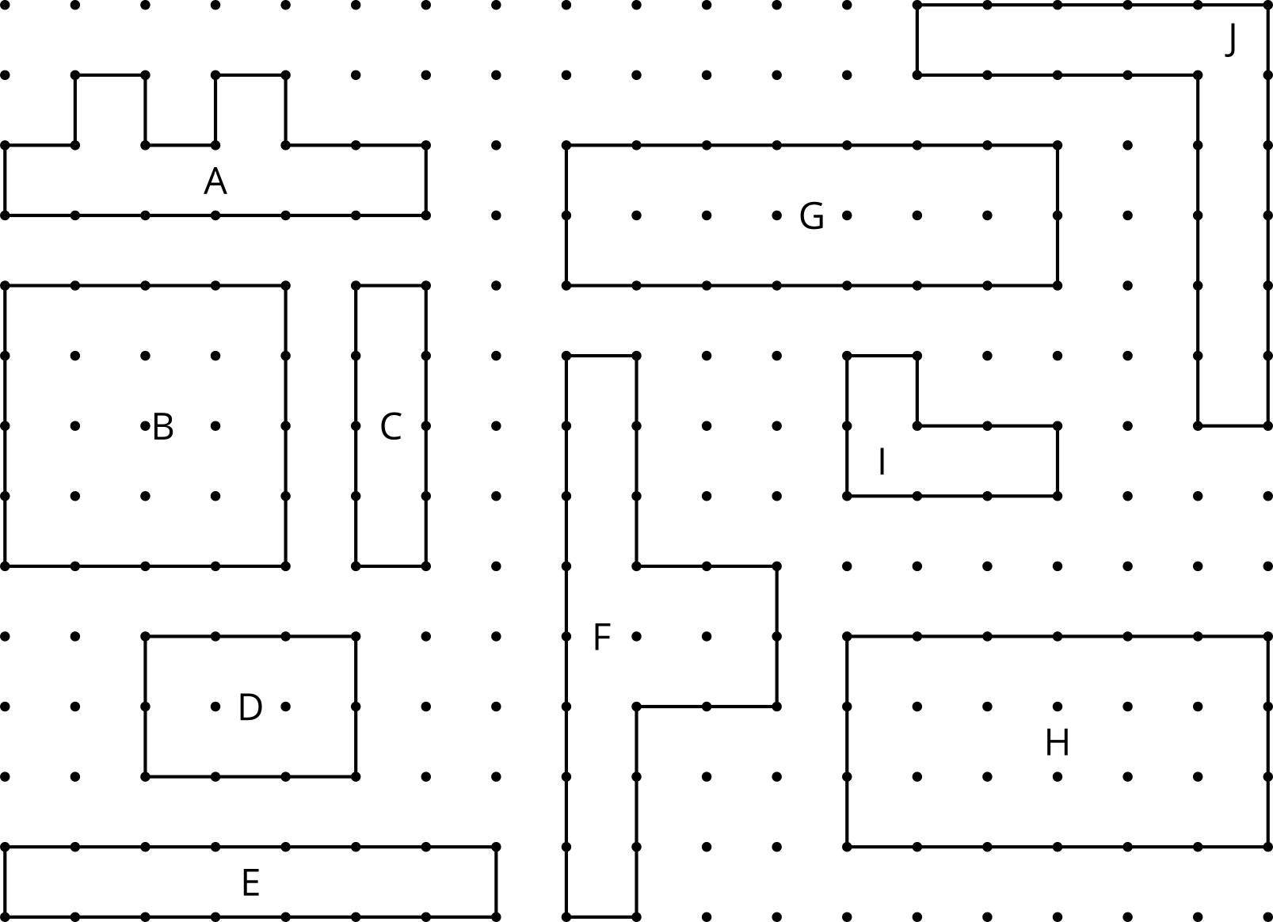

7.2: Draw Your Own
- Draw 2 shapes with each perimeter.
- 12 units
- 26 units
- 48 units

  - With your partner, choose a length. Then, draw your own shape with that perimeter.
  - Share the shapes you drew and discuss how they are alike and how they are different.
© CC BY 2021 Illustrative Mathematics®

