Unit 4 Lesson 2: Count 2 Groups of Images

WU Questions About Us: Winter or Summer? (Warm up)

Student Task Statement

1 Put Together Dots on 5-Frames

Student Task Statement
There are
dots.
There are
dots.
There are
dots.
There are
dots.
There are
dots.

2 How Many Apples?

Student Task Statement

- 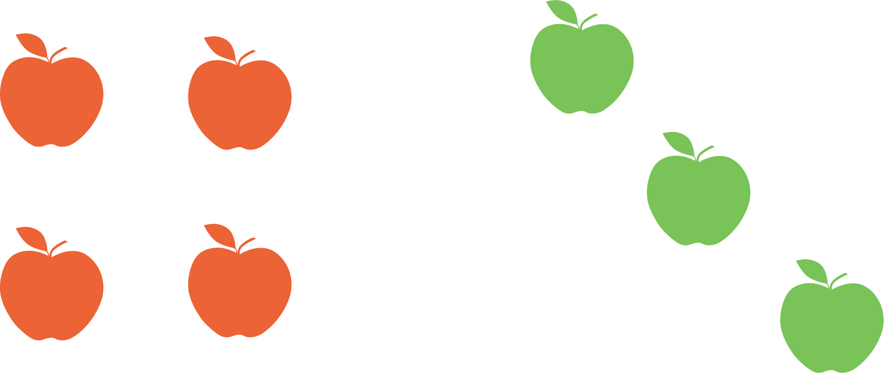
- There are
- apples.

- 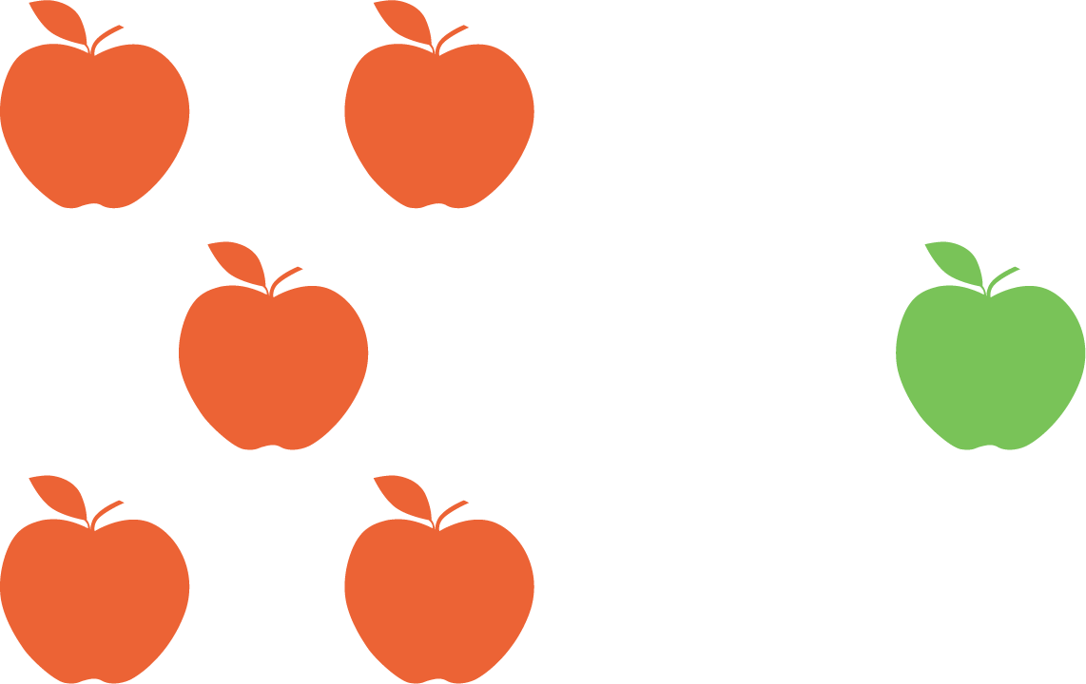
- There are
- apples.

- 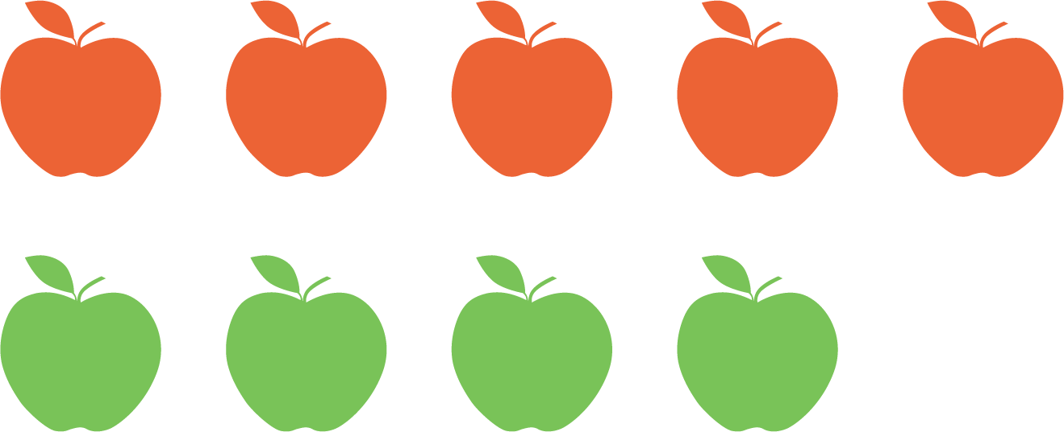
- There are
- apples.

- 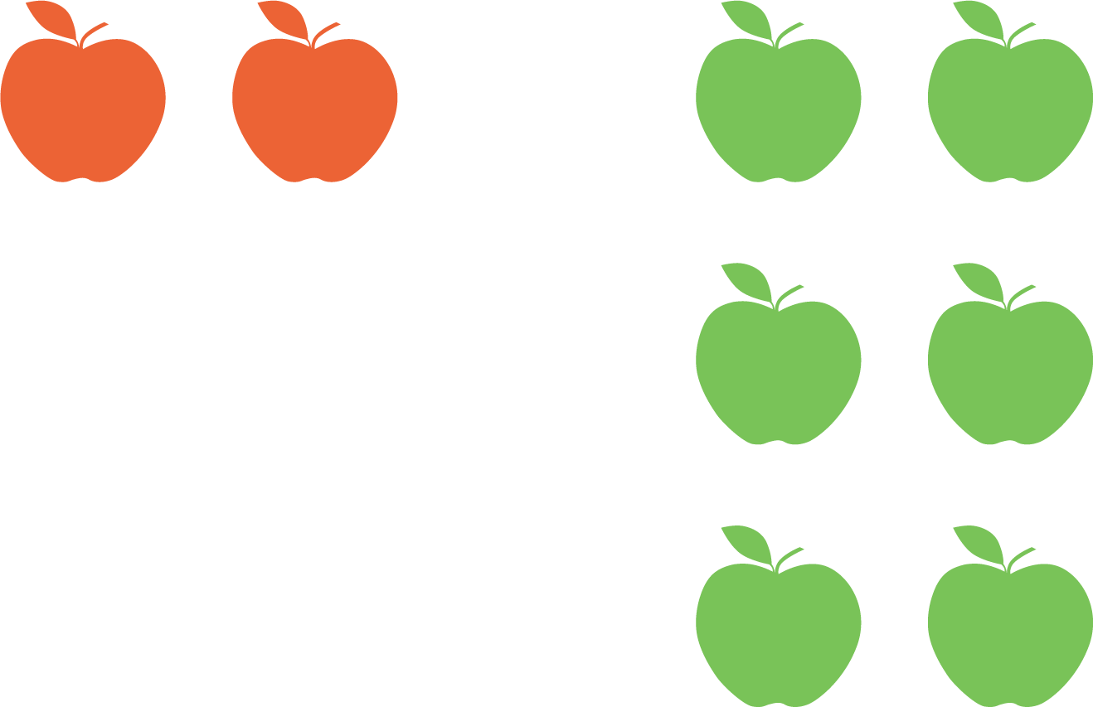
- There are
- apples.

3 Introduce Roll and Add, Dots

Student Task Statement
How many dots?
Choose a center.
Roll and Add
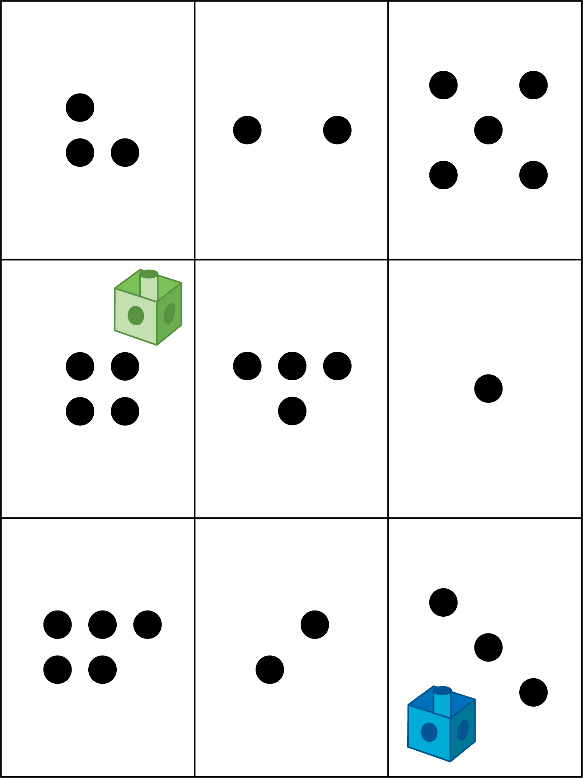
Math Libs
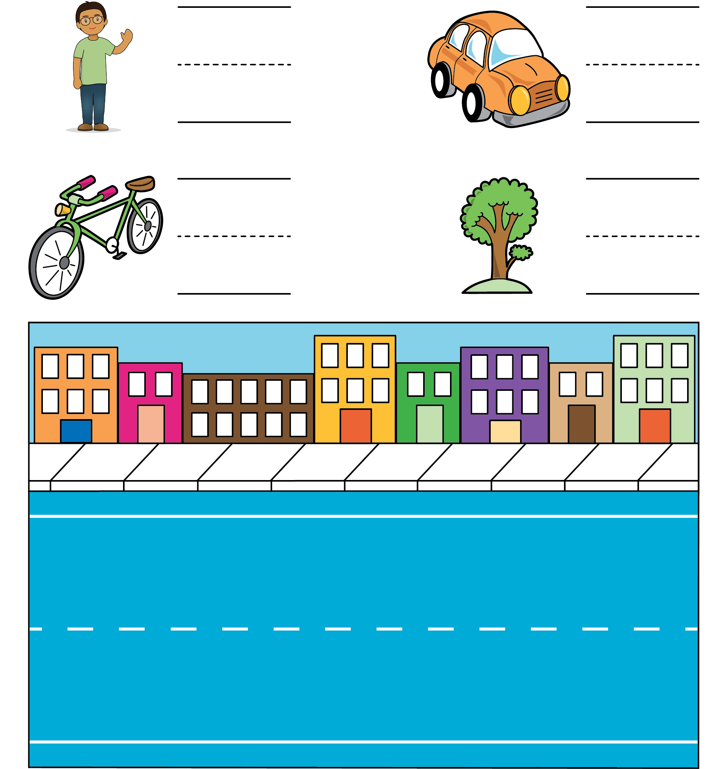
Match Mine
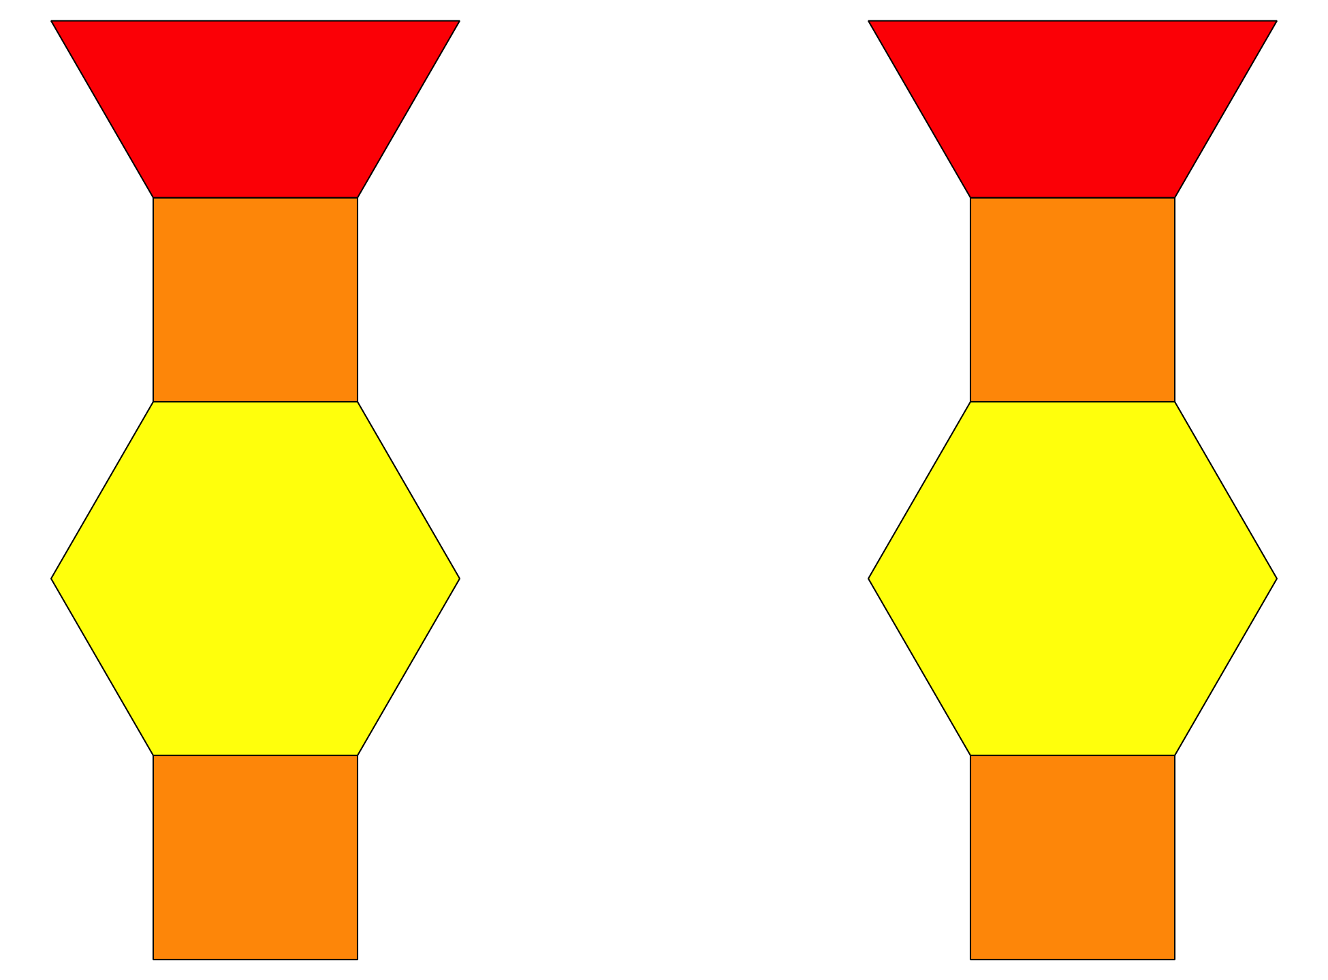
© CC BY 2021 Illustrative Mathematics®

