Lesson 13: Standard Deviation in Real-World Contexts
- Let’s think about standard deviation in the real world.

13.1: Estimation: Marathon Runner
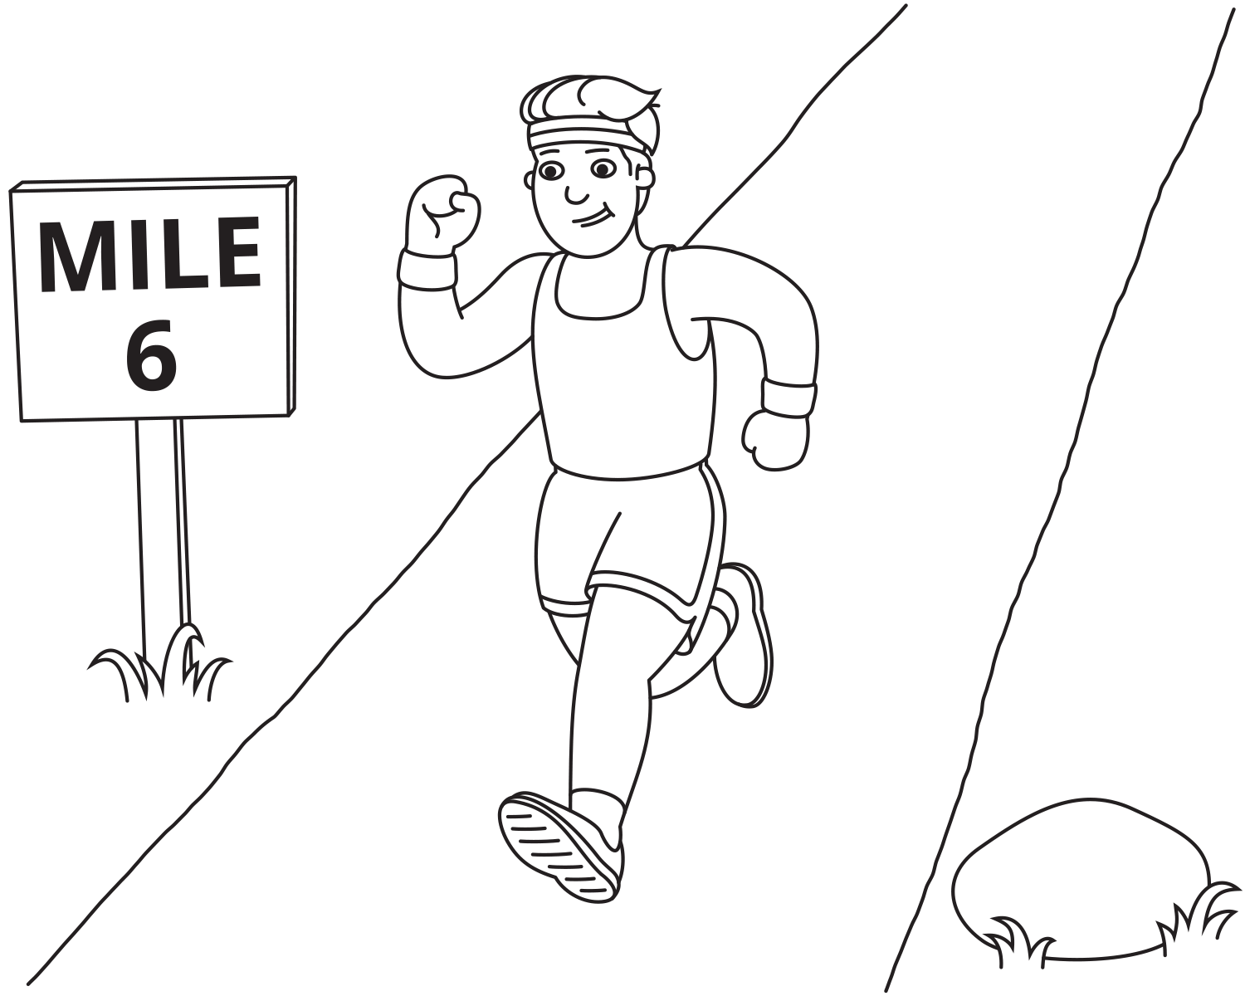
How long will it take the runner to finish the marathon?
- Record an estimate that is:
- too low | - about right | - too high
- Explain your reasoning.

13.2: Calculate Standard Deviation
Movie A ratings on a 10 point scale:
9, 8, 10, 10, 7, 1, 8, 1, 2, 8
Movie B ratings on a 10 point scale:
9, 8, 8, 7, 9, 7, 7, 9, 7, 8
Restaurant A ratings on a 100 point scale:
88, 87, 89, 90, 87, 85, 88, 91, 86, 86, 88, 89
Restaurant B ratings on a 100 point scale:
90, 65, 89, 50, 94, 93, 95, 95, 75, 70, 88, 89
- Calculate the mean and standard deviation for each data set.
- Based on these statistics, which movie and restaurant would you choose? Explain your reasoning.

13.3: Which Route is the Best Route?
Priya timed the ride from home to school on two different routes.
Here are the times in minutes:
Route A: 21.5, 23, 24, 25, 26.5
Route B: 12, 20, 24, 28, 36
- Before calculating the standard deviation, predict which route has a greater standard deviation. Explain your reasoning.
- Calculate the standard deviation and use it to decide which route you would recommend for Priya.
© CC BY 2019 by Illustrative Mathematics®

