Lesson 1: Patterns that Grow
- Let's describe patterns and think about what might come next.

Warm-up: Notice and Wonder: Sets of Circles
What do you notice? What do you wonder?
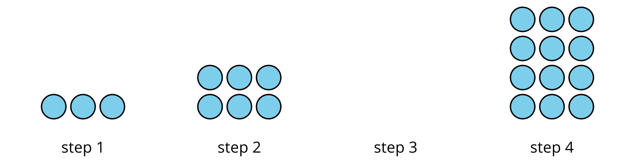

1.1: Bottle Cap Patterns
Han is arranging his bottle caps in a pattern. Here are the first two steps.
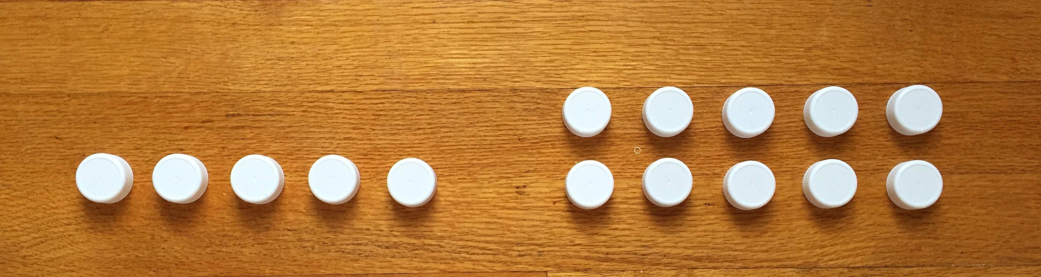

  - What might be the rule that Han has in mind? How do you think the pattern might continue?
  - Describe or draw the next 2 steps.
- Is there another possible rule?
- For each rule that you found, write the numbers that represent the number of caps in step 1 through step 6.

1.2: Taller and Taller
Jada used pattern blocks to make giraffes. Here are the first two steps. She continued to add 2 square blocks for each step that followed.
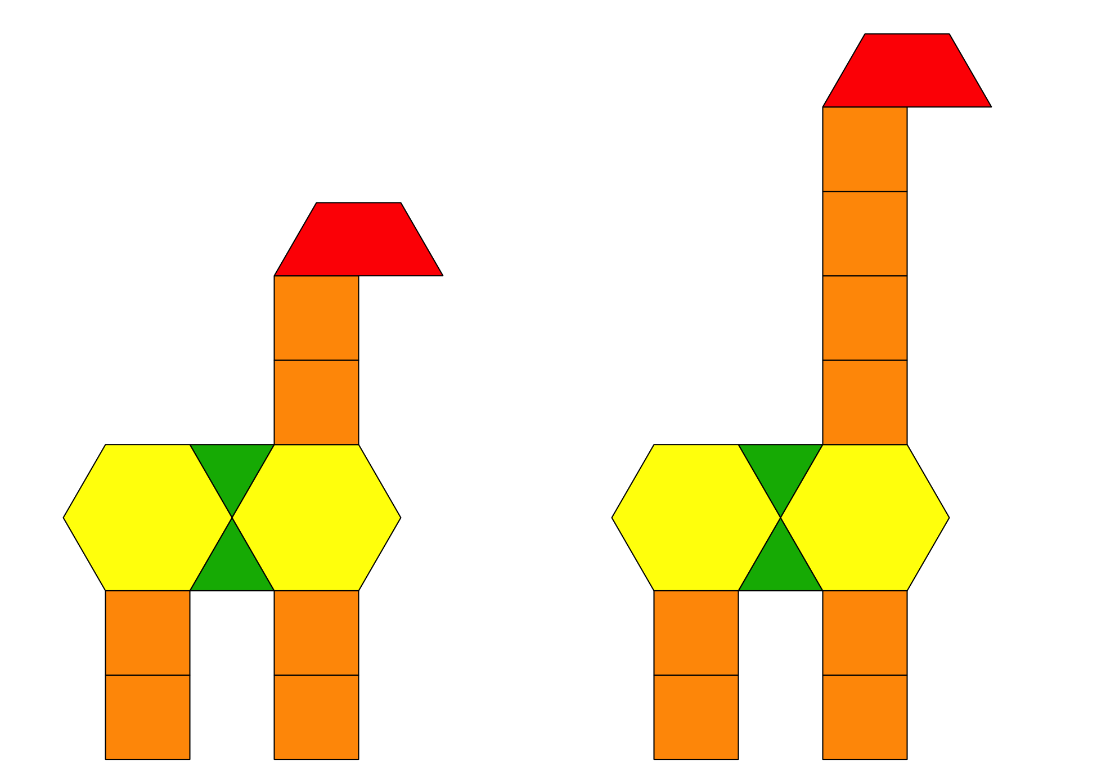
Partner A:
- List the number of square blocks in each of the first five steps. Write two observations about the numbers.
- Without drawing the giraffe, predict how many square blocks the tenth step will have. Explain or show your reasoning.
- Will a step ever have 25 square blocks? Explain or show your reasoning.
Partner B:
- List the total number of blocks in each of the first five steps. Write two observations about the numbers.
- Predict how many total blocks the tenth step will have. Explain or show your reasoning.
- Will a step ever have a total of 25 blocks? Explain or show your reasoning.
© CC BY 2021 Illustrative Mathematics®

