Lesson 12: Meaning of Exponents
Let’s see how exponents show repeated multiplication.

12.1: Notice and Wonder: Dots and Lines
What do you notice? What do you wonder?
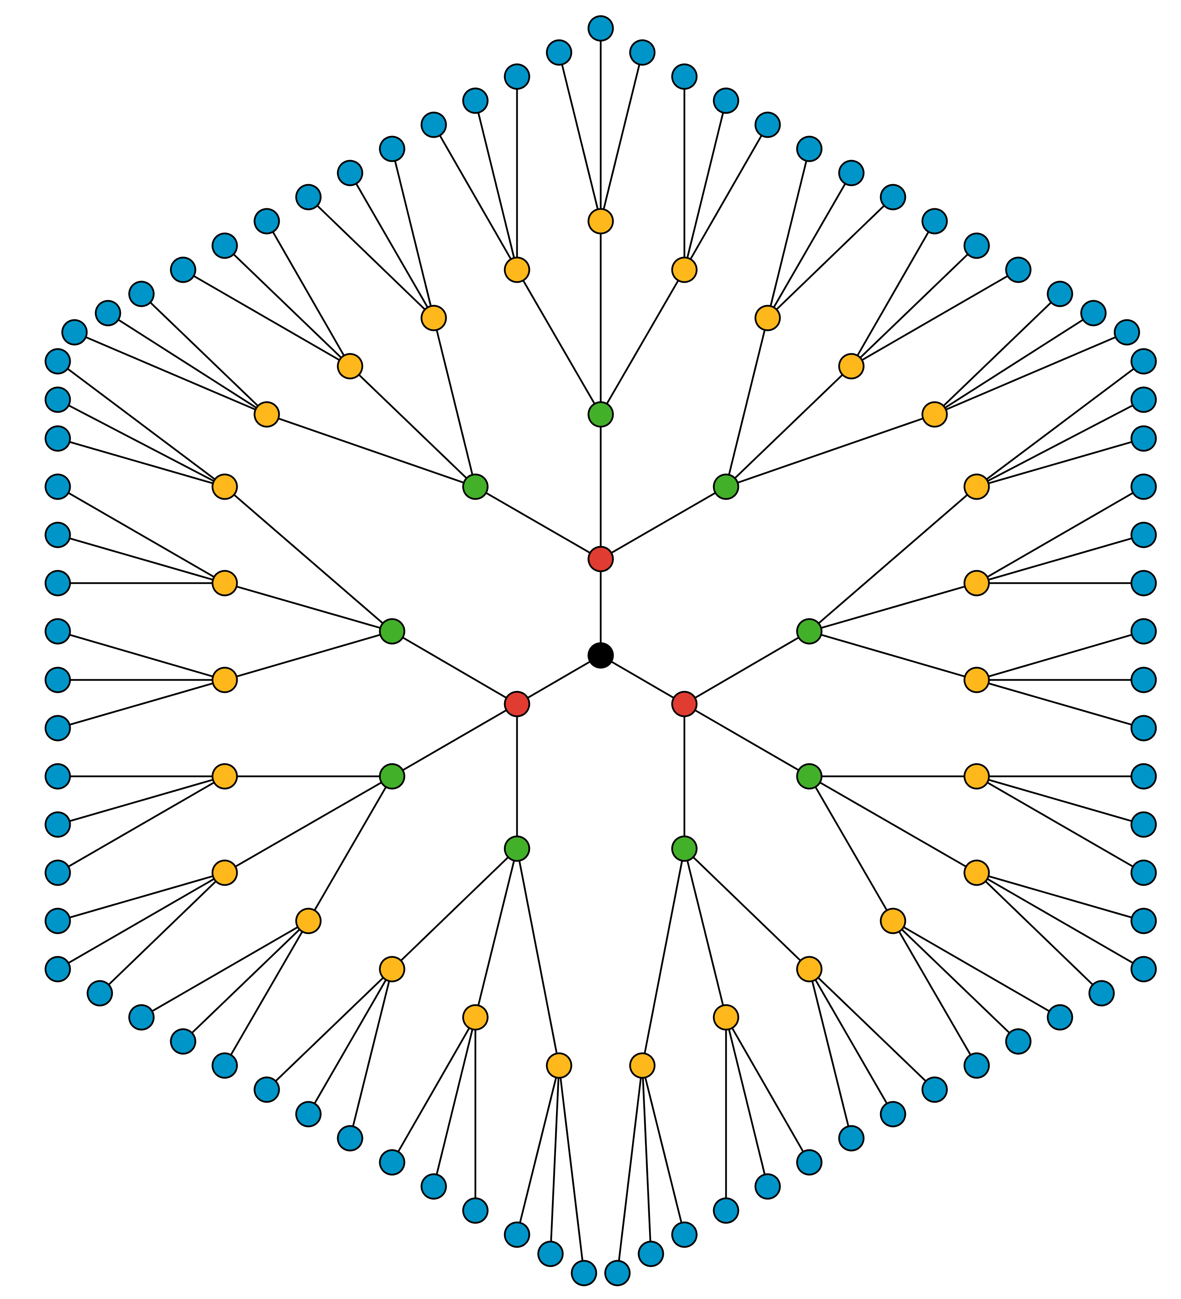

12.2: The Genie’s Offer
You find a brass bottle that looks really old. When you rub some dirt off of the bottle, a genie appears! The genie offers you a reward. You must choose one:
$50,000 or a magical $1 coin.
The coin will turn into two coins on the first day. The two coins will turn into four coins on the second day. The four coins will double to 8 coins on the third day. The genie explains the doubling will continue for 28 days.
- The number of coins on the third day will be $2⋅2⋅2$. Write an equivalent expression using exponents.
- What do $2^{5}$ and $2^{6}$ represent in this situation? Evaluate $2^{5}$ and $2^{6}$ without a calculator. Pause for discussion.
- How many days would it take for the number of magical coins to exceed $50,000?
- Will the value of the magical coins exceed a million dollars within the 28 days? Explain or show your reasoning.

Are you ready for more?
A scientist is growing a colony of bacteria in a petri dish. She knows that the bacteria are growing and that the number of bacteria doubles every hour.
When she leaves the lab at 5 p.m., there are 100 bacteria in the dish. When she comes back the next morning at 9 a.m., the dish is completely full of bacteria. At what time was the dish half full?

12.3: Make 81
- Here are some expressions. All but one of them equals 16. Find the one that is not equal to 16 and explain how you know.
- $2^{3}⋅2$
- $4^{2}$
- $\frac{2^{5}}{2}$
- $8^{2}$
- Write three expressions containing exponents so that each expression equals 81.

Lesson 12 Summary
When we write an expression like $2^{n}$, we call $n$ the exponent.
If $n$ is a positive whole number, it tells how many factors of 2 we should multiply to find the value of the expression. For example, $2^{1}=2$, and $2^{5}=2⋅2⋅2⋅2⋅2$.
There are different ways to say $2^{5}$. We can say “two raised to the power of five” or “two to the fifth power” or just “two to the fifth.”
© CC BY Open Up Resources. Adaptations CC BY IM.

