Unit 1 Lesson 5: Sequences are Functions

1 Bowling for Triangles (Part 1) (Warm up)

Student Task Statement
Describe how to produce one step of the pattern from the previous step.
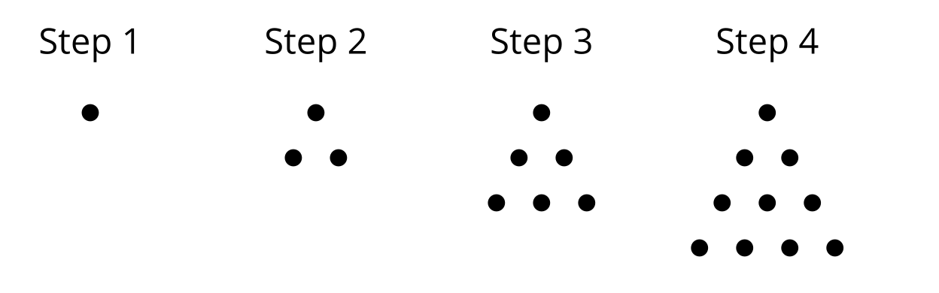

2 Bowling for Triangles (Part 2)

Student Task Statement
Here is a visual pattern of dots. The number of dots $D\left(n\right)$ is a function of the step number $n$.
- What values make sense for $n$ in this situation? What values don't make sense for $n$?
- Complete the table for Steps 1 to 5.
- $n$ | - $D\left(n\right)$
- 1 | - 1
- 2 | - $D\left(1\right)+2=3$
- 3 | - $D\left(2\right)+3=6$
- 4
- 5
- Following the pattern in the table, write an equation for $D\left(n\right)$ in terms of the previous step. Be prepared to explain your reasoning.

3 Let's Define Some Sequences

Student Task Statement
Use the first 5 terms of each sequence to state if the sequence is arithmetic, geometric, or neither. Next, define the sequence recursively using function notation.
- $A$: 30, 40, 50, 60, 70, . . .
- $B$: 80, 40, 20, 10, 5, 2.5, . . .
- $C$: 1, 2, 4, 8, 16, 32, . . .
- $D$: $1,\frac{1}{2},\frac{1}{4},\frac{1}{8},\frac{1}{16},$ . . .
- $E$: 20, 13, 6, -1, -8, . . .
- $F$: 1, 3, 7, 15, 31, . . .
© CC BY 2019 by Illustrative Mathematics®

