Unit 1 Lesson 10: Center Day 2

WU Choral Count: Count by 10 (Warm up)

Student Task Statement

1 Revisit What’s Behind My Back, 10 Cubes

Student Task Statement

2 Centers: Choice Time

Student Task Statement
Choose a center.
Five in a Row: Addition and Subtraction
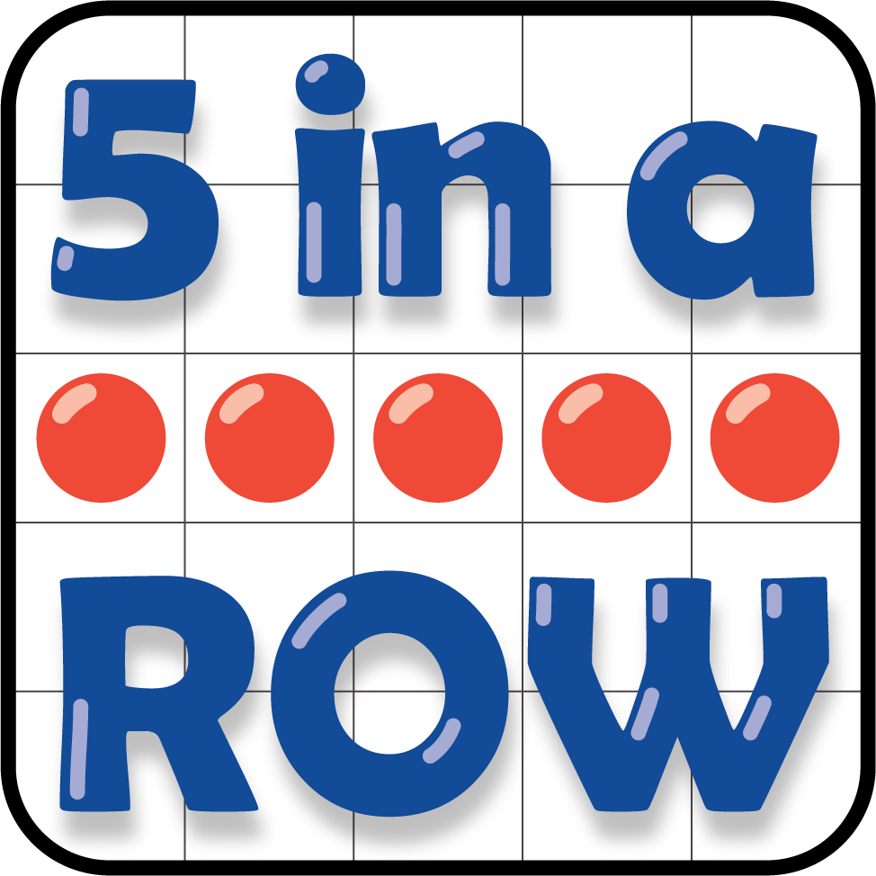
Check it Off
What's Behind My Back
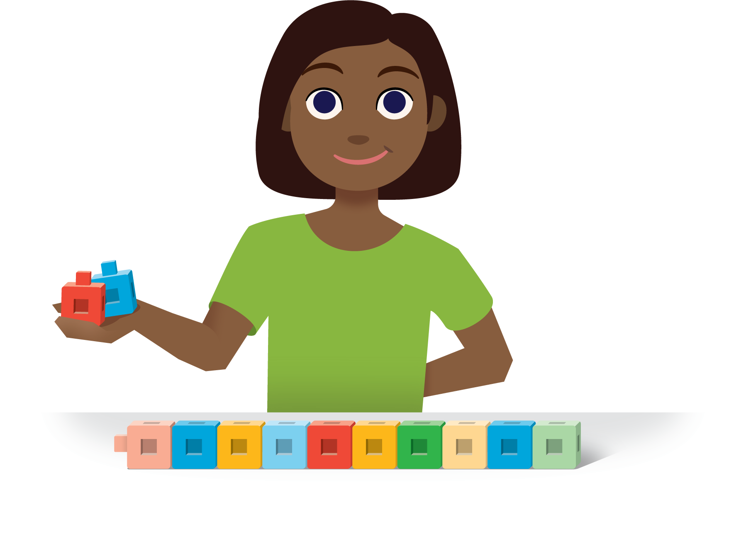
Find the Pair
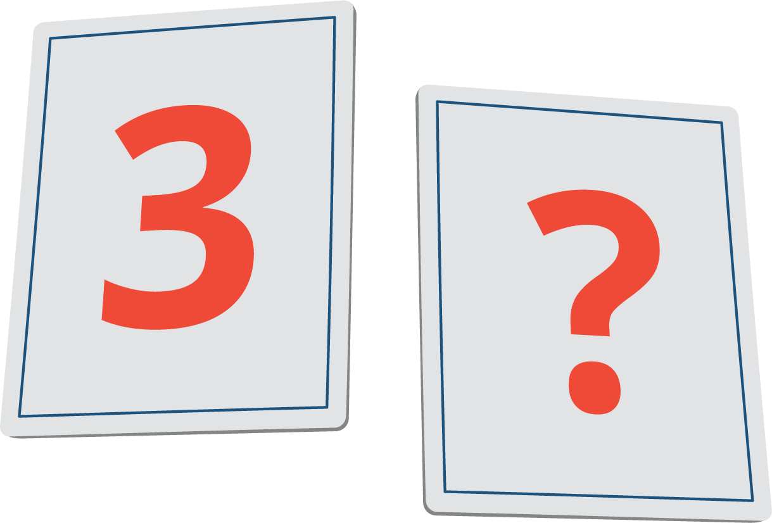
© CC BY 2021 Illustrative Mathematics®

