Unit 4 Lesson 6: Tell and Act Out Stories

WU How Many Do You See: Add To (Warm up)

Student Task Statement
How many do you see?
How do you see them?

1 What is Happening?

Student Task Statement
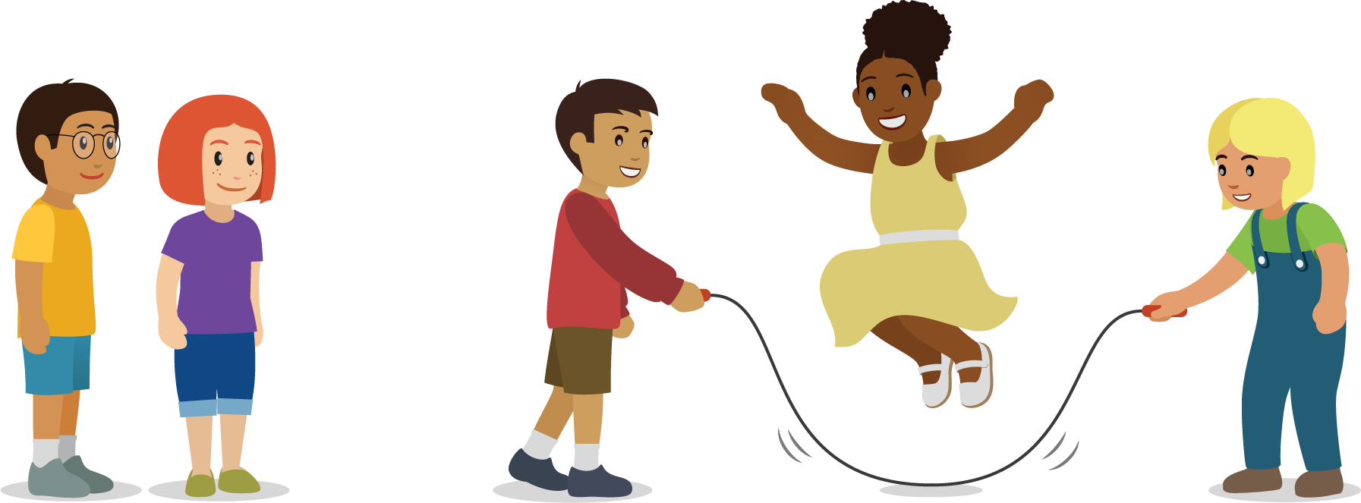

2 Act Out a Story

Student Task Statement
- There were 4 students jumping rope at recess.
2 more students came out to play with them.
- There were 6 students playing soccer at recess.
3 of the students had to go inside.
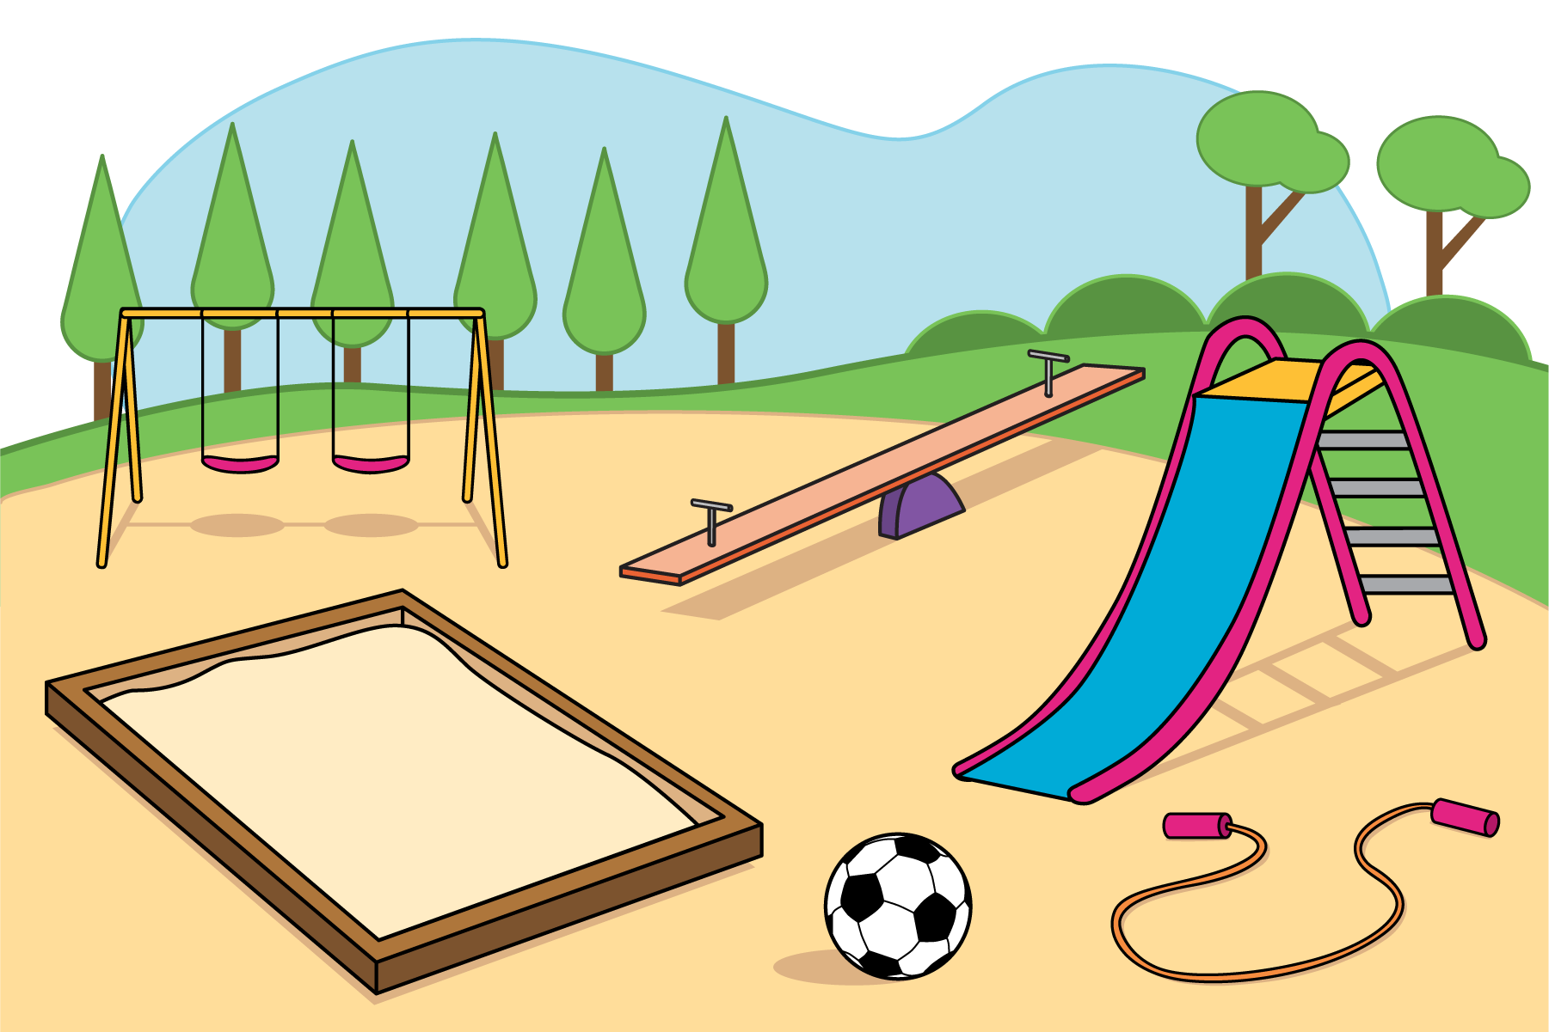

3 Introduce Subtraction Towers, Objects

Student Task Statement
Choose a center.
Subtraction Towers
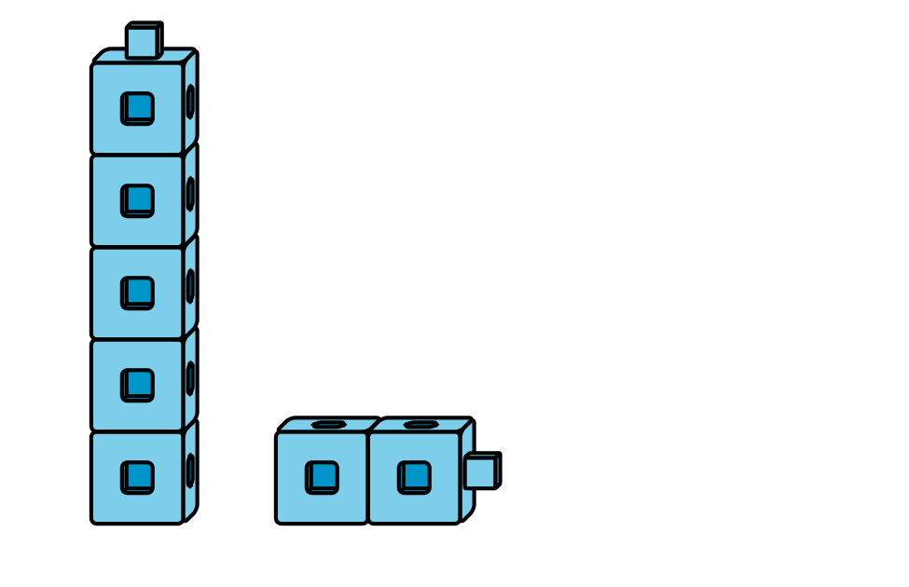
5-frames
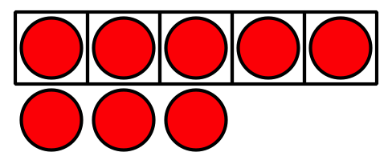
Build Shapes
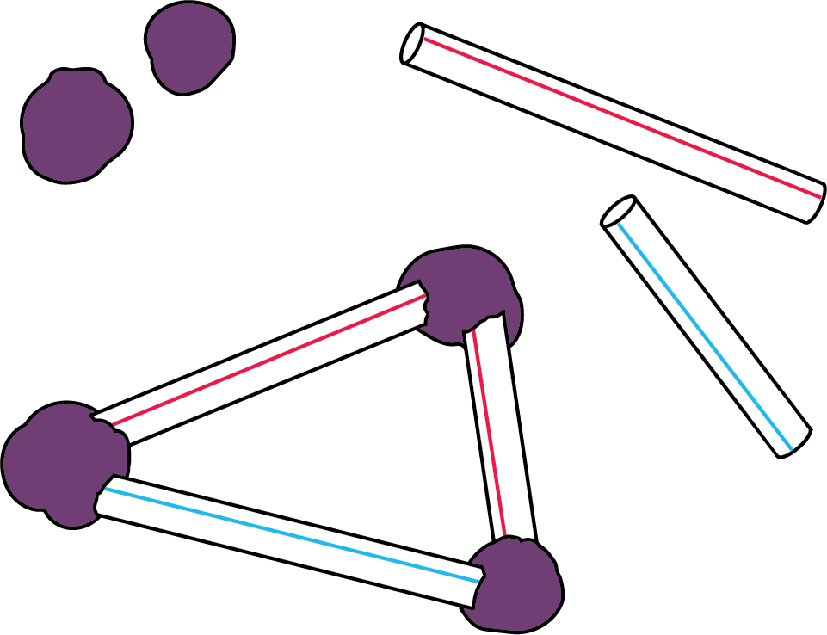
Counting Collections
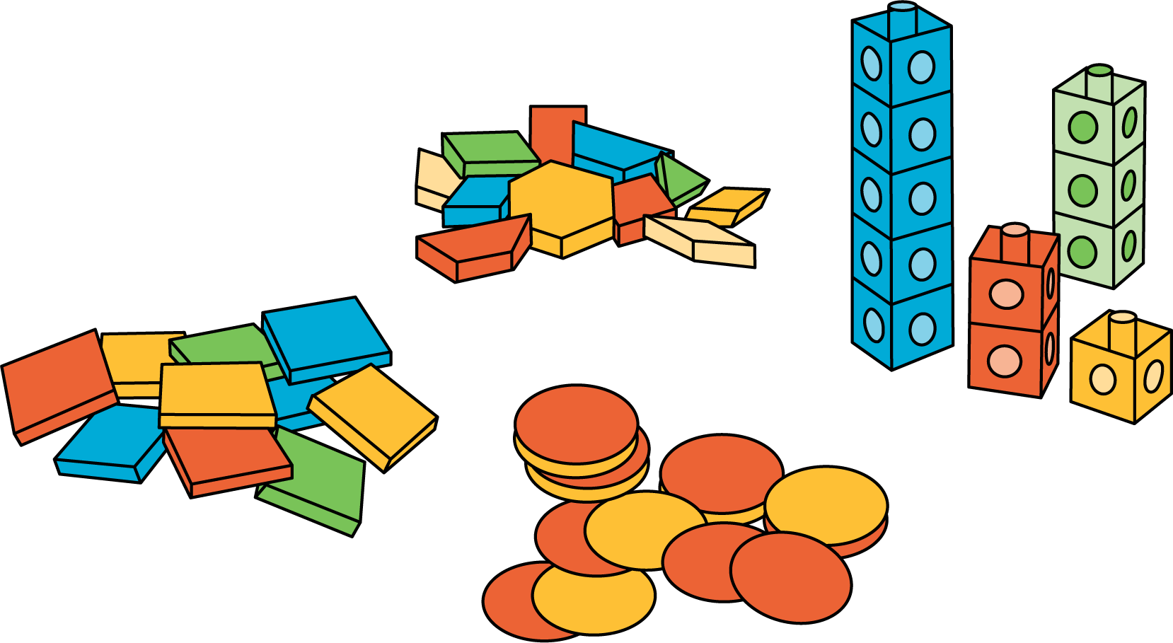
© CC BY 2021 Illustrative Mathematics®

