Unit 7 Lesson 6: Sums and Products

1 An Area Puzzle (Warm up)

Student Task Statement
- Find the length $a$ in inches.
- Find the length $b$ in inches.
- Find the area $C$ in square inches.
- Find the area $D$ in square inches.
- Find the area of the entire large rectangle in the figure. Explain or show your reasoning.

2 Framing Photos

Student Task Statement
A picture framer has 2 pictures to include in a single, rectangular frame. One picture is 8 inches by 10 inches and the other is 6 inches by 4 inches. The framer wants to create the smallest rectangular frame that will enclose the pictures when arranged as in the image.
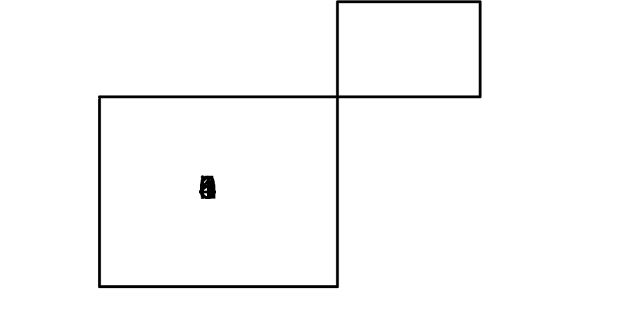
- What are the dimensions of the entire frame?
- Write an expression that would result in the area of the frame.
- Rewrite your expression for the area of the frame using the values 8, 10, 6, and 4 one time each. Explain how your rewritten equation is connected to the arrangement in the image.
- 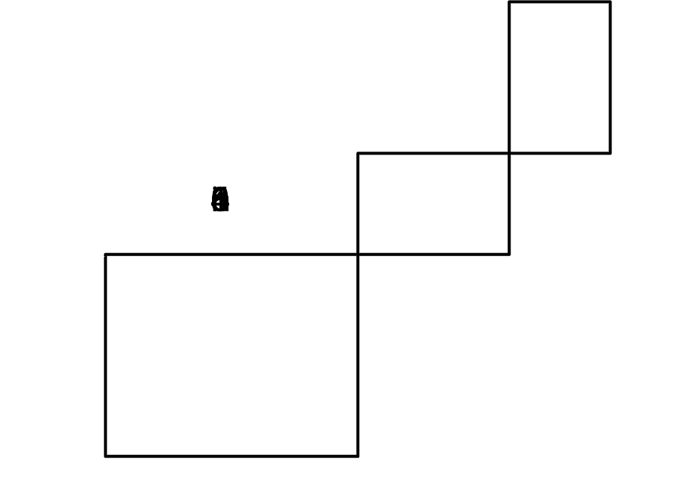
- For another frame, the picture framer has 3 photos arranged as in the diagram. What are the width and height of the frame that would contain these three photos?
- Use the width and height to find the area enclosed by the frame.
- Before the frame is made, the customer decides to not include the 8 inch by 10 inch photo. What are the length and width of the new, smaller frame? What is the area enclosed by the smaller frame?
- How do the dimensions of the photo that is removed connect to the width and height of the originally planned frame with 3 photos? How does the area of the originally planned frame connect to the area of the new frame?

3 Solving Number Riddles

Student Task Statement
- List all the pairs of integers whose product is 12.
- Circle any pairs with a sum of 7.
- Draw a box around any pairs with a sum of 13.
- Here is a riddle: “I have 2 dogs. The product of their ages is 12 and the sum of their ages is 8. How old are my dogs?"
- Here is a harder riddle: “I have 3 daughters. The product of their ages is 24. The sum of their ages is the lowest number it could possibly be. How old are they?”
- Here is a challenge riddle: “I have 3 sons. The product of their ages is 72. If I told you the sum of their ages, you wouldn’t have enough information to know how old they are. My oldest son prefers strawberry ice cream. Now you know enough to figure out how old they are. What are the ages of my sons?”
© CC BY 2019 by Illustrative Mathematics®

