Lesson 5: Products Beyond 100
- Let’s find products beyond 100.

Warm-up: Number Talk: A Number Times Some Multiple of 10
Find the value of each expression mentally.
- $8×30$
- $5×30$
- $10×30$
- $15×30$

5.1: Elena’s Sticky Gift
Elena receives a sheet of fancy stickers as a gift.
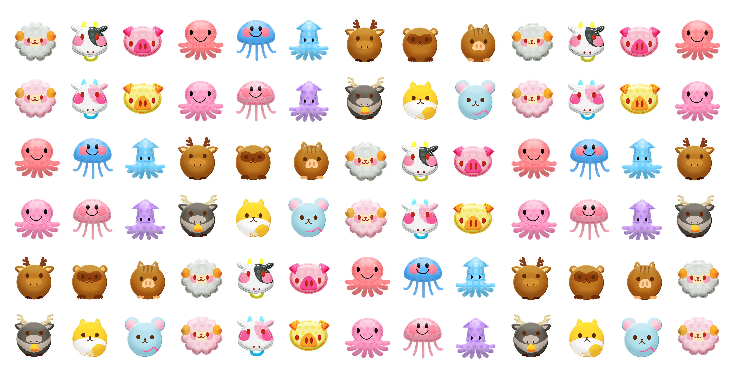
How many stickers are there? Explain or show how you would find out without counting every sticker.

5.2: More and More Stickers
- Elena has another sheet of stickers that has 9 rows and 21 stickers in each row. How many stickers does Elena have? Explain or show your reasoning.
- Noah’s sticker sheet has 3 rows with 48 stickers in each row. Andre’s sticker sheet has 7 rows with 23 stickers in each row.
- Who has more stickers? Explain or show your reasoning.
© CC BY 2021 Illustrative Mathematics®

