Lesson 4: Color Mixtures

4.1: Number Talk: Adjusting a Factor
Find the value of each product mentally.
$6⋅15$
$12⋅15$
$6⋅45$
$13⋅45$

4.2: Turning Green
Your teacher mixed milliliters of blue water and milliliters of yellow water in the ratio $5:15$.
- Doubling the original recipe:
  - Draw a diagram to represent the amount of each color that you will combine to double your teacher’s recipe.
  - Use a marker to label an empty cup with the ratio of blue water to yellow water in this double batch.
  - Predict whether these amounts of blue and yellow will make the same shade of green as your teacher’s mixture. Next, check your prediction by measuring those amounts and mixing them in the cup.
  - Is the ratio in your mixture equivalent to the ratio in your teacher’s mixture? Explain your reasoning.
- Tripling the original recipe:
  - Draw a diagram to represent triple your teacher’s recipe.
  - Label an empty cup with the ratio of blue water to yellow water.
  - Predict whether these amounts will make the same shade of green. Next, check your prediction by mixing those amounts.
  - Is the ratio in your new mixture equivalent to the ratio in your teacher’s mixture? Explain your reasoning.
- Next, invent your own recipe for a bluer shade of green water.
  - Draw a diagram to represent the amount of each color you will combine.
  - Label the final empty cup with the ratio of blue water to yellow water in this recipe.
  - Test your recipe by mixing a batch in the cup. Does the mixture yield a bluer shade of green?
  - Is the ratio you used in this recipe equivalent to the ratio in your teacher’s mixture? Explain your reasoning.

Are you ready for more?
Someone has made a shade of green by using 17 ml of blue and 13 ml of yellow. They are sure it cannot be turned into the original shade of green by adding more blue or yellow. Either explain how more can be added to create the original green shade, or explain why this is impossible.

4.3: Perfect Purple Water
The recipe for Perfect Purple Water says, “Mix 8 ml of blue water with 3 ml of red water.”
Jada mixes 24 ml of blue water with 9 ml of red water. Andre mixes 16 ml of blue water with 9 ml of red water.
- Which person will get a color mixture that is the same shade as Perfect Purple Water? Explain or show your reasoning.
- Find another combination of blue water and red water that will also result in the same shade as Perfect Purple Water. Explain or show your reasoning.

Lesson 4 Summary
When mixing colors, doubling or tripling the amount of each color will create the same shade of the mixed color. In fact, you can always multiply the amount of each color by the same number to create a different amount of the same mixed color.
For example, a batch of dark orange paint uses 4 ml of red paint and 2 ml of yellow paint.
- To make two batches of dark orange paint, we can mix 8 ml of red paint with 4 ml of yellow paint.
- To make three batches of dark orange paint, we can mix 12 ml of red paint with 6 ml of yellow paint.
Here is a diagram that represents 1, 2, and 3 batches of this recipe.
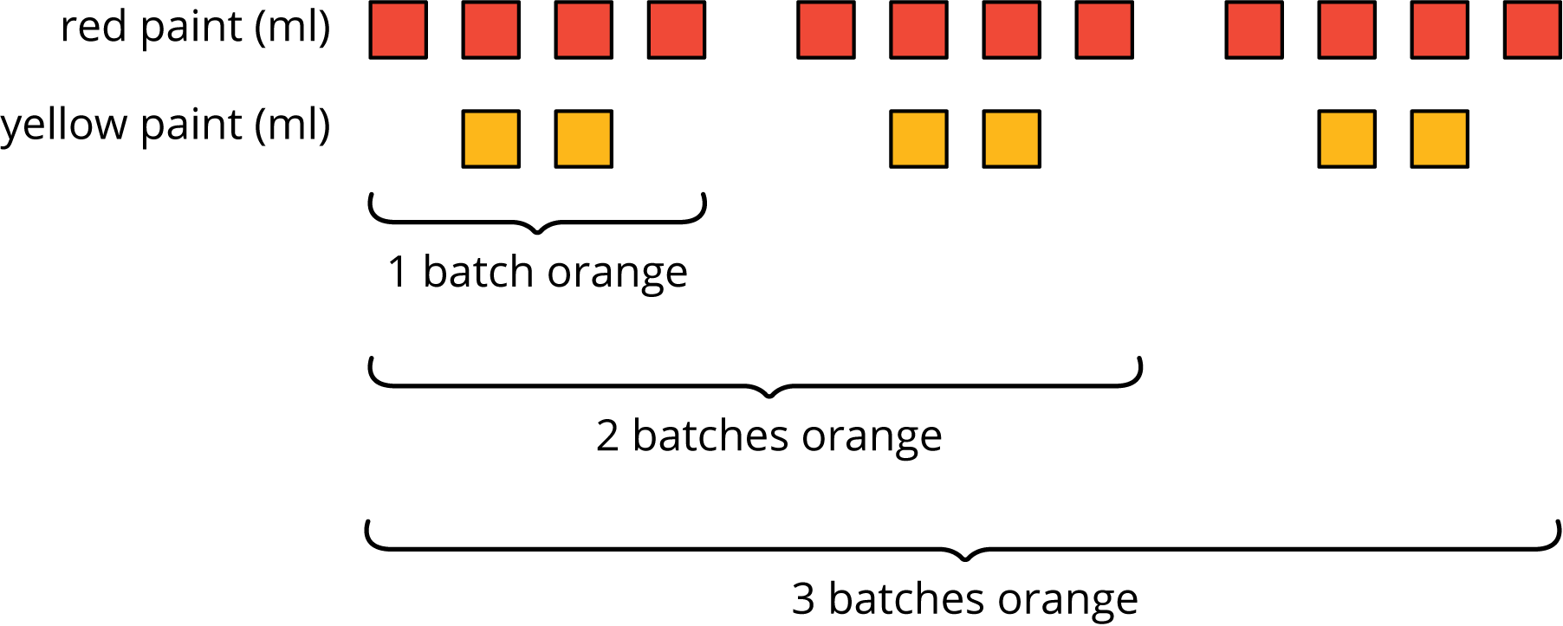
We say that the ratios $4:2$, $8:4$, and $12:6$ are equivalent because they describe the same color mixture in different numbers of batches, and they make the same shade of orange.
© CC BY Open Up Resources. Adaptations CC BY IM.

