Lesson 10 Practice Problems
- A scientist captures a sample of fish from 100 different locations along the Yellowstone river and measures the proportion of fish affected by copper toxicity for each sample. Describe how the scientist could use the data to estimate the proportion of fish affected by copper toxicity in the entire population along this portion of the river.
- A company produces 1,000 blue crayons every day. A sample of 50 crayons are analyzed, and 3 of them are found to not meet the standards of the company, so they are labeled defective. A simulation is run in which 50 crayons are chosen out of 1,000 so that each crayon chosen has a 6% chance of being defective. The simulation is run 500 times, and the mean proportion of defective crayons is 0.059 with a standard deviation of 0.012.
  - What is a good margin of error based on this simulation?
  - Based on a population proportion estimate and margin of error, is 0.07 a plausible value for the population proportion of crayons that are defective? Explain your reasoning.
- A researcher uses a random sample of 200 people in prison in the United States to find that the proportion of the prison population that is jailed for drug-related crimes is 0.485. The researcher simulates selecting a sample of 200 prisoners, each with a 48.5% chance of being in prison for drug-related crimes. The simulation is run 400 times, and the results are shown in the histogram. Use the histogram and information from the original sample to estimate the proportion of prisoners in the United States that is in prison for drug-related crimes. Be sure to include a margin of error with your estimate.
- 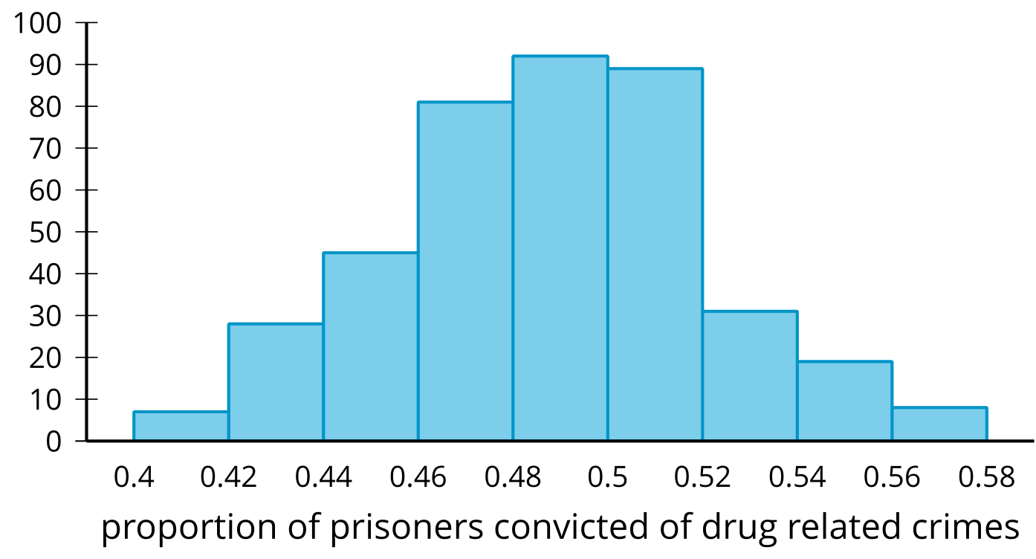

- A pizza company is interested in the average number of pizzas eaten each year by people. They send out 30 volunteers to conduct research by collecting random samples of 25 people each and determine the number of pizzas that the people in the group ate in the previous year. After looking at the sample means, the company estimates that the mean number of pizzas eaten is 6.4 with a margin of error of 1.3. Based on these values, what interval is likely to contain the true mean number of pizzas eaten in the previous year by the population?
- (From Unit 7, Lesson 9.)
- Based on surveys of random samples from students at a university, the proportion of university students interested in a new chain restaurant opening on their campus is 0.62 with a standard deviation of 0.04. Which of these intervals is the smallest that likely contains 95% of the sample proportions?
  - 0.31 to 0.93
  - 0.54 to 0.70
  - 0.58 to 0.66
  - 0.60 to 0.64
- (From Unit 7, Lesson 9.)
- Kiran collects information about 25 classmates. He believes his data set is perfectly symmetrical with a mean and median of 6. He then realizes that the number he has recorded as 12 was actually supposed to be 10. What is true about the mean and median of his corrected data set?
  - The mean and median of the corrected set are both still 6.
  - The mean of the corrected data set is still 6, but the median is greater than 6.
  - The median of the corrected data set is still 6, but the mean is greater than 6.
  - The median of the corrected data set is still 6, but the mean is less than 6.
- (From Unit 7, Lesson 4.)
© CC BY 2019 by Illustrative Mathematics®

