Lesson 1: Growing and Growing
Let's choose the better deal.

1.1: Splitting Bacteria
There are some bacteria in a dish. Every hour, each bacterium splits into 3 bacteria.
- This diagram shows a bacterium in hour 0 and then hour 1. Draw what happens in hours 2 and 3.
- How many bacteria are there in hours 2 and 3?

1.2: A Genie in a Bottle
You are walking along a beach and your toe hits something hard. You reach down, grab onto a handle, and pull out a bottle! It is sandy. You start to brush it off with your towel. Poof! A genie appears.
He tells you, "Thank you for freeing me from that bottle! I was getting claustrophobic. You can choose one of these purses as a reward."
- Purse A which contains $1,000 today. If you leave it alone, it will contain $1,200 tomorrow (by magic). The next day, it will have $1,400. This pattern of $200 additional dollars per day will continue.
- Purse B which contains 1 penny today. Leave that penny in there, because tomorrow it will (magically) turn into 2 pennies. The next day, there will be 4 pennies. The amount in the purse will continue to double each day.
- How much money will be in each purse after a week? After two weeks?
- The genie later added that he will let the money in each purse grow for three weeks. How much money will be in each purse then?
- Which purse contains more money after 30 days?

1.3: Graphing the Genie's Offer
Here are graphs showing how the amount of money in the purses changes. Remember Purse A starts with $1,000 and grows by $200 each day. Purse B starts with $0.01 and doubles each day.
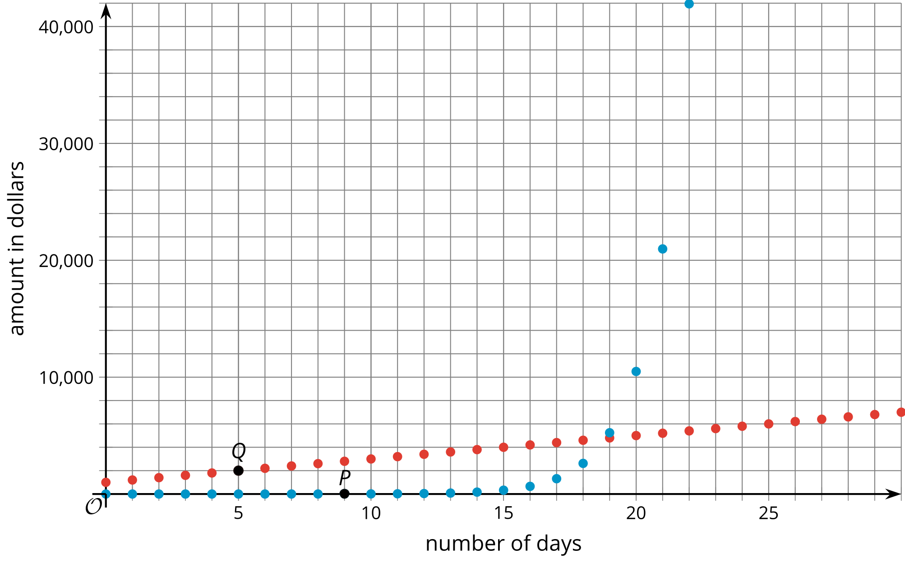
- Which graph shows the amount of money in Purse A? Which graph shows the amount of money in Purse B? Explain how you know.
- Points $P$ and $Q$ are labeled on the graph. Explain what they mean in terms of the genie’s offer.
- What are the coordinates of the vertical intercept for each graph? Explain how you know.
- When does Purse B become a better choice than Purse A? Explain your reasoning.
- Knowing what you know now, which purse would you choose? Explain your reasoning.

Are you ready for more?
Okay, okay, the genie smiles, disappointed. I will give you an even more enticing deal. He explains that Purse B stays the same, but Purse A now increases by $250,000 every day. Which purse should you choose?

Lesson 1 Summary
When we repeatedly double a positive number, it eventually becomes very large. Let's start with 0.001. The table shows what happens when we begin to double:
0.001 | 0.002 | 0.004 | 0.008 | 0.016
If we want to continue this process, it is convenient to use an exponent. For example, the last entry in the table, 0.016, is 0.001 being doubled 4 times, or $\left(0.001\right)⋅2⋅2⋅2⋅2$, which can be expressed as $\left(0.001\right)⋅2^{4}$.
Even though we started with a very small number, 0.001, we don't have to double it that many times to reach a very large number. For example, if we double it 30 times, represented by $\left(0.001\right)⋅2^{30}$, the result is greater than 1,000,000.
Throughout this unit, we will look at many situations where quantities grow or decrease by applying the same factor repeatedly.
© CC BY 2019 by Illustrative Mathematics®

