Lesson 4 Practice Problems
- The table shows values of the expressions $10x^{2}$ and $2^{x}$.
  - Describe how the values of each expression change as $x$ increases.
  - Predict which expression will have a greater value when:
    - $x$ is 8
    - $x$ is 10
    - $x$ is 12
  - Find the value of each expression when $x$ is 8, 10, and 12.
  - Make an observation about how the values of the two expressions change as $x$ becomes greater and greater.
- $x$ | - $10x^{2}$ | - $2^{x}$
- 1 | - 10 | - 2
- 2 | - 40 | - 4
- 3 | - 90 | - 8
- 4 | - 160 | - 16
- 8
- 10
- 12
- Function $f$ is defined by $f\left(x\right)={1.5}^{x}$. Function $g$ is defined by $g\left(x\right)=500x^{2}+345x$.
  - Which function is quadratic? Which one is exponential?
  - The values of which function will eventually be greater for larger and larger values of $x$?
- Create a table of values to show that the exponential expression $3{\left(2\right)}^{x}$ eventually overtakes the quadratic expression $3x^{2}+2x$.
- The table shows the values of $4^{x}$ and $100x^{2}$ for some values of $x$.
- Use the patterns in the table to explain why eventually the values of the exponential expression $4^{x}$ will overtake the values of the quadratic expression $100x^{2}$.
- $x$ | - $4^{x}$ | - $100x^{2}$
- 1 | - 4 | - 100
- 2 | - 16 | - 400
- 3 | - 64 | - 900
- 4 | - 256 | - 1600
- 5 | - 1024 | - 2500
- Here is a pattern of shapes. The area of each small square is 1 sq cm.
- 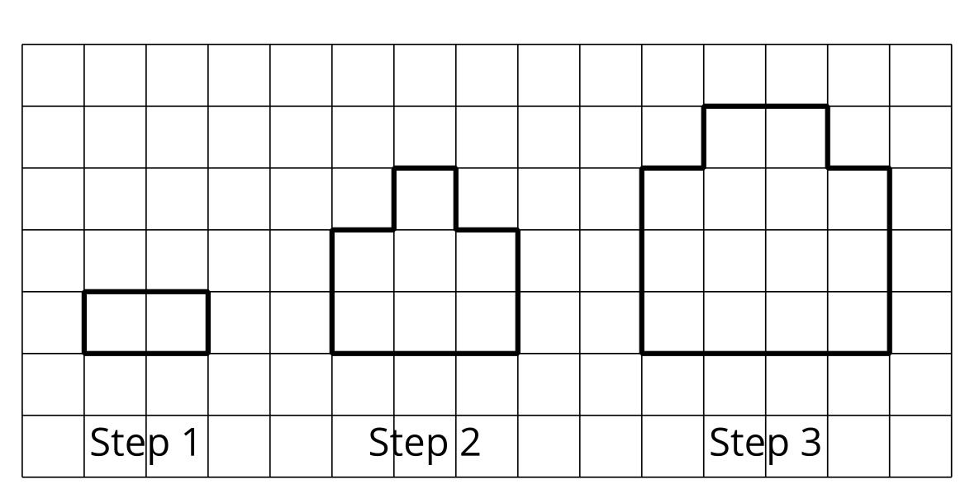
  - What is the area of the shape in Step 10?
  - What is the area of the shape in Step $n$?
  - Explain how you see the pattern growing.
- (From Unit 6, Lesson 2.)
- A bicycle costs $240 and it loses $\frac{3}{5}$ of its value each year.
  - Write expressions for the value of the bicycle, in dollars, after 1, 2, and 3 years.
  - When will the bike be worth less than $1?
  - Will the value of the bike ever be 0? Explain your reasoning.
- (From Unit 5, Lesson 4.)
- A farmer plants wheat and corn. It costs about $150 per acre to plant wheat and about $350 per acre to plant corn. The farmer plans to spend no more than $250,000 planting wheat and corn. The total area of corn and wheat that the farmer plans to plant is less than 1200 acres.
- 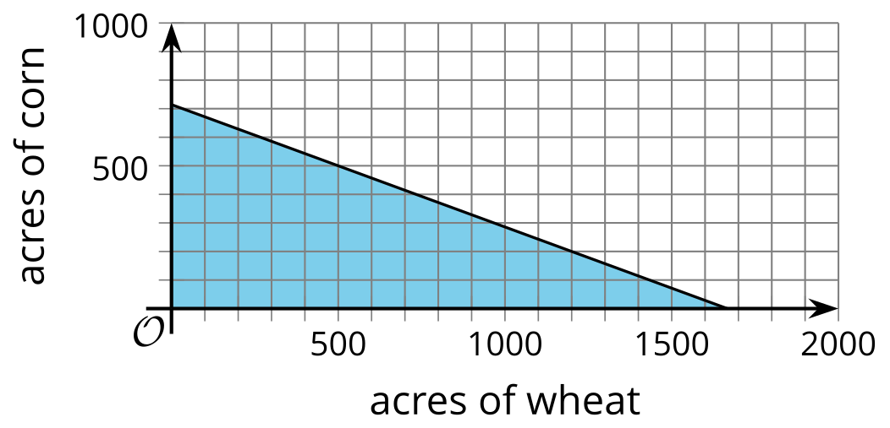
- This graph represents the inequality, $150w+350c≤250,​000$, which describes the cost constraint in this situation. Let $w$ represent the number of acres of wheat and $c$ represent the number of acres of corn.
  - The inequality, $w+c<1,​200$ represents the total area constraint in this situation. On the same coordinate plane, graph the solution to this inequality.
  - Use the graphs to find at least two possible combinations of the number of acres of wheat and the number of acres of corn that the farmer could plant.
  - The combination of 400 acres of wheat and 700 acres of corn meets one constraint in the situation but not the other constraint. Which constraint does this meet? Explain your reasoning.
- (From Unit 2, Lesson 25.)
© CC BY 2019 by Illustrative Mathematics®

