Unit 1 Lesson 7: Sort Math Tools

WU Notice and Wonder: Math Tools (Warm up)

Student Task Statement
What do you notice?
What do you wonder?
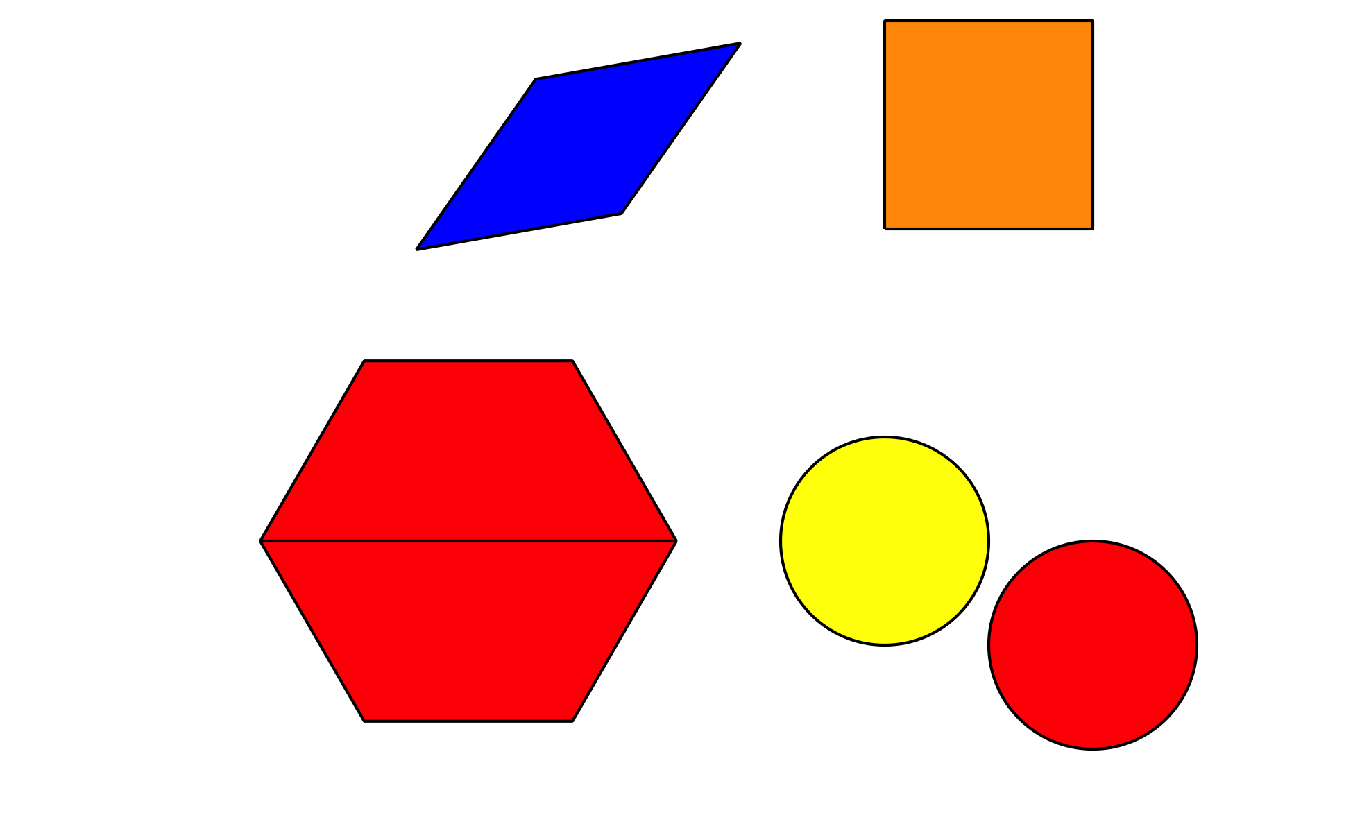

1 Sort Objects

Student Task Statement

2 How Did They Sort?

Student Task Statement

3 Centers: Choice Time

Student Task Statement
Choose a center.
Counting Collections
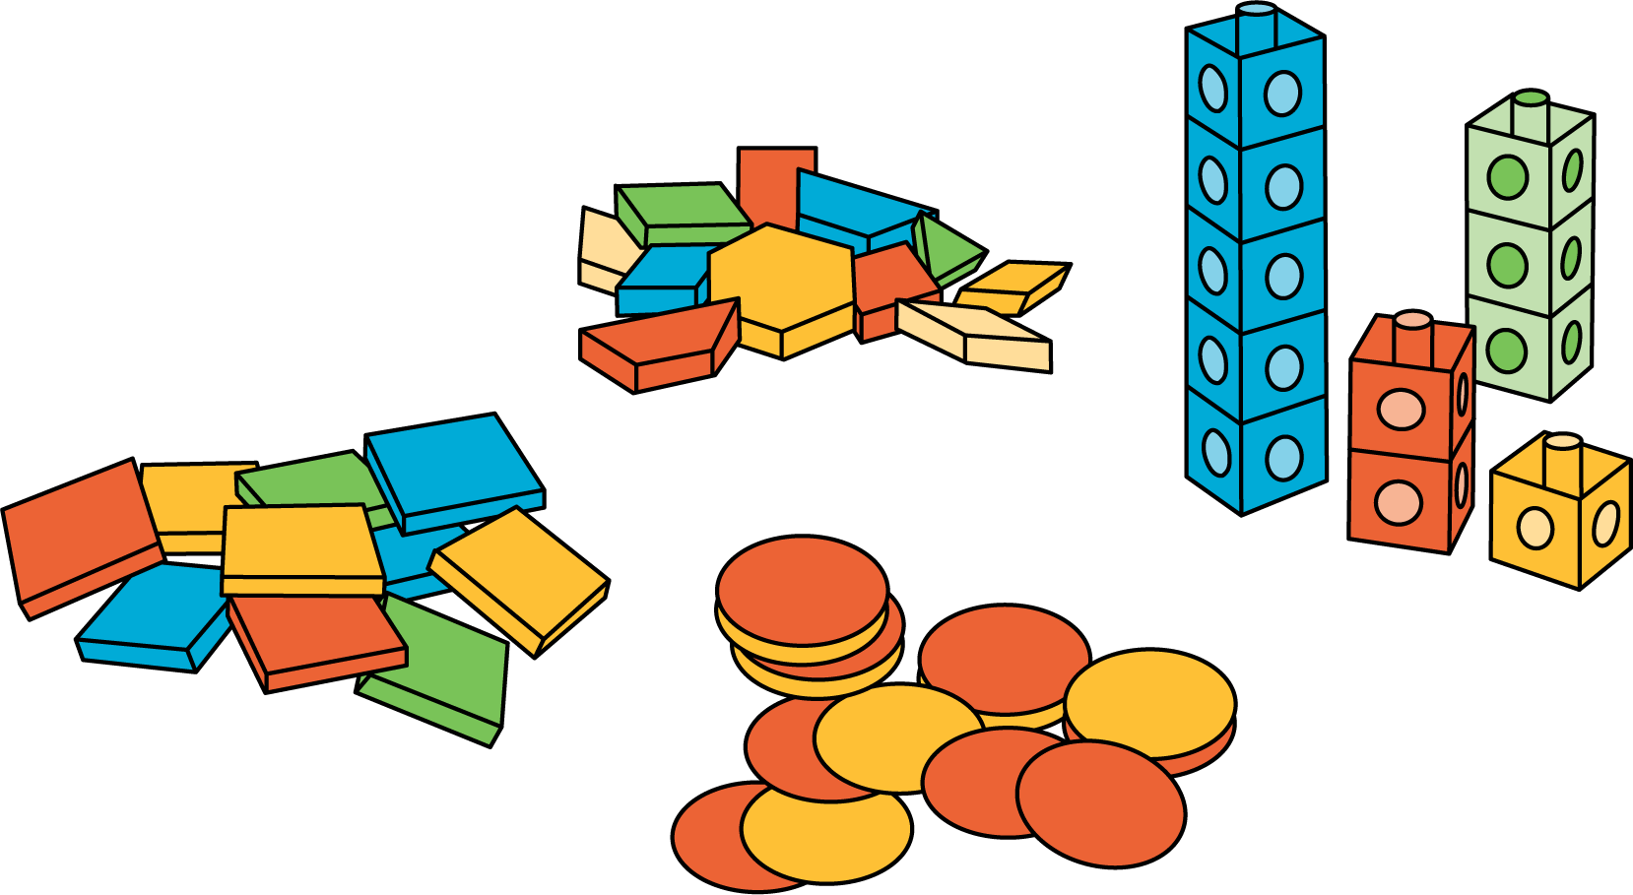
Number Race
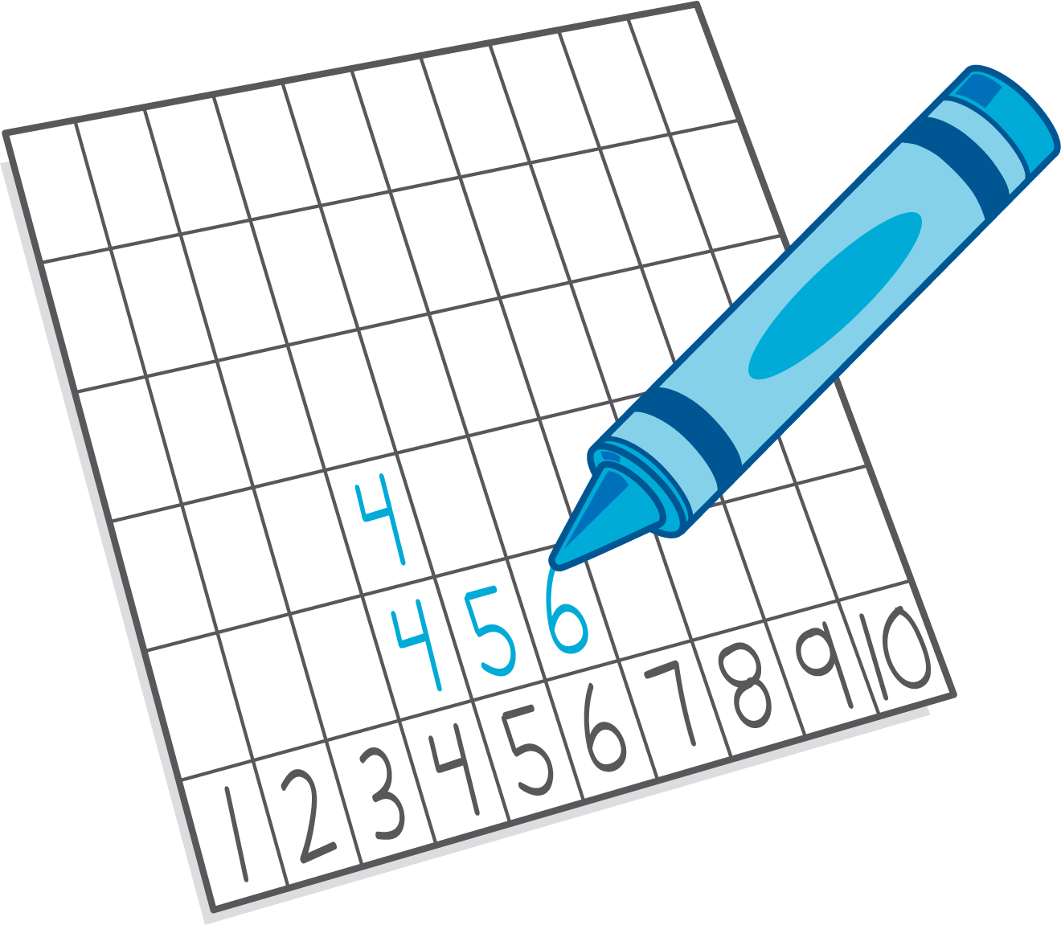
Check it Off
Five in a Row: Addition and Subtraction
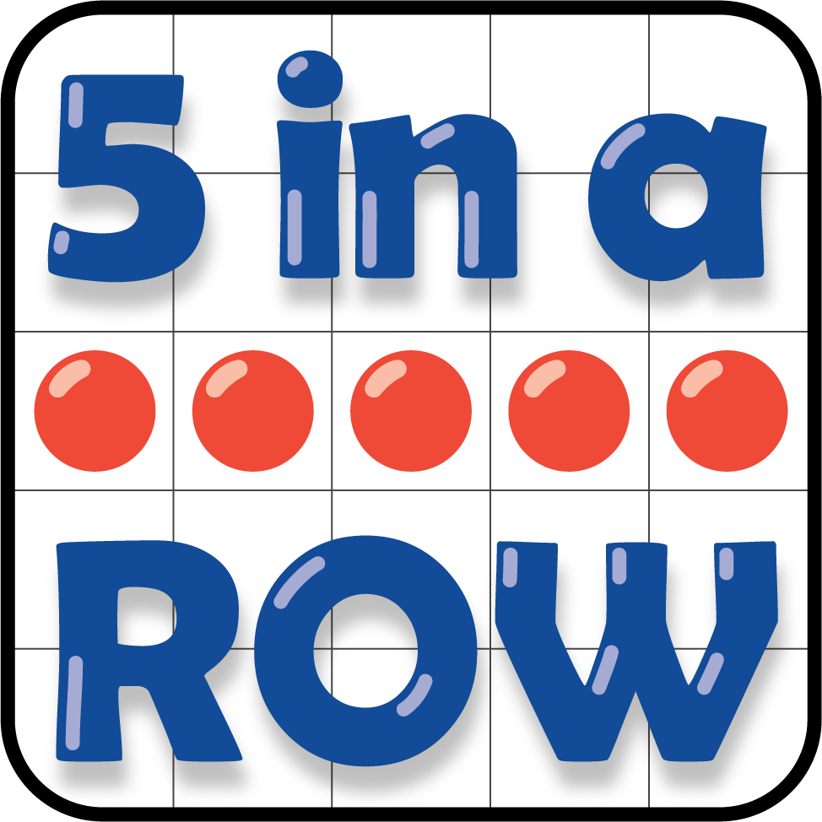
Find the Pair
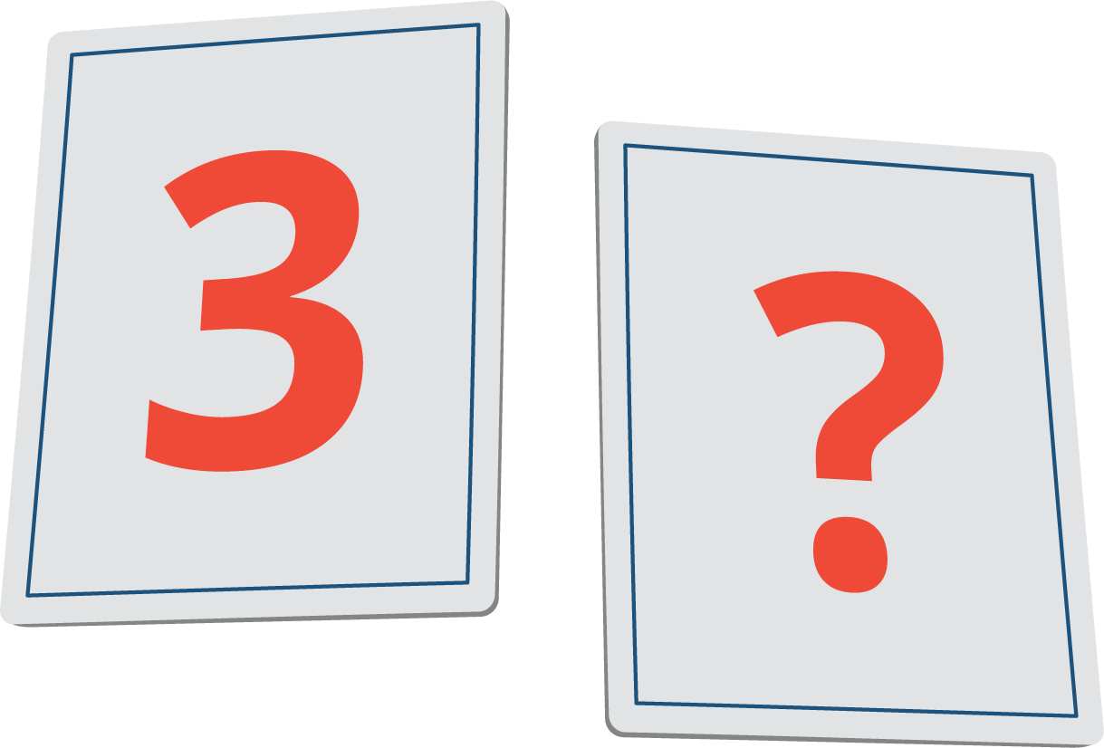
© CC BY 2021 Illustrative Mathematics®

