Lesson 8: Find the Perimeter
- Let’s find the perimeter of more shapes.

Warm-up: Number Talk: Decreasing Dividend
Find the value of each expression mentally.
- $90÷9$
- $81÷9$
- $45÷9$
- $54÷9$

8.1: Ways to Find Perimeter
What do you notice? What you wonder?
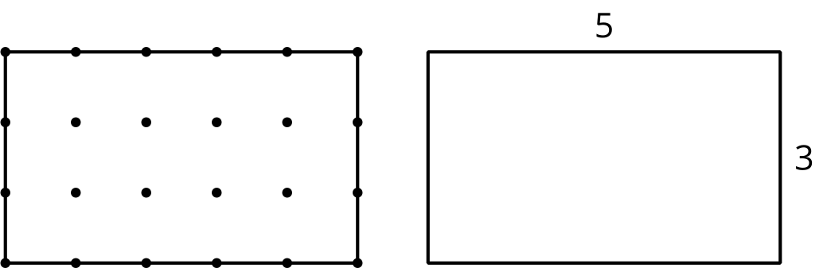
Find the perimeter of each shape. Explain or show your reasoning.

- 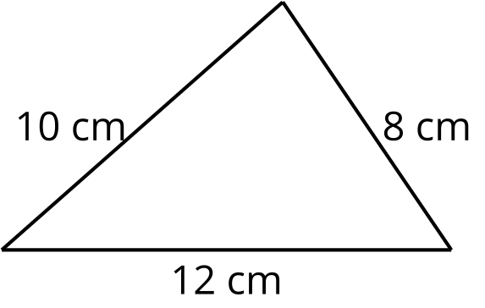

- 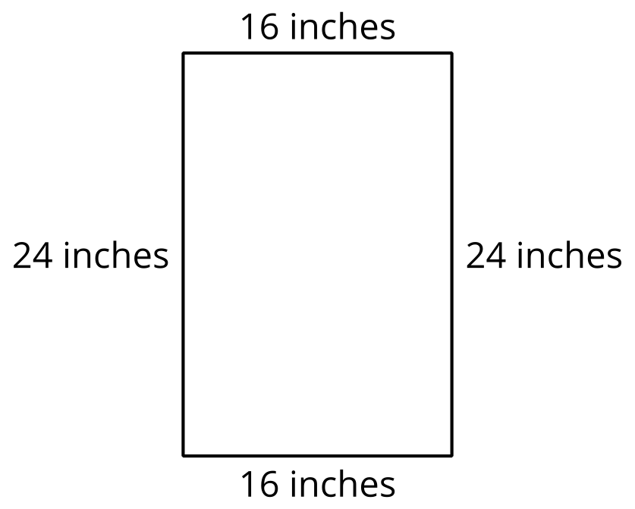

- 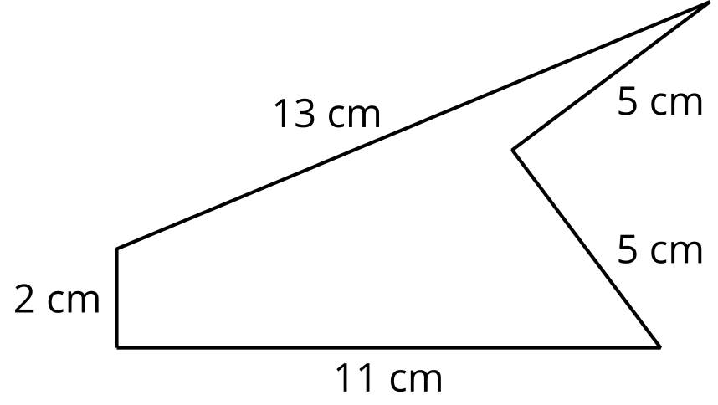

- 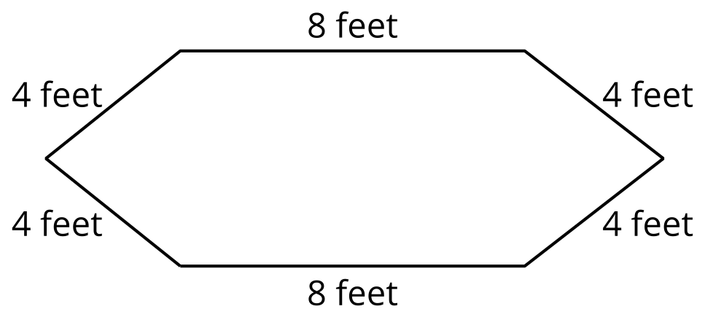

- 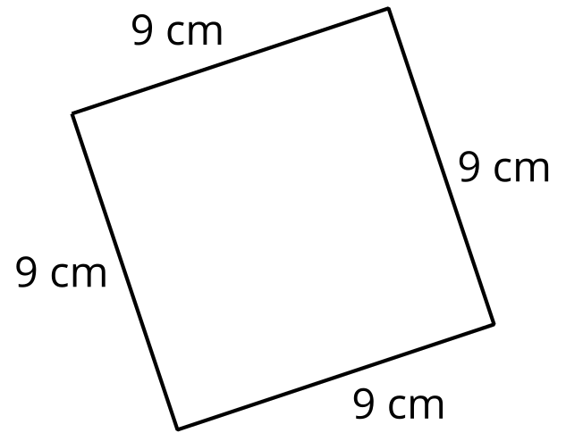

8.2: Something is Missing
- Find the perimeter of this rectangle. Explain or show your reasoning.
- 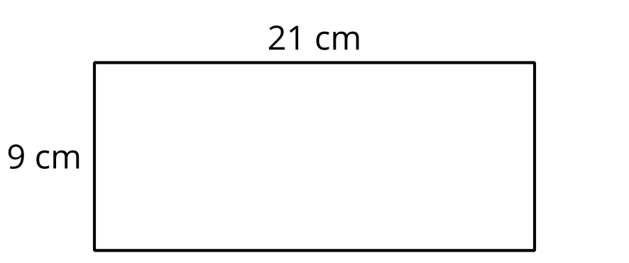

- All the short sides of this figure are the same length, and all the angles are right angles. Find the perimeter. Explain or show your reasoning.
- 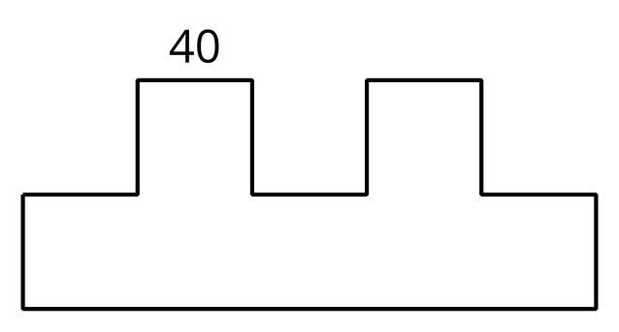
- All the sides of the octagon are the same length. Find the perimeter. Explain or show your reasoning.
- 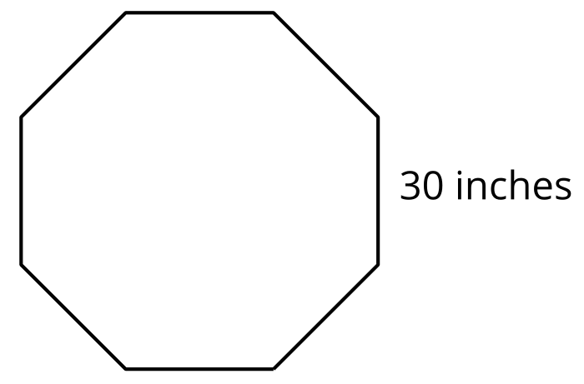
© CC BY 2021 Illustrative Mathematics®

