Unit 4 Lesson 3: Count 2 Groups of Scattered Images

WU Choral Count: Count to 40 (Warm up)

Student Task Statement

1 Count Organized and Scattered Images

Student Task Statement

- There are
- balls.

- There are
- balls.

- There are
- balls.

- There are
- balls.

2 Count Scattered Images

Student Task Statement

- 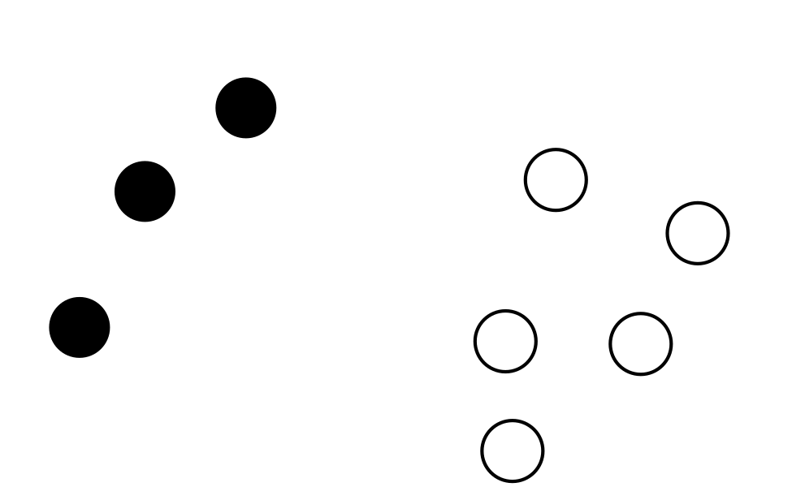
- There are
- circles.

- There are
- circles.

- There are
- circles.

- There are
- circles.

3 Centers: Choice Time

Student Task Statement
Choose a center.
Roll and Add
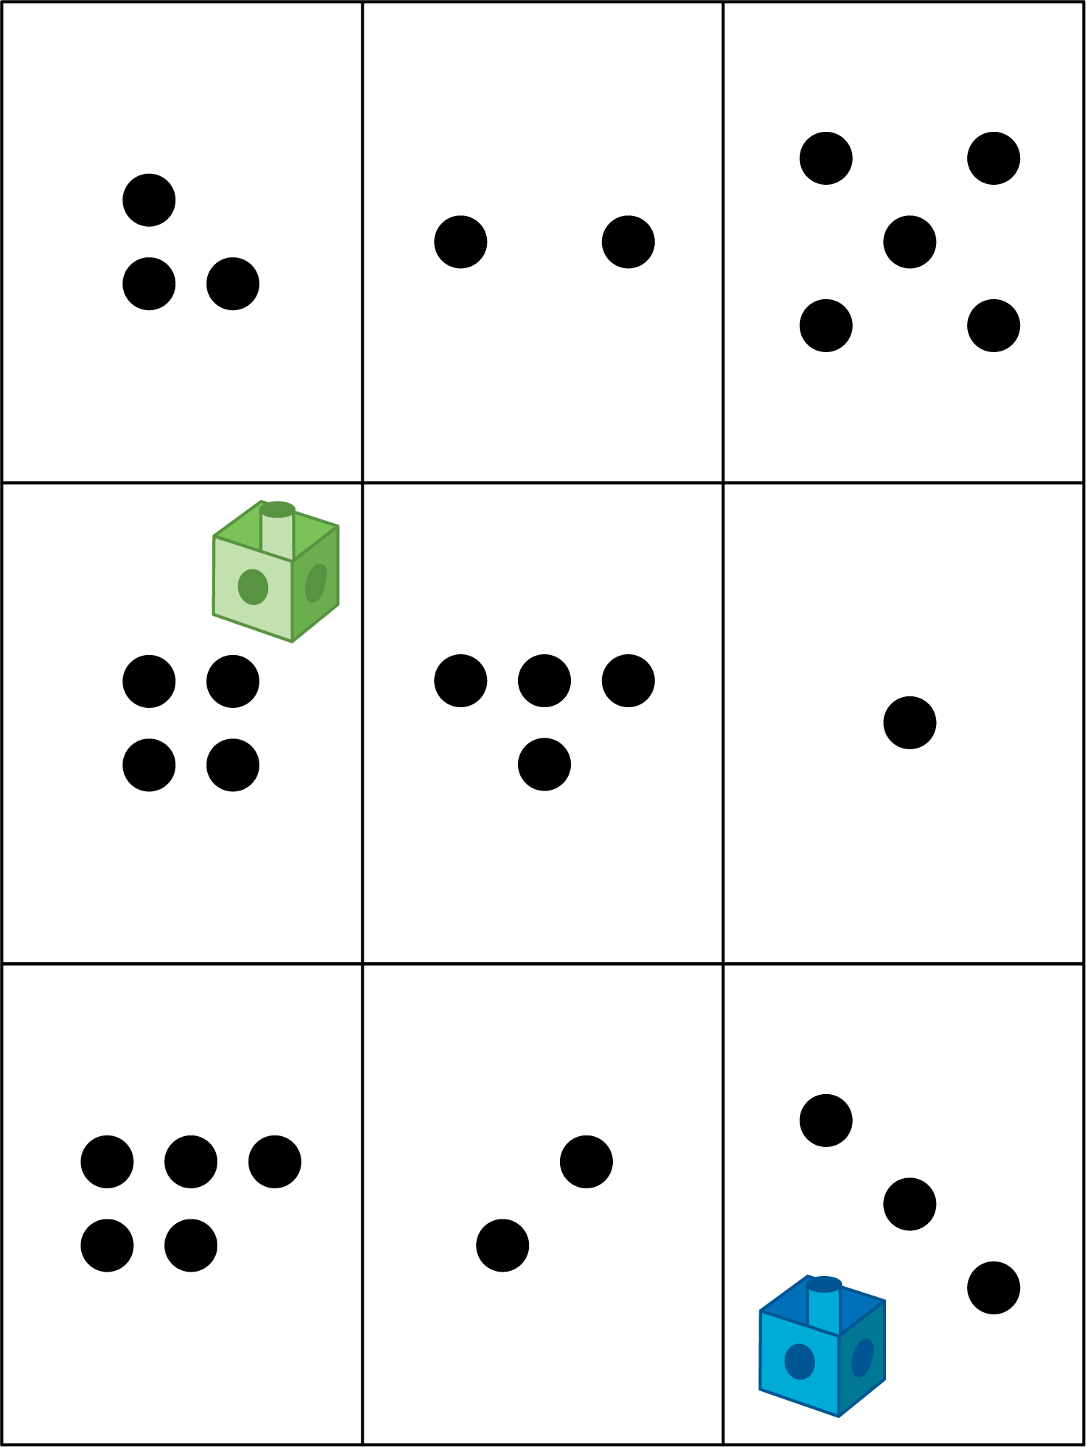
Math Libs
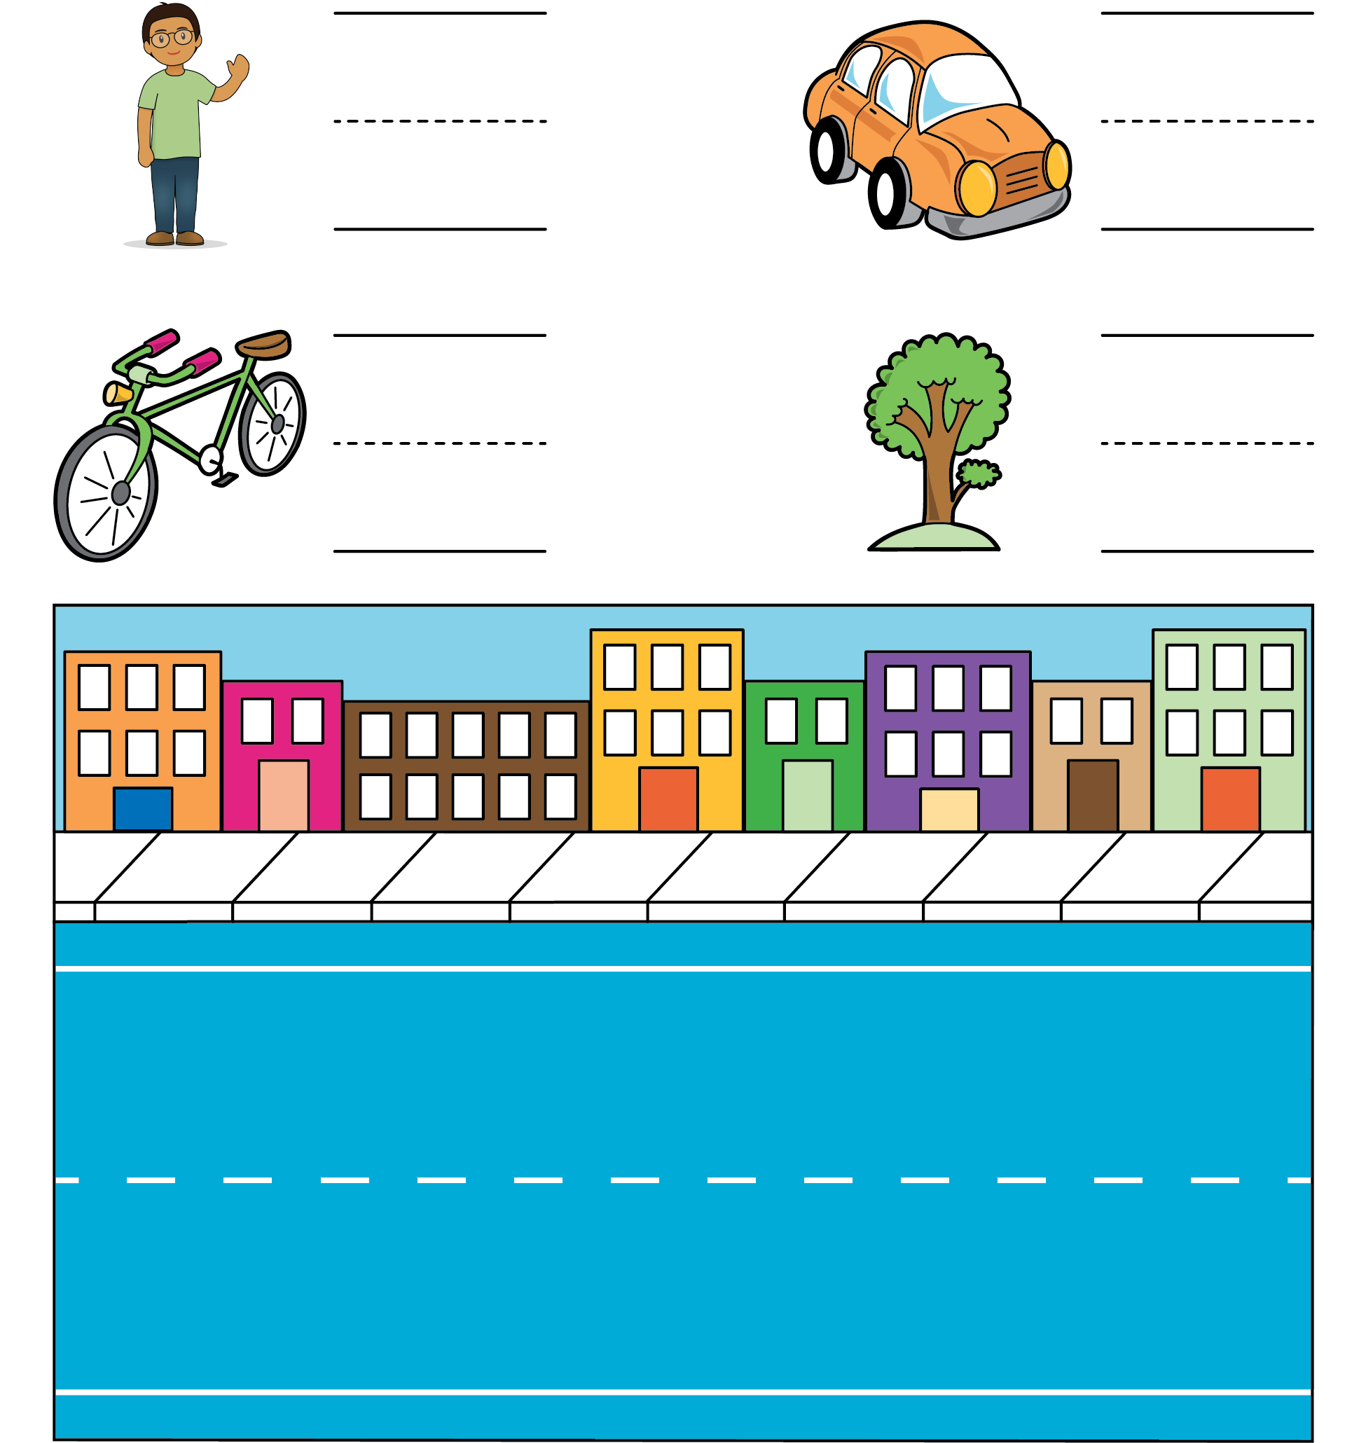
Match Mine
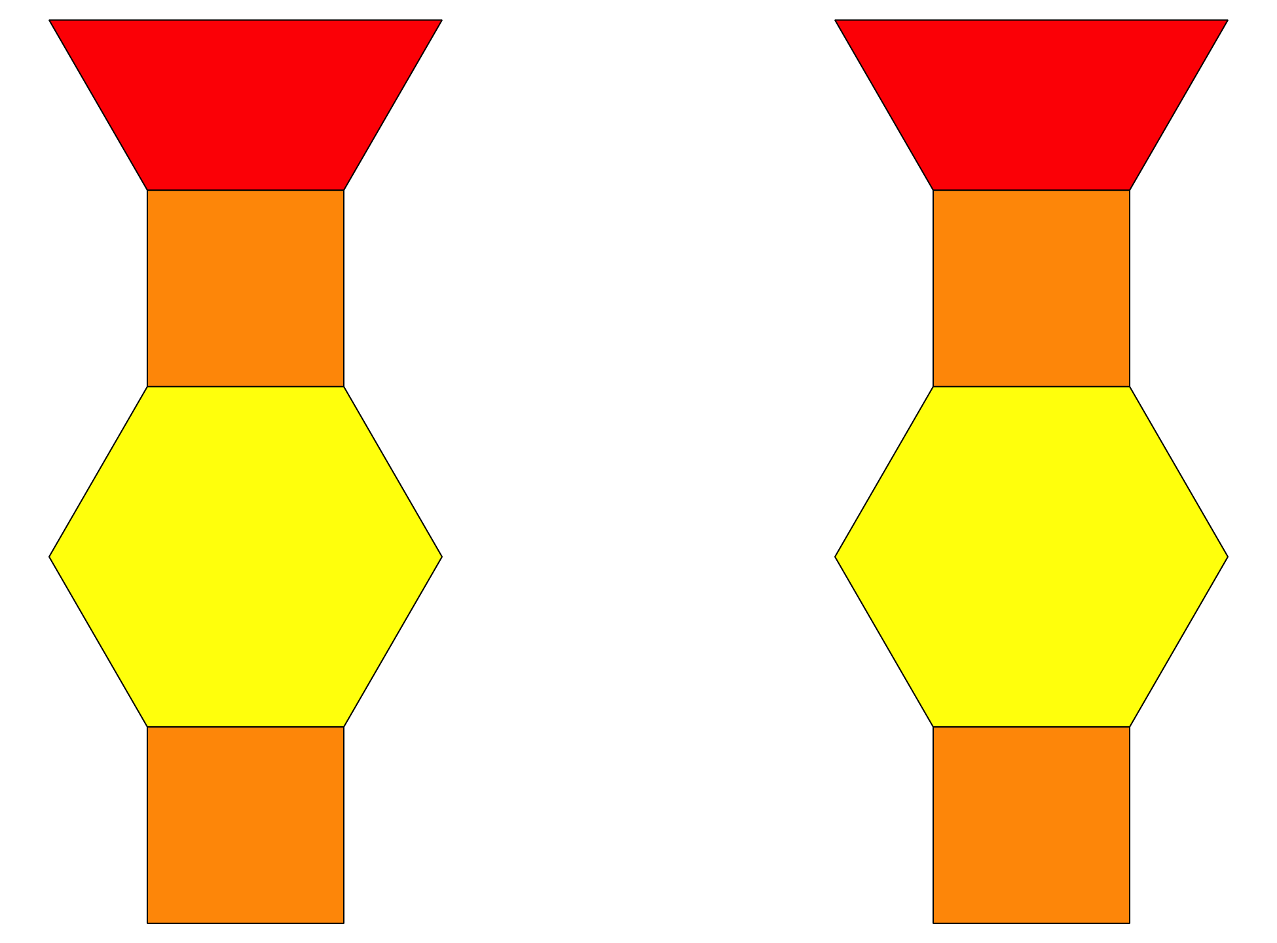
© CC BY 2021 Illustrative Mathematics®

