Lesson 10: Multiplication and Division

Standards Alignments
Addressing | 3.OA.A.3, 3.OA.B.6

Teacher-facing Learning Goals
- Interpret representations of the relationship between multiplication and division.
- Represent the relationship between multiplication and division.

Student-facing Learning Goals
- Let’s represent equal groups and write equal groups situations.

Lesson Purpose
The purpose of this lesson is for students to use a variety of representations to illustrate the relationship between multiplication and division to develop fluency with division within 100.
In previous units, students learned the meaning of multiplication and division and understood division as an unknown-factor problem. They have worked to develop fluency with multiplication within 100. In this lesson, they continue that work by reinforcing their understanding of the relationship between multiplication and division.
In the first activity, students are given a card with an equation or a diagram and asked to find another student whose card represents the same situation or quantities. Then, they create an additional diagram and a situation that matches their division equation. Students then view and compare the diagrams and the situations that their classmates created in a gallery walk.
If students need additional support with the concepts in this lesson, refer back to Unit 4, Section B in the curriculum materials.

Access for:

Students with Disabilities
- Engagement (Activity 1)

English Learners
- MLR7 (Activity 2)

Instructional Routines
Card Sort (Activity 1), Which One Doesn’t Belong? (Warm-up)

Materials to Gather
- Glue or tape: Activity 1
- Materials from a previous activity: Activity 2
- Tools for creating a visual display: Activity 1

Materials to Copy
- Find the Match (groups of 24): Activity 1

Lesson Timeline
Warm-up | 10 min
Activity 1 | 25 min
Activity 2 | 10 min
Lesson Synthesis | 10 min
Cool-down | 5 min

Teacher Reflection Question
What did you say, do, or ask during the lesson synthesis that helped students be clear on the learning of the day? How did previewing the cool-down of the lesson help you synthesize student learning?

Cool-down
(to be completed at the end of the lesson) 5min
Relate Multiplication to Division

Standards Alignments
Addressing | 3.OA.B.6

Student-facing Task Statement
Give an example of how multiplication and division are related. Explain or show your reasoning.

Student Responses
Sample responses:
- We can think of $24÷4=?$ as $4×?=24$.
- If I’m dividing, it’s like multiplying, but instead of not knowing the total number of objects, I’m missing the number of equal groups or the number in each group.
- This diagram shows multiplication: the side lengths are known but the area isn’t.
- 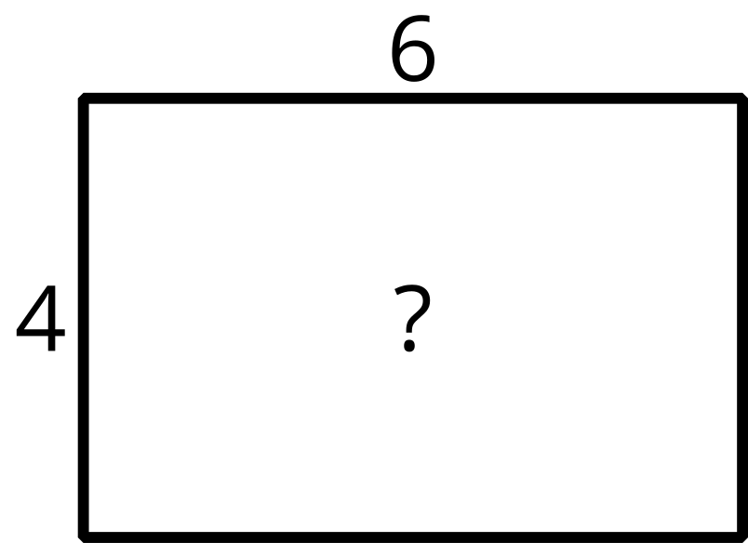
- This diagram shows division: the area is known, but a side length is missing.
- 