Lesson 3: Revisiting Proportional Relationships

3.1: Recipe Ratios
A recipe calls for $\frac{1}{2}$ cup sugar and 1 cup flour. Complete the table to show how much sugar and flour to use in different numbers of batches of the recipe.
sugar (cups) | flour (cups)
$\frac{1}{2}$ | 1
$\frac{3}{4}$
 | $1\frac{3}{4}$
1
 | $2\frac{1}{2}$

3.2: The Price of Rope
Two students are solving the same problem: At a hardware store, they can cut a length of rope off of a big roll, so you can buy any length you like. The cost for 6 feet of rope is $7.50. How much would you pay for 50 feet of rope, at this rate?
- Kiran knows he can solve the problem this way.
- 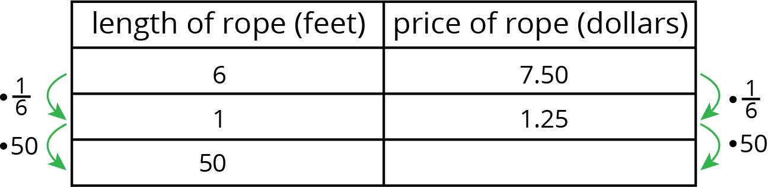
- What would be Kiran's answer?
- Kiran wants to know if there is a more efficient way of solving the problem. Priya says she can solve the problem with only 2 rows in the table.
- length of rope (feet) | - price of rope (dollars)
- 6 | - 7.50
- 50
- What do you think Priya's method is?

3.3: Swimming, Manufacturing, and Painting
- Tyler swims at a constant speed, 5 meters every 4 seconds. How long does it take him to swim 114 meters?
- distance (meters) | - time (seconds)
- 5 | - 4
- 114
- A factory produces 3 bottles of sparkling water for every 8 bottles of plain water. How many bottles of sparkling water does the company produce when it produces 600 bottles of plain water?
- number of bottles  of sparkling water | - number of bottles  of plain water
- A certain shade of light blue paint is made by mixing $1\frac{1}{2}$ quarts of blue paint with 5 quarts of white paint. How much white paint would you need to mix with 4 quarts of blue paint?

- For each of the previous three situations, write an equation to represent the proportional relationship.

Are you ready for more?
Different nerve signals travel at different speeds.
- Pressure and touch signals travel about 250 feet per second.
- Dull pain signals travel about 2 feet per second.
- How long does it take you to feel an ant crawling on your foot?
- How much longer does it take to feel a dull ache in your foot?

3.4: Finishing the Race and More Orange Juice
- Lin runs $2\frac{3}{4}$ miles in $\frac{2}{5}$ of an hour. Tyler runs $8\frac{2}{3}$ miles in $\frac{4}{3}$ of an hour. How long does it take each of them to run 10 miles at that rate?
- Priya mixes $2\frac{1}{2}$ cups of water with $\frac{1}{3}$ cup of orange juice concentrate. Diego mixes $1\frac{2}{3}$ cups of water with $\frac{1}{4}$ cup orange juice concentrate. How much concentrate should each of them mix with 100 cups of water to make juice that tastes the same as their original recipe? Explain or show your reasoning.

Lesson 3 Summary
If we identify two quantities in a problem and one is proportional to the other, then we can calculate the constant of proportionality and use it to answer other questions about the situation. For example, Andre runs at a constant speed, 5 meters every 2 seconds. How long does it take him to run 91 meters at this rate?
In this problem there are two quantities, time (in seconds) and distance (in meters). Since Andre is running at a constant speed, time is proportional to distance. We can make a table with distance and time as column headers and fill in the given information.
distance (meters) | time (seconds)
5 | 2
91
To find the value in the right column, we multiply the value in the left column by $\frac{2}{5}$ because $\frac{2}{5}⋅5=2$. This means that it takes Andre $\frac{2}{5}$ seconds to run one meter.
At this rate, it would take Andre $\frac{2}{5}⋅91=\frac{182}{5}$, or 36.4 seconds to walk 91 meters. In general, if $t$ is the time it takes to walk $d$ meters at that pace, then $t=\frac{2}{5}d$.
© CC BY Open Up Resources. Adaptations CC BY IM.

