Unit 7 Lesson 14 Cumulative Practice Problems
- Edge lengths are given in units. Find the surface area of each prism in square units.
- 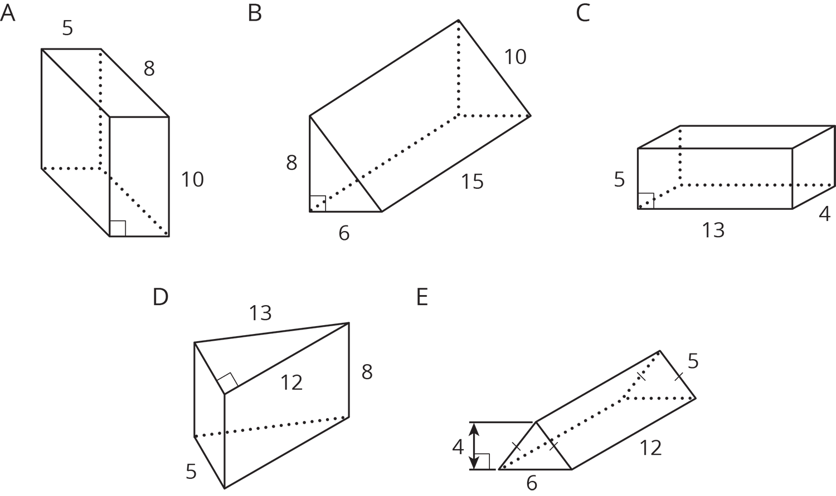

- Priya says, “No matter which way you slice this rectangular prism, the cross section will be a rectangle.” Mai says, “I’m not so sure.” Describe a slice that Mai might be thinking of.
- 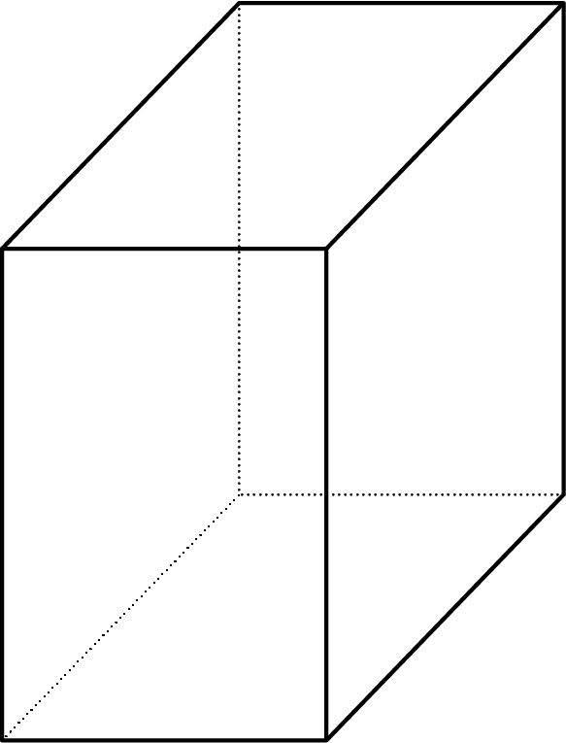
- (From Unit 7, Lesson 11.)
- $B$ is the intersection of line $AC$ and line $ED$. Find the measure of each of the angles.
  - Angle $ABF$
  - Angle $ABD$
  - Angle $EBC$
  - Angle $FBC$
  - Angle $DBG$
- 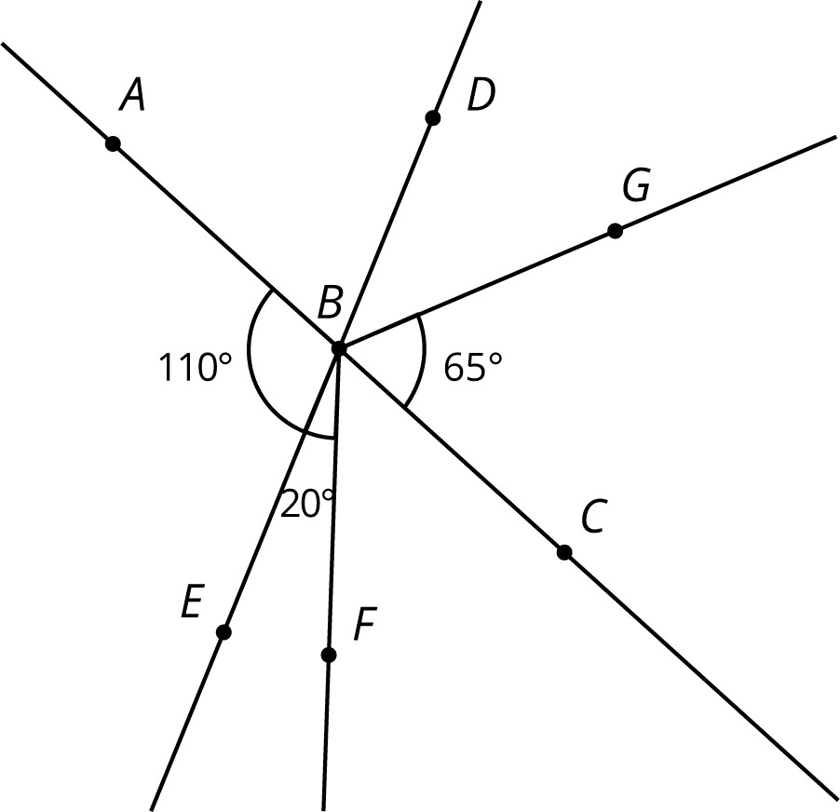
- (From Unit 7, Lesson 5.)
- Write each expression with fewer terms.
  - $12m−4m$
  - $12m−5k+m$
  - $9m+k−(3m−2k)$
- (From Unit 6, Lesson 20.)
  - Find 44% of 625 using the facts that 40% of 625 is 250 and 4% of 625 is 25.
  - What is 4.4% of 625?
  - What is 0.44% of 625?
- (From Unit 4, Lesson 9.)
© CC BY Open Up Resources. Adaptations CC BY IM.

