Lesson 1: Introducing Ratios and Ratio Language

1.1: What Kind and How Many?
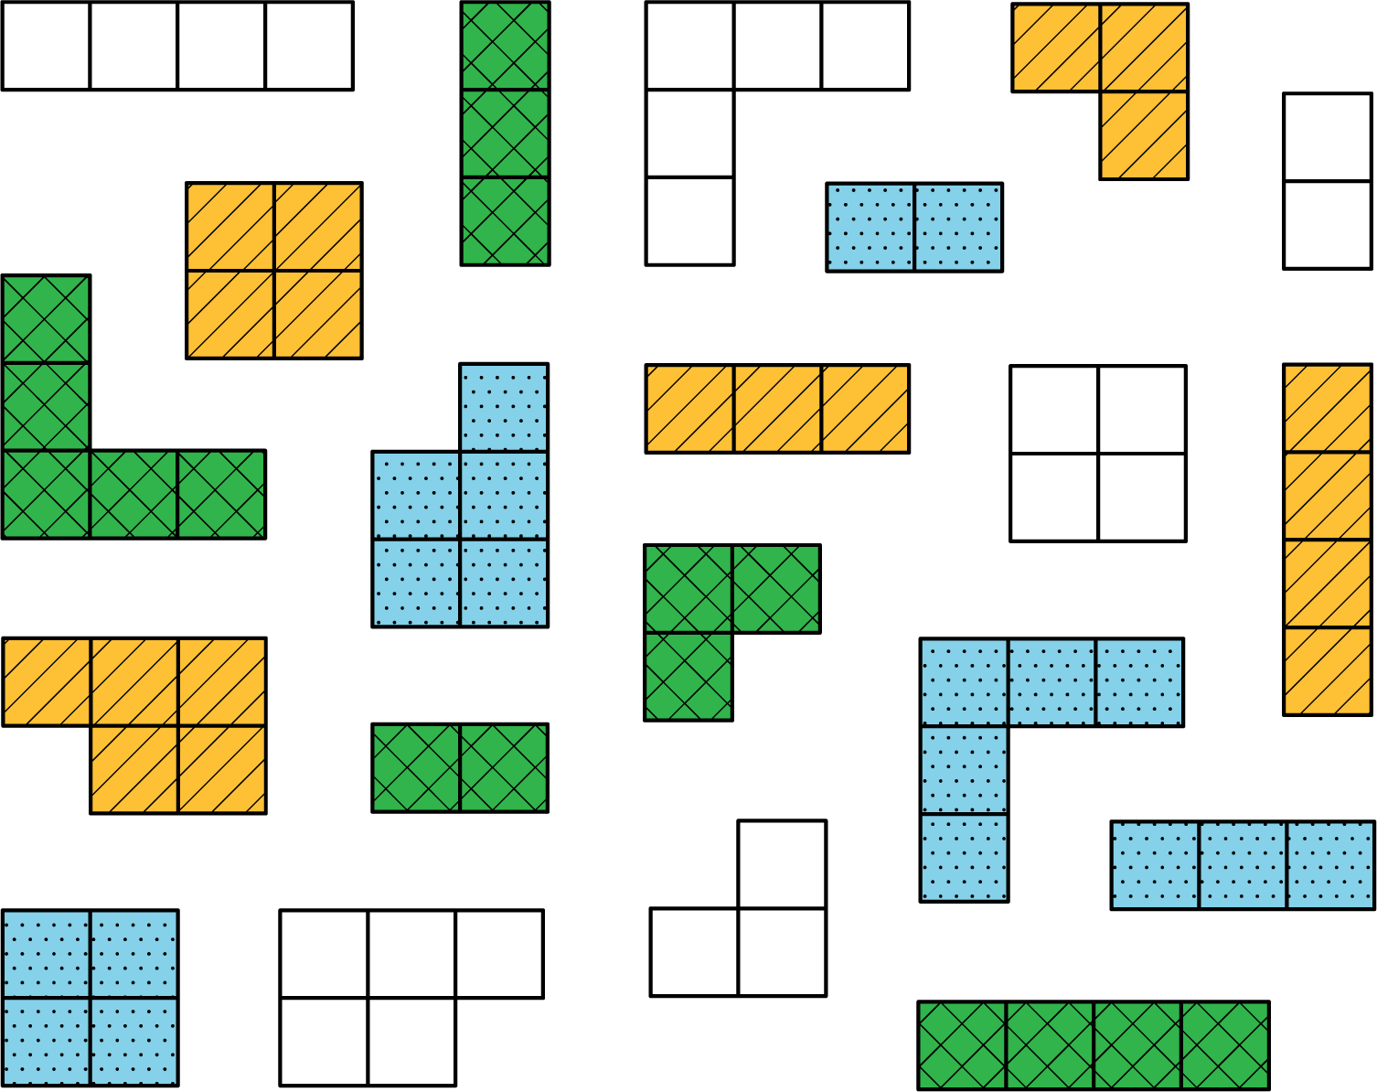
Think of different ways you could sort these figures. What categories could you use? How many groups would you have?

1.2: The Teacher’s Collection
- Think of a way to sort your teacher’s collection into two or three categories. Count the items in each category, and record the information in the table.
- category name
- category amount
- Pause here so your teacher can review your work.
- Write at least two sentences that describe ratios in the collection. Remember, there are many ways to write a ratio:
  - The ratio of one category to another category is ________ to ________.
  - The ratio of one category to another category is ________ : ________.
  - There are _______ of one category for every _______ of another category.

1.3: The Student’s Collection
- Sort your collection into three categories. You can experiment with different ways of arranging these categories. Then, count the items in each category, and record the information in the table.
- category name
- category amount
- Write at least two sentences that describe ratios in the collection. Remember, there are many ways to write a ratio:
  - The ratio of one category to another category is ________ to ________.
  - The ratio of one category to another category is ________ : ________.
  - There are _______ of one category for every _______ of another category.
- Pause here so your teacher can review your sentences.
- Make a visual display of your items that clearly shows one of your statements. Be prepared to share your display with the class.

Are you ready for more?
- Use two colors to shade the rectangle so there are 2 square units of one color for every 1 square unit of the other color.
- The rectangle you just colored has an area of 24 square units. Draw a different shape that does not have an area of 24 square units, but that can also be shaded with two colors in a $2:1$ ratio. Shade your new shape using two colors.

Lesson 1 Summary
A ratio is an association between two or more quantities. There are many ways to describe a situation in terms of ratios. For example, look at this collection:
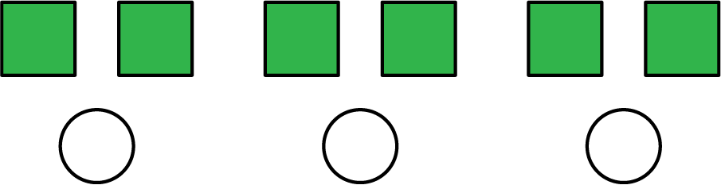
Here are some correct ways to describe the collection:
- The ratio of squares to circles is $6:3$.
- The ratio of circles to squares is 3 to 6.
Notice that the shapes can be arranged in equal groups, which allow us to describe the shapes using other numbers.
- There are 2 squares for every 1 circle.
- There is 1 circle for every 2 squares.
© CC BY Open Up Resources. Adaptations CC BY IM.

