Unit 5 Lesson 15: Area of a Circle

1 Irrigating a Field (Warm up)

Images for Launch
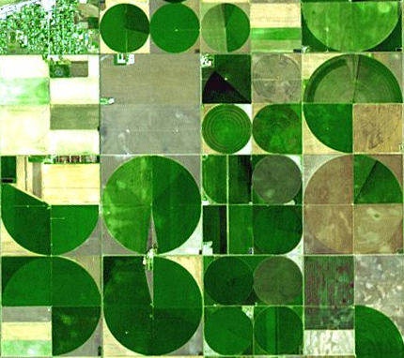
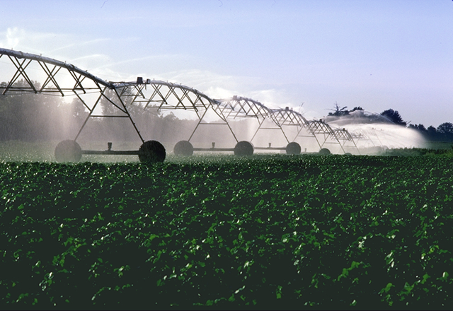

Student Task Statement
A circular field is set into a square with an 800 m side length. Estimate the field's area.
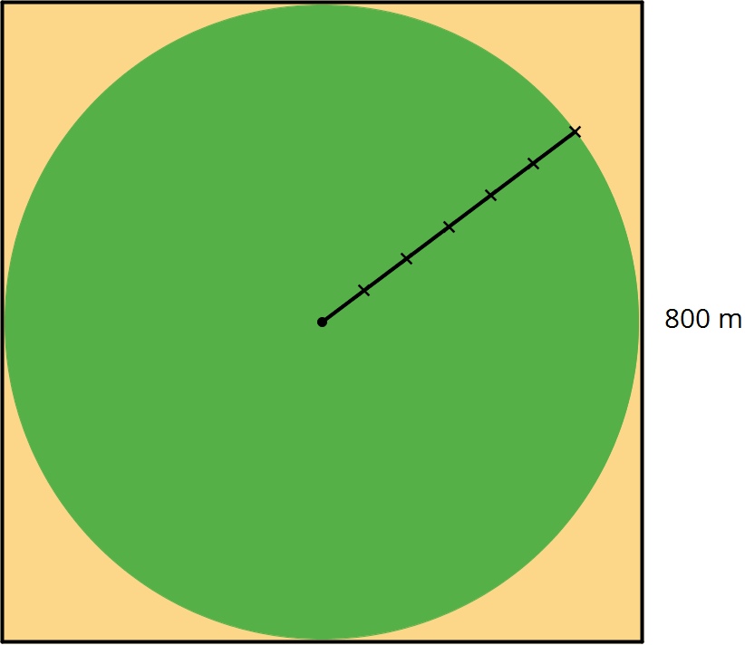
- About 5,000 m²
- About 50,000 m²
- About 500,000 m²
- About 5,000,000 m²
- About 50,000,000 m²

2 Estimating Areas of Circles

Student Task Statement
Your teacher will give your group two circles of different sizes.
- For each circle, use the squares on the graph paper to measure the diameter and estimate the area of the circle. Record your measurements in the table.
- diameter (cm) | - estimated area (cm²)
- Plot the values from the table on the class coordinate plane. Then plot the class’s data points on your coordinate plane.
- In a previous lesson, you graphed the relationship between the diameter and circumference of a circle. How is this graph the same? How is it different?

3 Making a Polygon out of a Circle

Student Task Statement
Your teacher will give you a circular object, a marker, and two pieces of paper of different colors.
Follow these instructions to create a visual display:
- Using a thick marker, trace your circle in two separate places on the same piece of paper.
- Cut out both circles, cutting around the marker line.
- Fold and cut one of the circles into fourths.
- Arrange the fourths so that straight sides are next to each other, but the curved edges are alternately on top and on bottom. Pause here so your teacher can review your work.
- Fold and cut the fourths in half to make eighths. Arrange the eighths next to each other, like you did with the fourths.
- If your pieces are still large enough, repeat the previous step to make sixteenths.
- Glue the remaining circle and the new shape onto a piece of paper that is a different color.
After you finish gluing your shapes, answer the following questions.
- How do the areas of the two shapes compare?
- What polygon does the shape made of the circle pieces most resemble?
- How could you find the area of this polygon?

Activity Synthesis
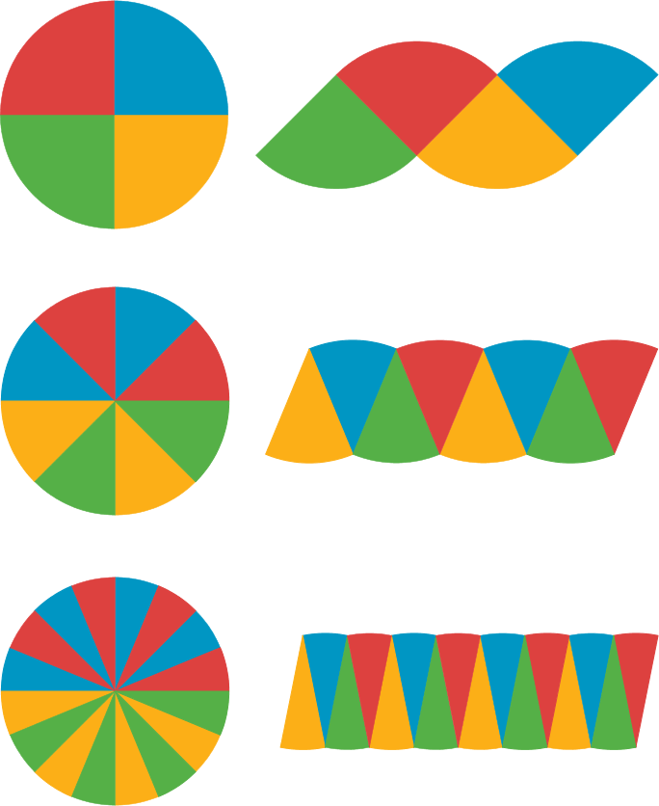

4 Making Another Polygon out of a Circle (Optional)

Student Task Statement
Imagine a circle made of rings that can bend, but not stretch.
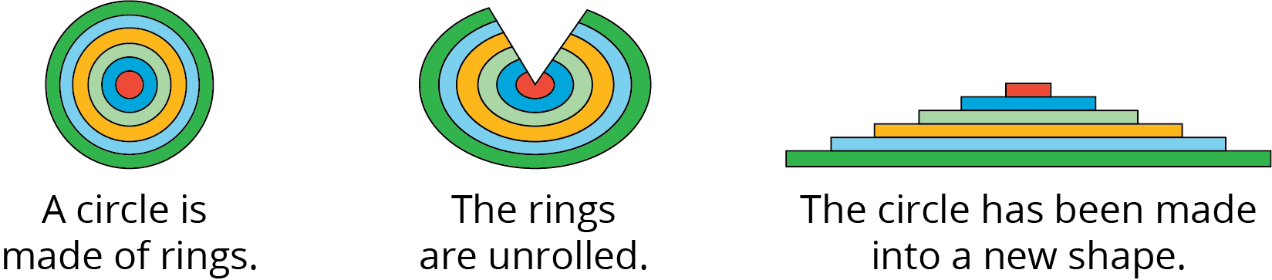
- What polygon does the new shape resemble?
- How does the area of the polygon compare to the area of the circle?
- How can you find the area of the polygon?
- Show, in detailed steps, how you could find the polygon’s area in terms of the circle’s measurements. Show your thinking. Organize it so it can be followed by others.
- After you finish, trade papers with a partner and check each other’s work. If you disagree, work to reach an agreement. Discuss:
  - Do you agree or disagree with each step?
  - Is there a way to make the explanation clearer?
- Return your partner’s work, and revise your explanation based on the feedback you received.
© CC BY Open Up Resources. Adaptations CC BY IM.

