Lesson 1: Sort, Count, and Compare Groups of Objects
- Let’s figure out which group has more objects.

1.1: Sort, Count, and Compare
How many beads are in each group?
Show your thinking using drawings, numbers, or words.
_______________
_______________
Circle the group that has fewer beads.

1.2: Who Has More?
- How many beads are in each group?
Show your thinking using drawings, numbers, or words.
- _______________
- _______________
- How many beads are in your bag altogether?
- _______________

1.3: Centers: Choice Time
Choose a center.
Less, Same, More
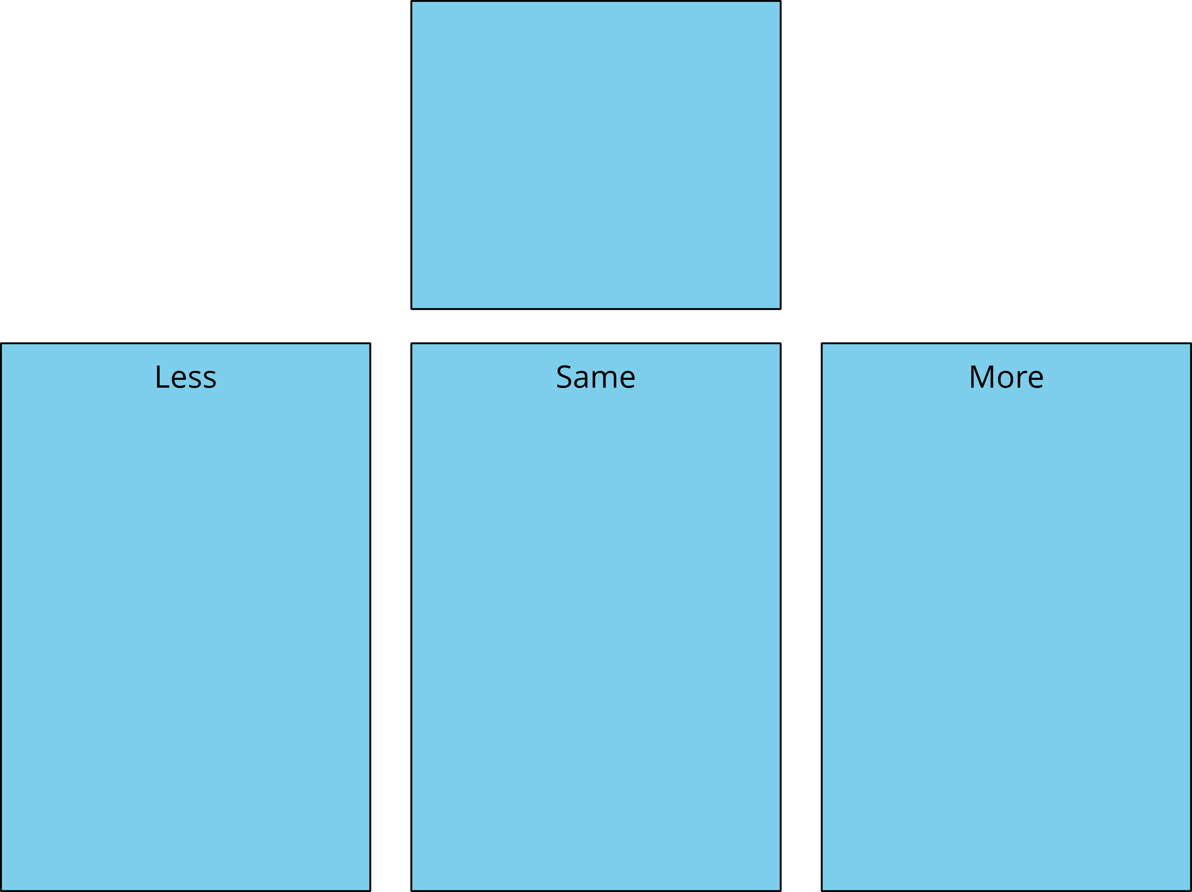
Math Fingers
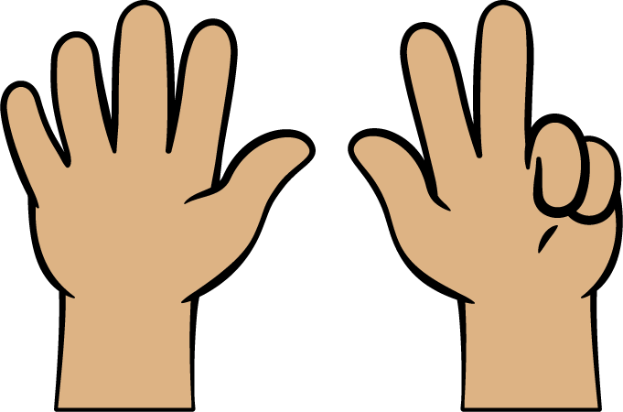
Tower Build
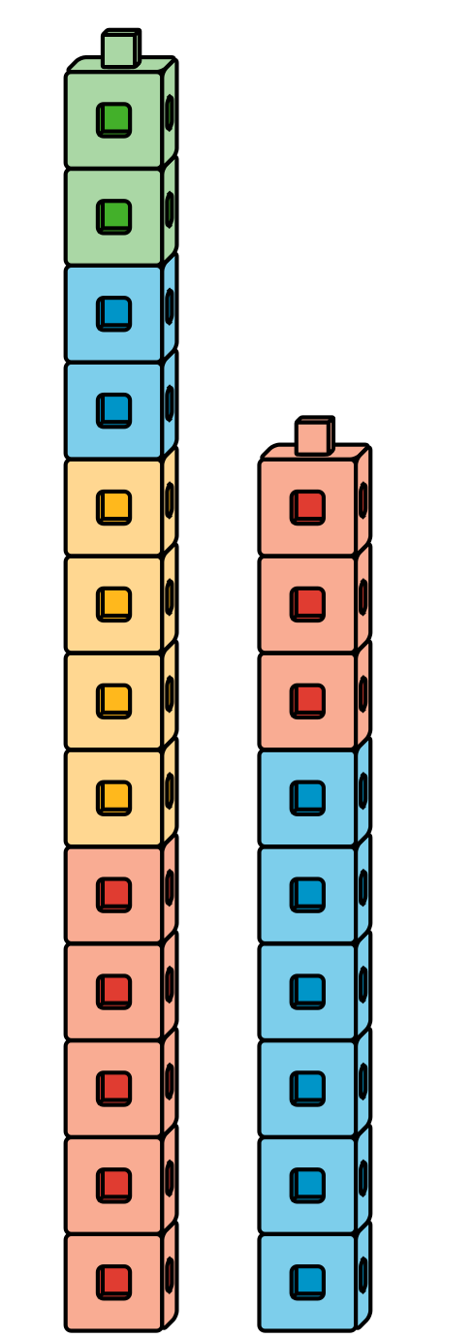
Math Stories
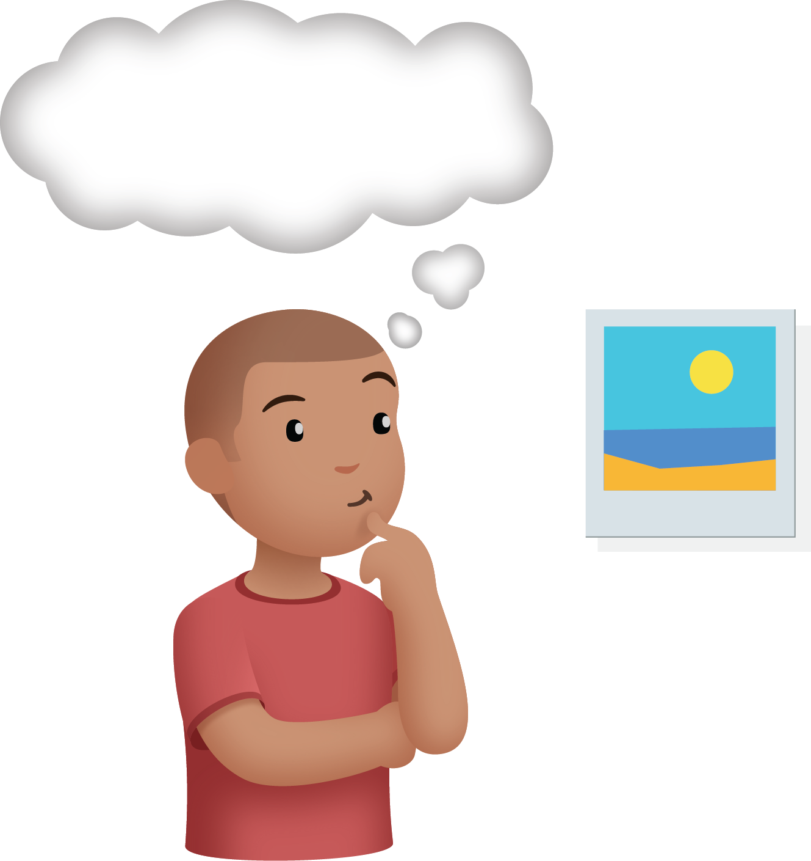
Which One
© CC BY 2021 Illustrative Mathematics®

