Lesson 15: Finding This Percent of That
Let’s solve percentage problems like a pro.

15.1: Number Talk: Decimals
Find the value of each expression mentally.
$\left(0.23\right)⋅100$
$50÷100$
$145⋅\frac{1}{100}$
$7÷100$

15.2: Audience Size
A school held several evening activities last month—a music concert, a basketball game, a drama play, and literacy night. The music concert was attended by 250 people. How many people came to each of the other activities?
- Attendance at a basketball game was 30% of attendance at the concert.
- Attendance at the drama play was 140% of attendance at the concert.
- Attendance at literacy night was 44% of attendance at the concert.

Are you ready for more?
50% of the people who attended the drama play also attended the music concert. What percentage of the people who attended the music concert also attended the drama play?

15.3: Everything is On Sale
During a sale, every item in a store is 80% of its regular price.
- If the regular price of a T-shirt is $10, what is its sale price?
- The regular prices of five items are shown here. Find the sale price of each item.
 | - item 1 | - item 2 | - item 3 | - item 4 | - item 5
- regular price | - $1 | - $4 | - $10 | - $55 | - $120
- sale price
- You found 80% of many values. Was there a process you repeated over and over to find the sale prices? If so, describe it.
- 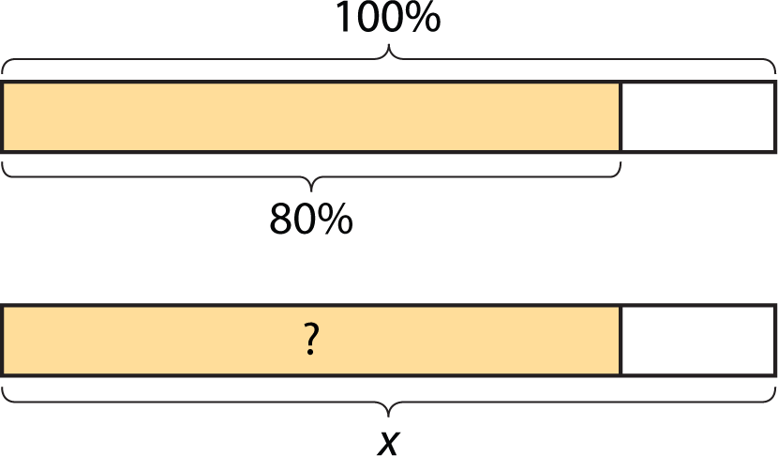
- Select all of the expressions that could be used to find 80% of $x$. Be prepared to explain your reasoning.
- $\frac{8}{100}⋅x$
- $\frac{80}{100}⋅x$
- $\frac{8}{10}⋅x$
- $\frac{4}{10}⋅x$
- $\frac{8}{5}⋅x$
- $\frac{4}{5}⋅x$
- $80⋅x$
- $8⋅x$
- $\left(0.8\right)⋅x$
- $\left(0.08\right)⋅x$

Lesson 15 Summary
To find 49% of a number, we can multiply the number by $\frac{49}{100}$ or 0.49.
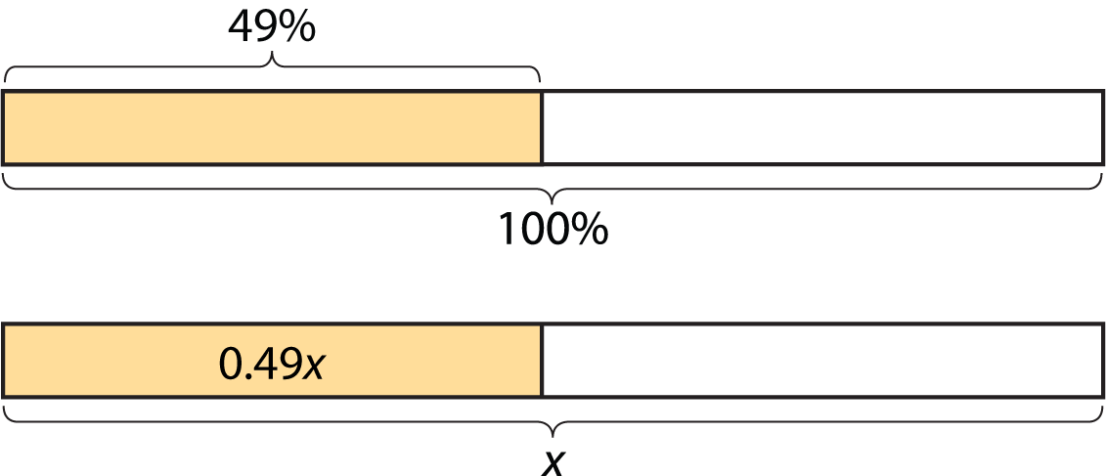
To find 135% of a number, we can multiply the number by $\frac{135}{100}$ or 1.35.
To find 6% of a number, we can multiply the number by $\frac{6}{100}$ or 0.06.
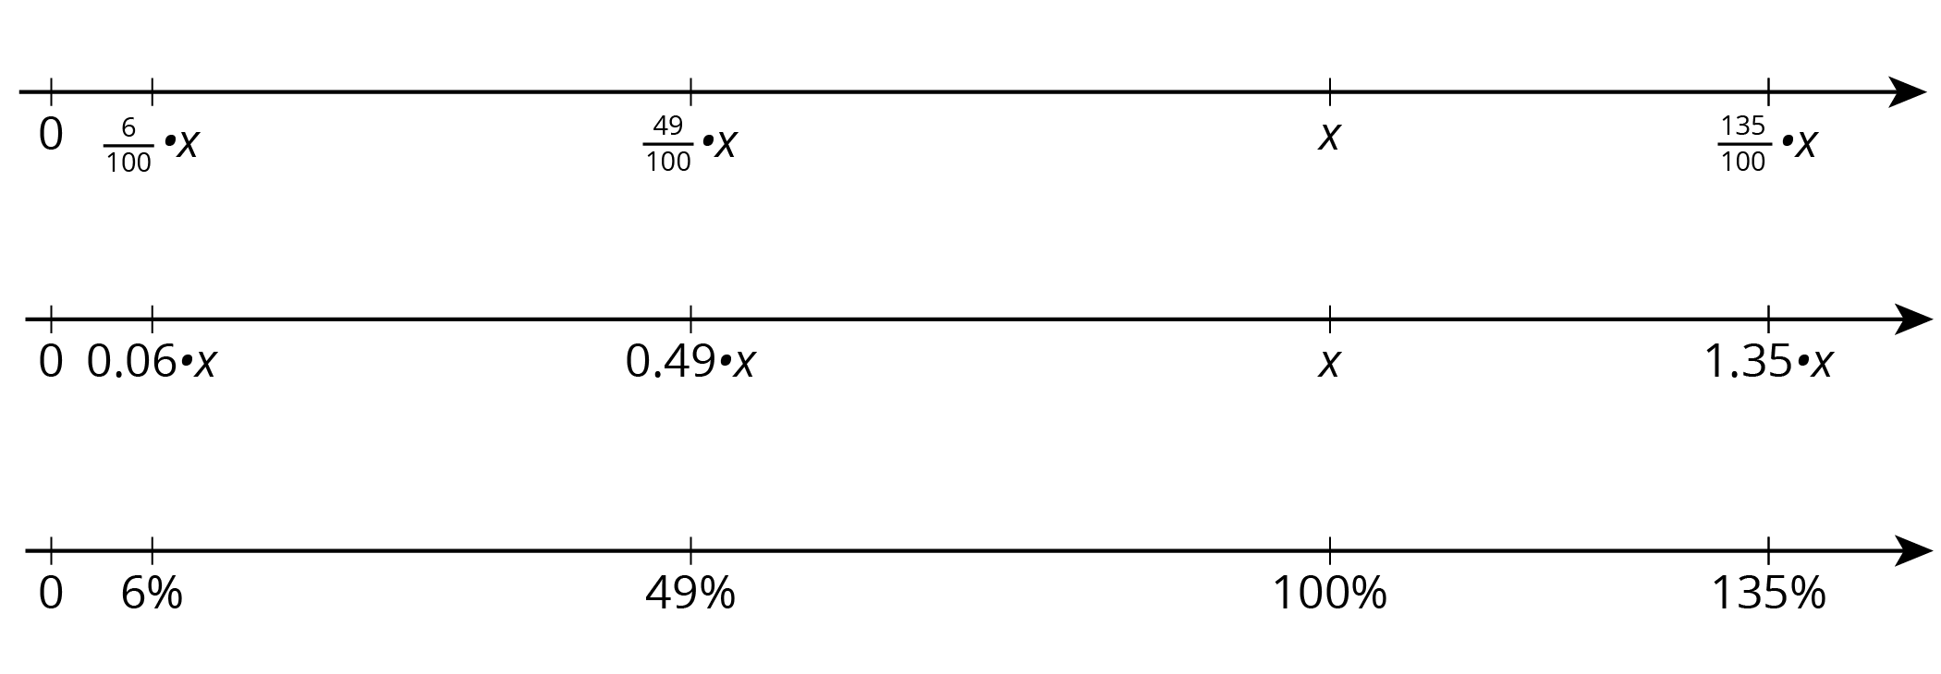
In general, to find $P\%$ of $x$, we can multiply: $\frac{P}{100}⋅x$
© CC BY Open Up Resources. Adaptations CC BY IM.

