Unit 1 Lesson 8: Sort and Count Shape Cards

WU Which One Doesn’t Belong: Show Quantities (Warm up)

Student Task Statement
Which one doesn’t belong?
A
B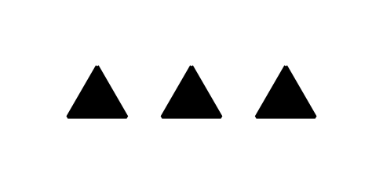
C
D

1 Sort Shapes

Student Task Statement

2 Show Your Sort

Student Task Statement
- Show how you sorted the shape cards.
Be sure that someone else who looks at your paper can see how many shapes are in each category.
- Complete the sentences:
  - The first category has ____________ shapes.
  - The second category has ____________ shapes.
  - The third category has ____________ shapes.
  - There are ____________ shapes all together.

3 Shape Sort Gallery Walk

Student Task Statement
© CC BY 2021 Illustrative Mathematics®

