Unit 4 Lesson 2: How Many in Each Group?

WU Notice and Wonder: More Apples (Warm up)

Student Task Statement
What do you notice? What do you wonder?
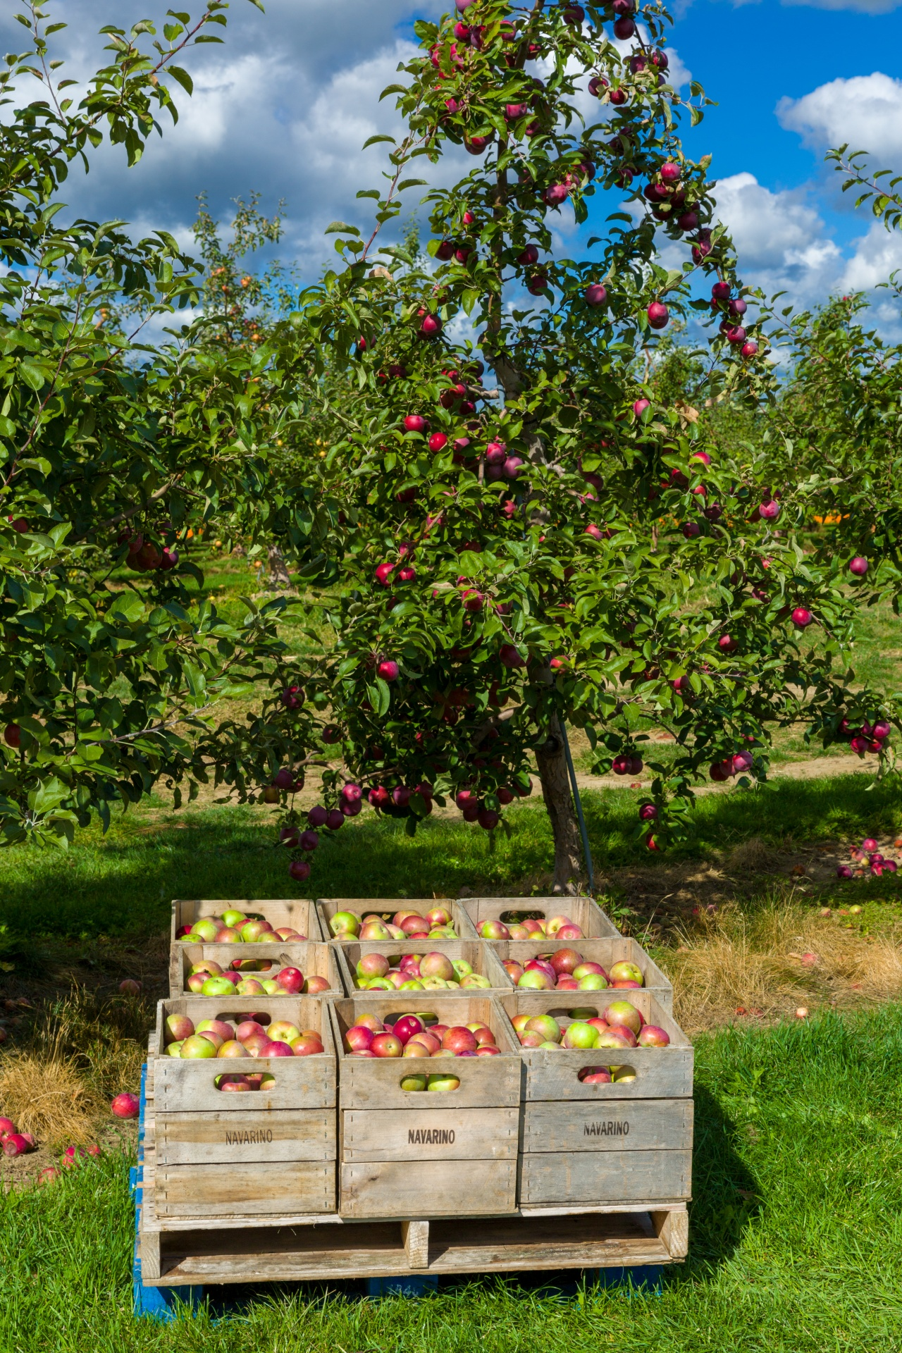

1 How Many Apples?

Student Task Statement
Solve each problem. Show your thinking using objects, a drawing, or a diagram.
- If 20 apples are packed into 4 boxes with each box having the same number of apples, how many apples are in each box?
- If 36 apples are packed into 6 boxes with each box having the same number of apples, how many apples are in each box?
- If 45 apples are packed into 9 boxes with each box having the same number of apples, how many apples are in each box?

2 Gallery Walk

Student Task Statement
Visit the posters around the room with your partner. Discuss what is the same and what is different about the thinking shown on each poster.

3 All the Apples

Student Task Statement
If 24 apples are put into boxes with 8 apples in each box, how many boxes are there?
If 20 apples are packed into 4 boxes with each box having the same number of apples, how many apples are in each box?
Discuss with your partner:
- How are these problems alike?
- How are they different?
- What is alike and what is different about how these problems are represented and solved?
© CC BY 2021 Illustrative Mathematics®

