Unit 4 Lesson 4: Add with Objects

WU Questions About Us: Bird or Fish? (Warm up)

Student Task Statement

1 Add Counters

Student Task Statement
- Count out 2 counters.
Add 2 more counters.
- There are
- counters altogether.
- Count out 5 counters.
Add 3 more counters.
- There are
- counters altogether.
- Count out 2 counters.
Add 4 more counters.
- There are
- counters altogether.
- Count out 6 counters.
Add 3 more counters.
- There are
- counters altogether.

2 Introduce 5-Frames, Add

Student Task Statement

3 Centers: Choice Time

Student Task Statement
Choose a center.
5-frames
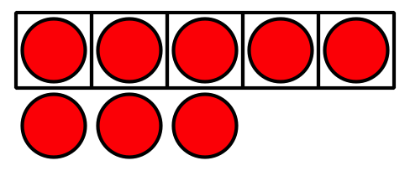
Roll and Add
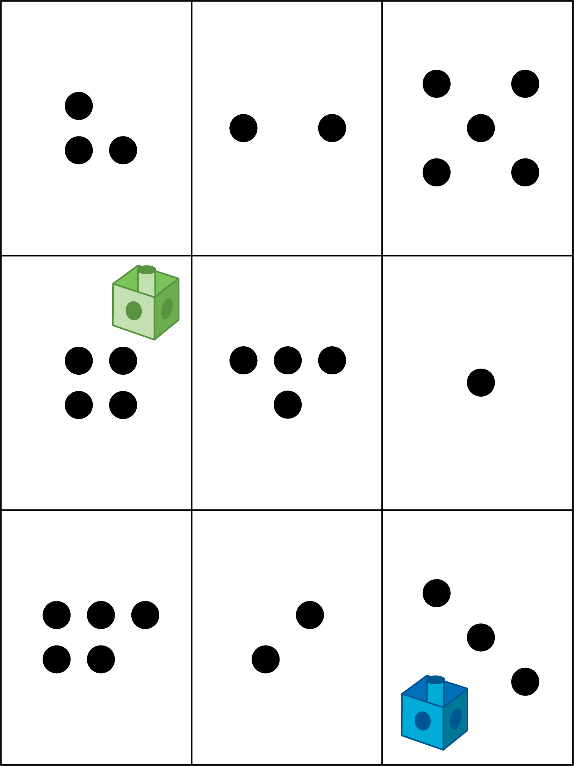
Math Libs
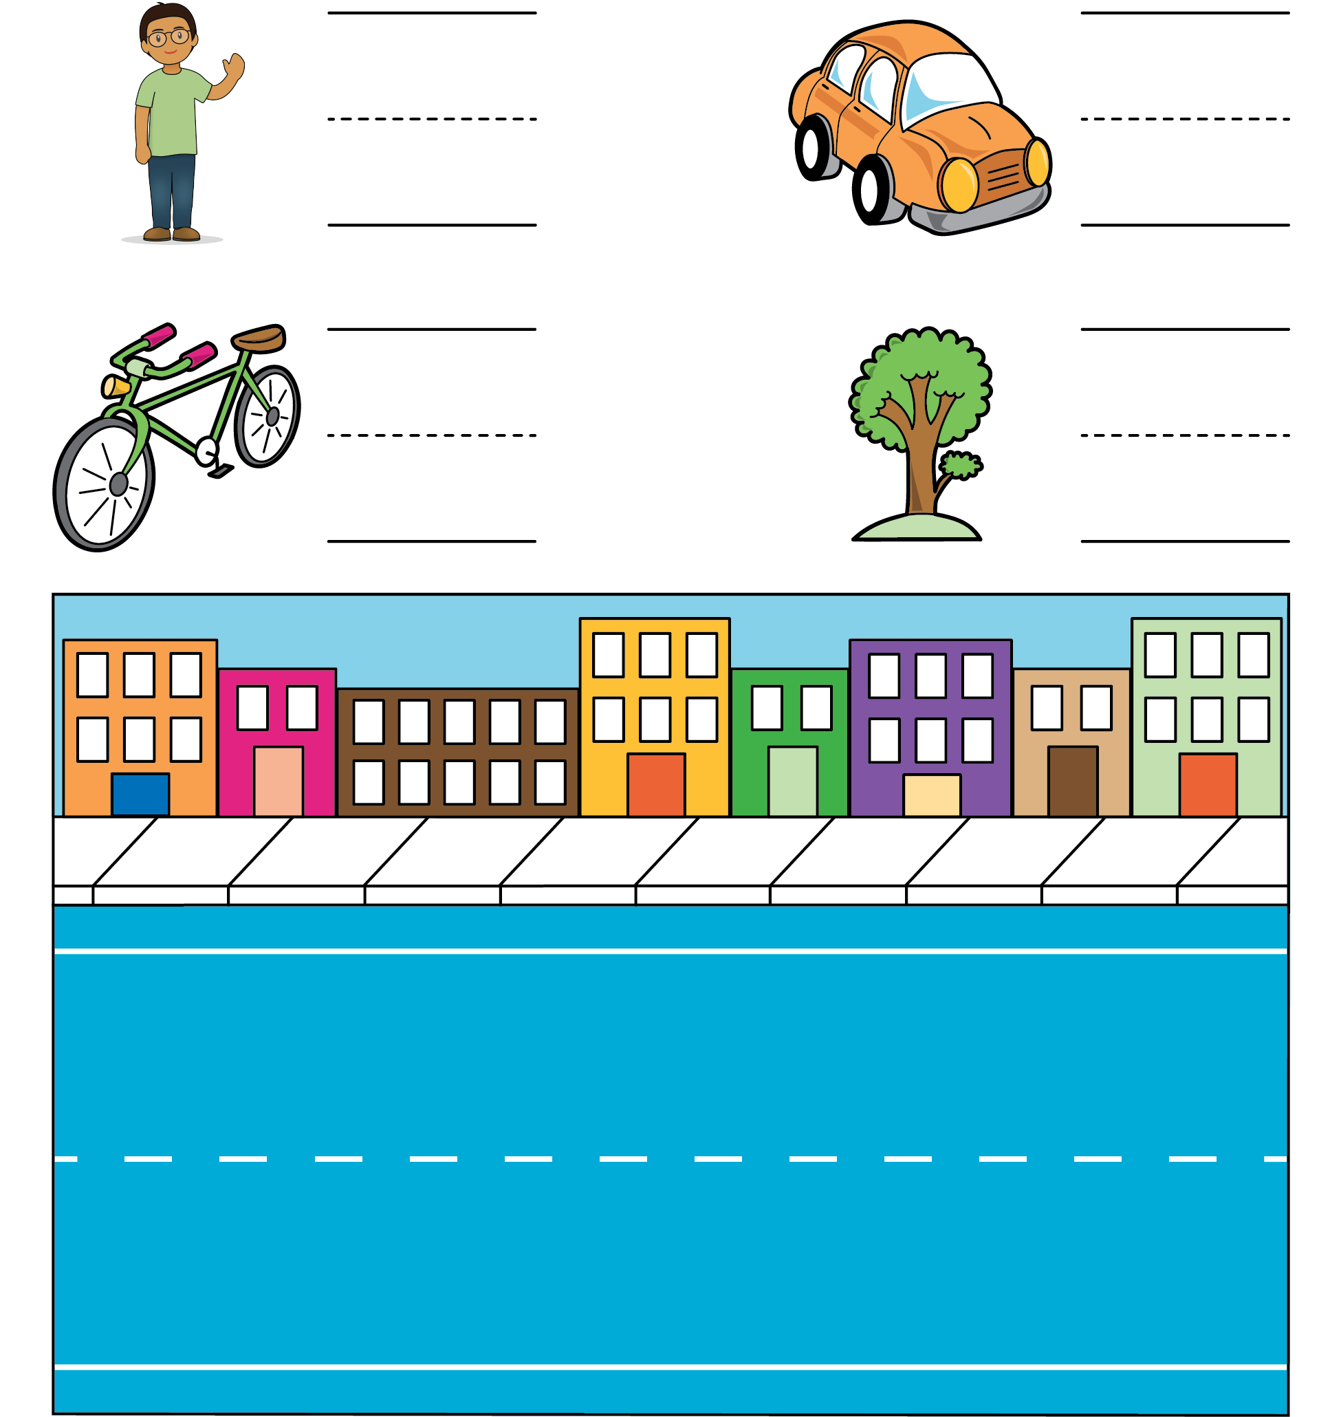
Match Mine
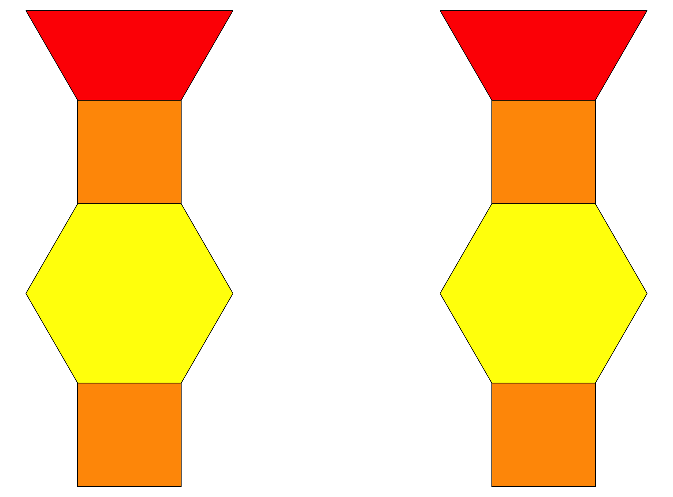
© CC BY 2021 Illustrative Mathematics®

