Lesson 3: From Visual Patterns to Numerical Patterns
- Let’s look at numerical patterns we can write to describe patterns in rectangles.

Warm-up: Number Talk: Patterns in Multiplication
Find the value of each expression mentally.
- $20×3$
- $21×3$
- $40×3$
- $42×3$

3.1: Growing Rectangles
Here is a pattern of rectangles that follows a rule.
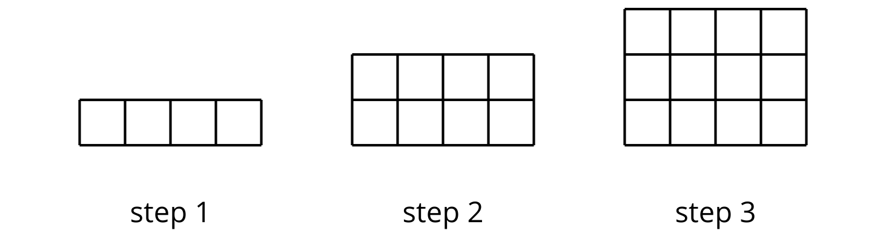
- Priya says, “Each step increases by 1.”
- Noah says, “Each step increases by 4.”
- Lin says, “Each step increases by 2.”
- Can you think of possible reasons that all of them could be correct even though they describe the patterns differently?
- Revise the statement made by each student so that what they mean is clearer and more precise.
- Priya writes the number list 1, 2, 3, 4, 5, 6 to represent the first six steps of the pattern she sees. Write a list of numbers to represent the first six steps of the pattern that Noah and Lin see.
- Predict what number Priya, Noah, and Lin will write for step 20 if the pattern of rectangles continue. Explain or show your reasoning.

3.2: More Growing Rectangles
Here is another pattern of rectangles that also follows a rule.
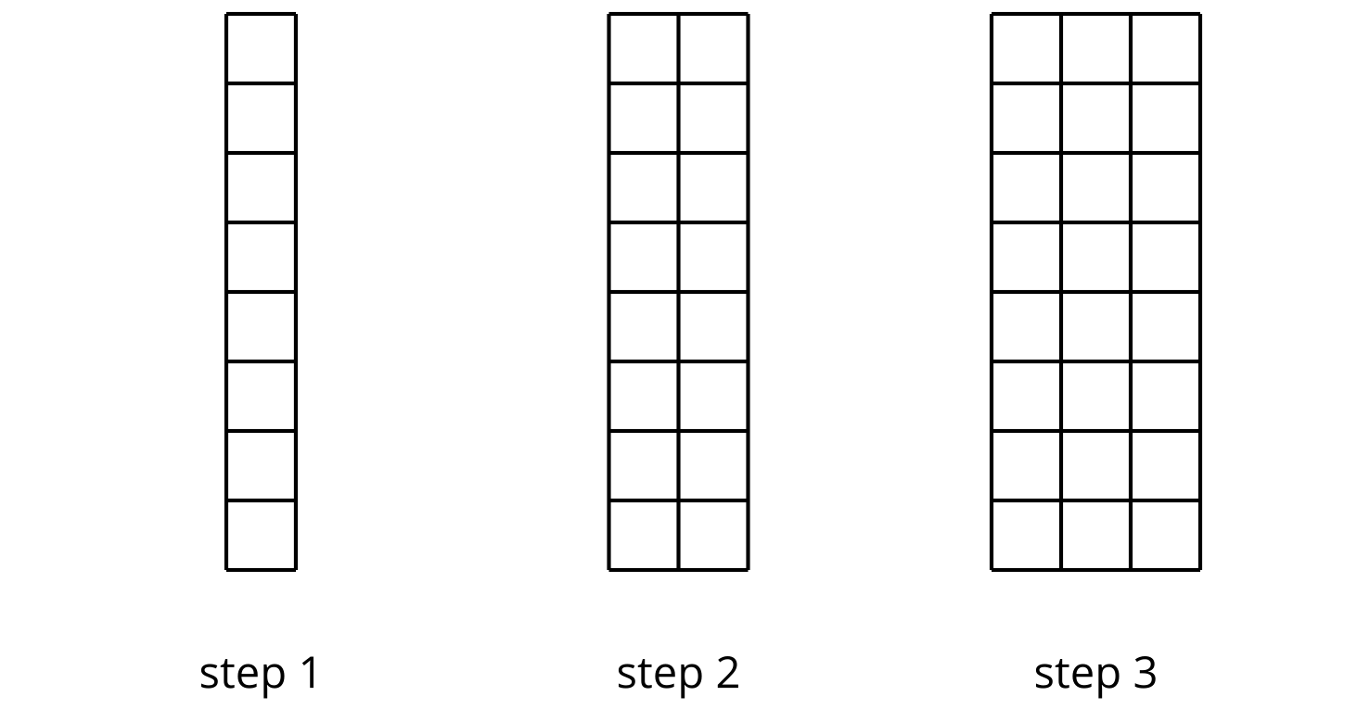
- The number list 1, 2, 3, _____, _____, _____ represents the number of vertical columns in the first six steps of the pattern. Complete the number list.
- Find another feature of the rectangles that can be represented with a number list and would show a pattern. Write at least one list of numbers for the first six steps of that feature.
- Feature: ________________________________________
- Number list: _____, _____, _____, _____, _____, _____
- Without writing out all the numbers, predict the 30th number in your list. Explain your reasoning by completing this sentence frame:
- I know that the 30th number is _____ because . . .

3.3: No Grid This Time!
Here are steps 1 and 4 in a pattern of rectangles. One side length of the rectangle increases by 5 units each time.
- Sketch the missing rectangles in steps 2 and 3. Label the sides with their lengths.
- Write two numerical patterns that each represent the rectangles, from step 1 to step 6.
  - What are you representing? : ________________________________________
  - Numerical pattern: _____, _____, _____, _____, _____, _____
  - What are you representing? : ________________________________________
  - Numerical pattern: _____, _____, _____, _____, _____, _____
- For each of the following questions, if you answer yes, show how you know and state the step number. If you answer no, explain or show why not.
- If the pattern continues:
  - Could 82 inches be a side length of a rectangle?
  - Could 300 square inches be the area of a rectangle in the pattern?
  - Could 100 inches be the perimeter of a rectangle in the pattern?
© CC BY 2021 Illustrative Mathematics®

