Unit 5 Lesson 24 Cumulative Practice Problems
- An ecologist is studying a forest with a mixture of tree types. Since the average tree height in the area is 40 feet, he measures the height of the tree against that. He also records the type of tree. The results are shown in the table and segmented bar graph. Is there evidence of an association between tree height and tree type? Explain your reasoning.
 | - under 40 feet | - 40 feet or taller | - total
- deciduous | - 45 | - 30 | - 75
- evergreen | - 14 | - 10 | - 24
- total | - 59 | - 40 | - 99
- 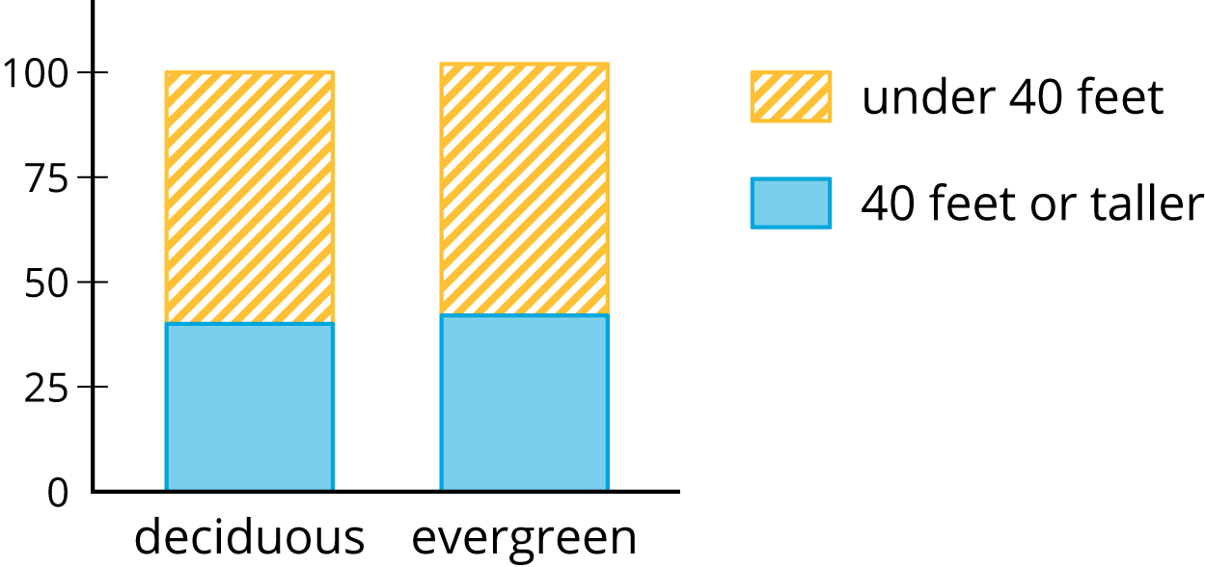
- Workers at an advertising agency are interested in people’s TV viewing habits. They take a survey of people in two cities to try to find patterns in the types of shows they watch. The results are recorded in a table and shown in a segmented bar graph. Is there evidence of different viewing habits? If so, explain.
 | - reality | - news | - comedy | - drama
- Chicago | - 50 | - 40 | - 90 | - 20
- Topeka | - 45 | - 70 | - 40 | - 45
- 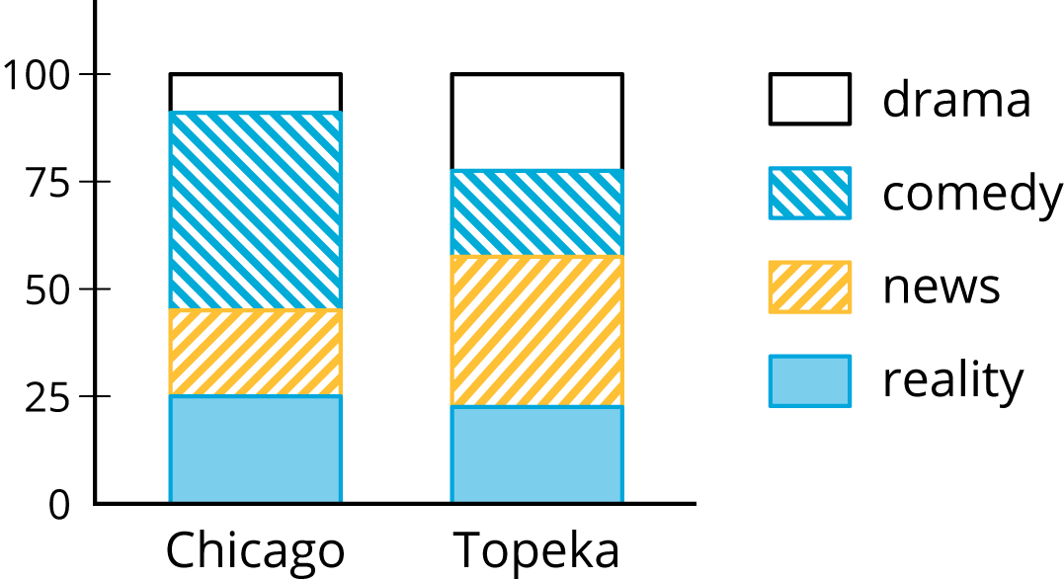
- A scientist is interested in whether certain species of butterflies like certain types of local flowers. The scientist captures butterflies in two zones with different flower types and records the number caught. Do these data show an association between butterfly type and zone? Explain your reasoning.
 | - zone 1 | - zone 2
- eastern tiger swallowtail | - 16 | - 34
- monarch | - 24 | - 46
© CC BY Open Up Resources. Adaptations CC BY IM.

