Lesson 3: Making the Moves

3.1: Notice and Wonder: The Isometric Grid
What do you notice? What do you wonder?

3.2: Transformation Information
Your teacher will give you tracing paper to carry out the moves specified. Use $A^{′}$, $B^{′}$, $C^{′}$, and $D^{′}$ to indicate vertices in the new figure that correspond to the points $A$, $B$, $C$, and $D$ in the original figure.
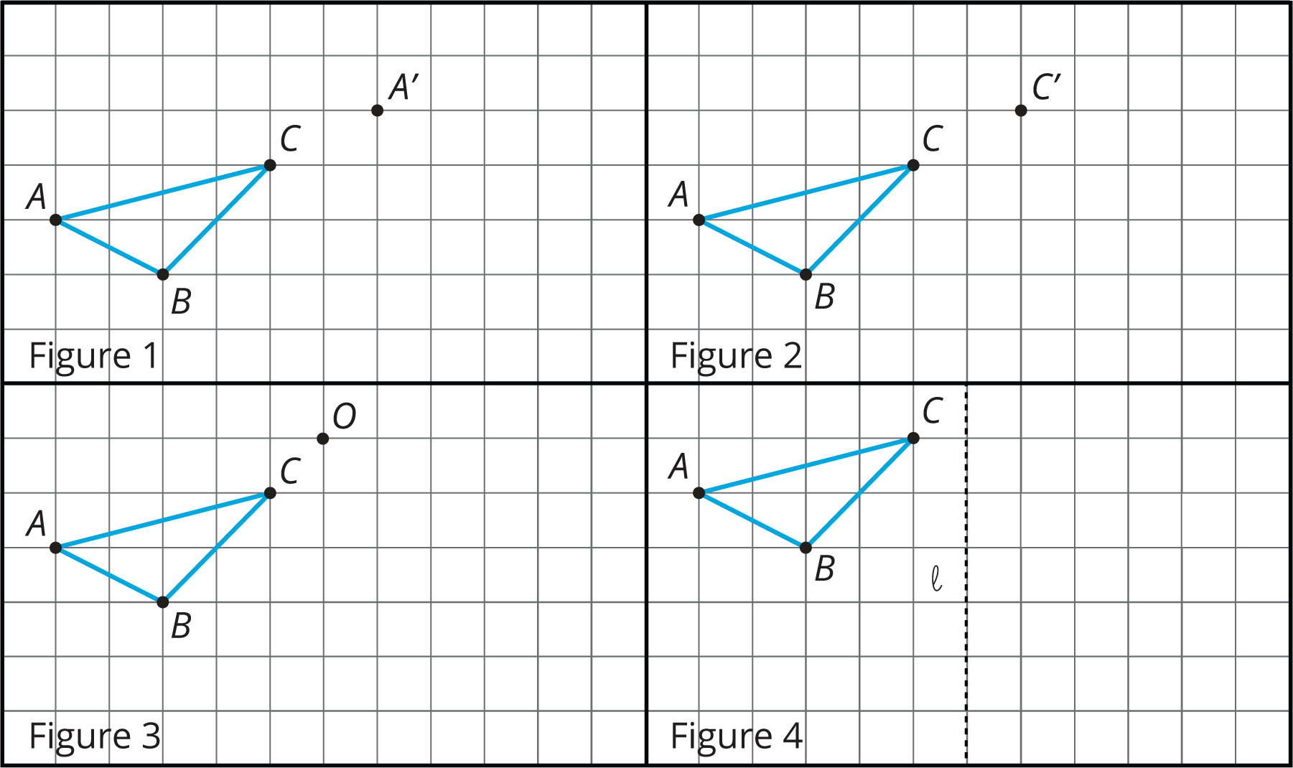
- In Figure 1, translate triangle $ABC$ so that $A$ goes to $A^{′}$.
- In Figure 2, translate triangle $ABC$ so that $C$ goes to $C^{′}$.
- In Figure 3, rotate triangle $ABC$ ${90}^{∘}$ counterclockwise using center $O$.
- In Figure 4, reflect triangle $ABC$ using line $ℓ$.
- 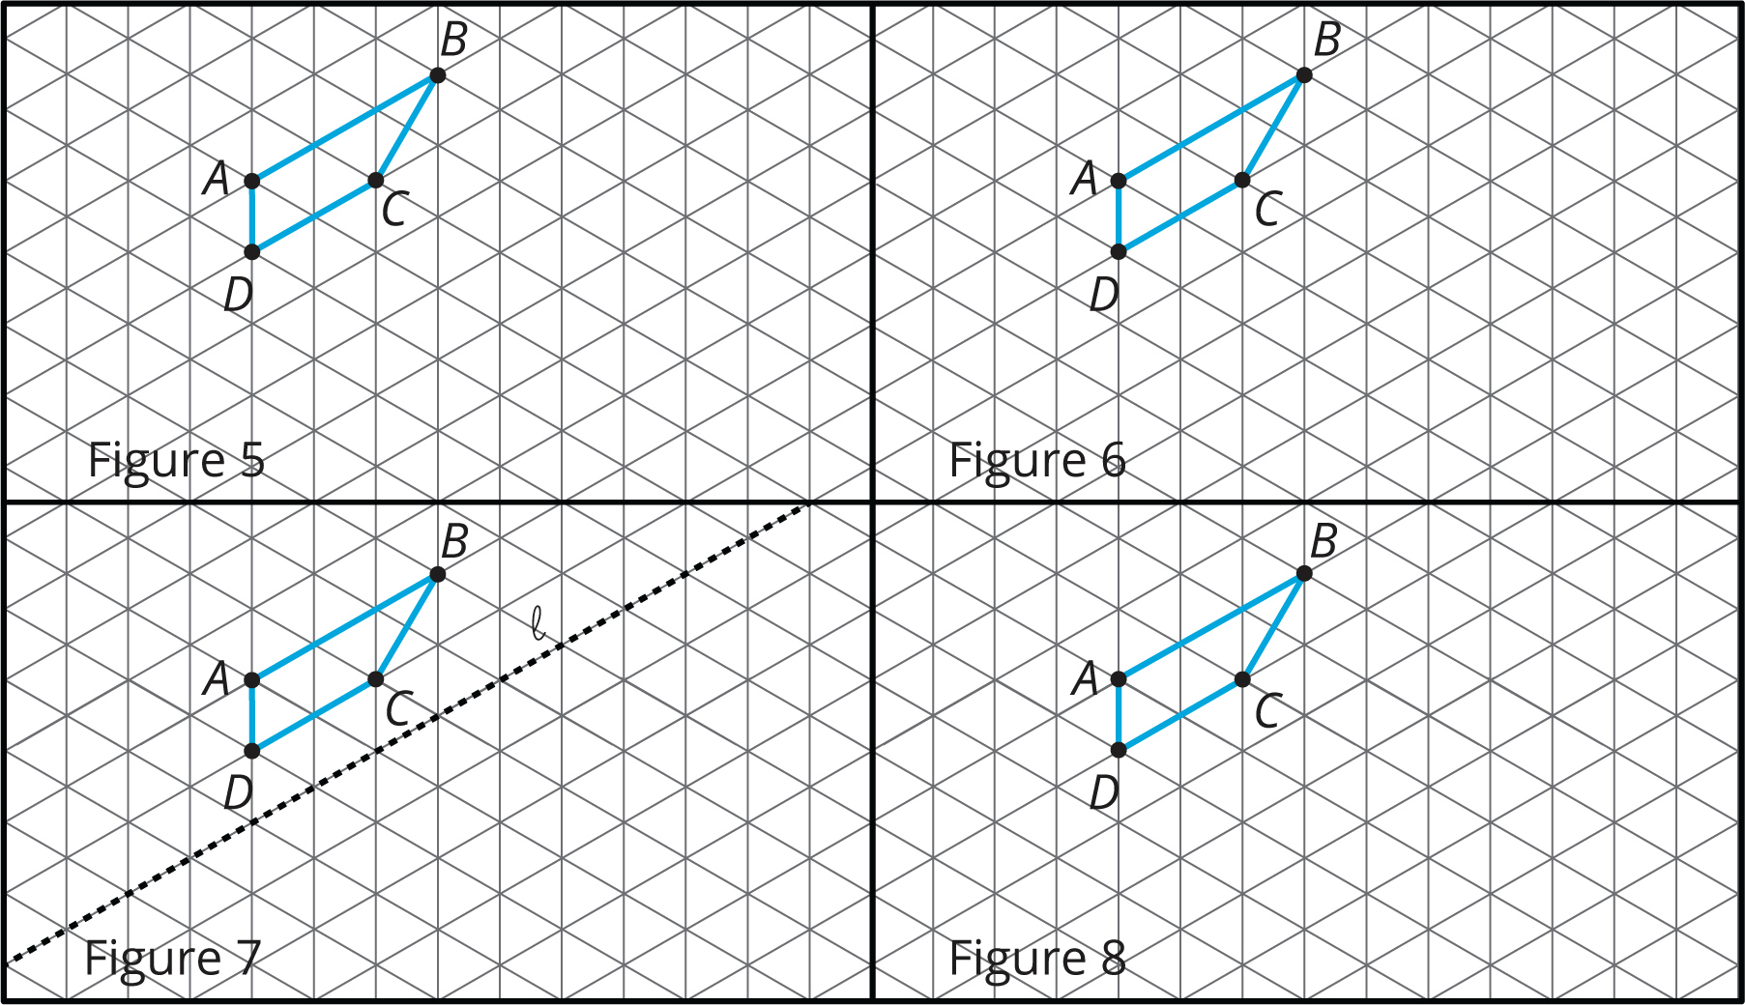
- In Figure 5, rotate quadrilateral $ABCD$ ${60}^{∘}$ counterclockwise using center $B$.
- In Figure 6, rotate quadrilateral $ABCD$ ${60}^{∘}$ clockwise using center $C$.
- In Figure 7, reflect quadrilateral $ABCD$ using line $ℓ$.
- In Figure 8, translate quadrilateral $ABCD$ so that $A$ goes to $C$.

Are you ready for more?
The effects of each move can be “undone” by using another move. For example, to undo the effect of translating 3 units to the right, we could translate 3 units to the left. What move undoes each of the following moves?
- Translate 3 units up
- Translate 1 unit up and 1 unit to the left
- Rotate 30 degrees clockwise around a point $P$
- Reflect across a line $ℓ$

3.3: A to B to C
Here are some figures on an isometric grid.
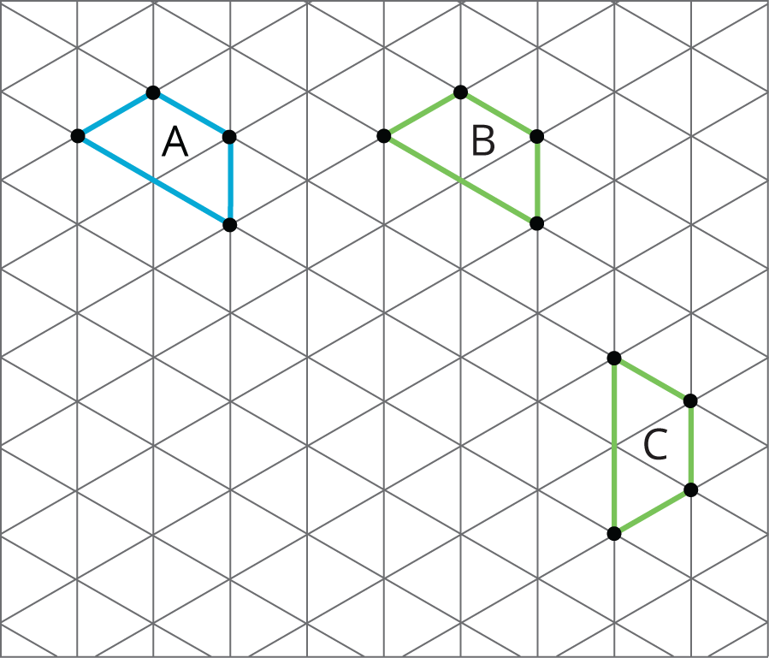
- Name a transformation that takes Figure $A$ to Figure $B$. Name a transformation that takes Figure $B$ to Figure $C$.
- What is one sequence of transformations that takes Figure $A$ to Figure $C$? Explain how you know.

Are you ready for more?
Experiment with some other ways to take Figure $A$ to Figure $C$. For example, can you do it with. . .
- No rotations?
- No reflections?
- No translations?

Lesson 3 Summary
A move or combination of moves is called a transformation. When we do 1 or more moves in a row, we often call that a sequence of transformations. When a figure is on a grid, we can use the grid to describe a transformation. We use the word image to describe the figure after a transformation. To distinguish the original figure from its image, points in the image are sometimes labeled with the same letters as the original figure, but with the symbol $​^{′}$ attached, as in $A^{′}$ (pronounced “A prime”) is the image of $A$ after a transformation.
- A translation can be described by two points. If a translation moves point $A$ to point $A^{′}$, it moves the entire figure the same distance and direction as the distance and direction from $A$ to $A^{′}$. The distance and direction of a translation can be shown by an arrow.
- For example, here is a translation of quadrilateral $ABCD$ that moves $A$ to $A^{′}$.
- 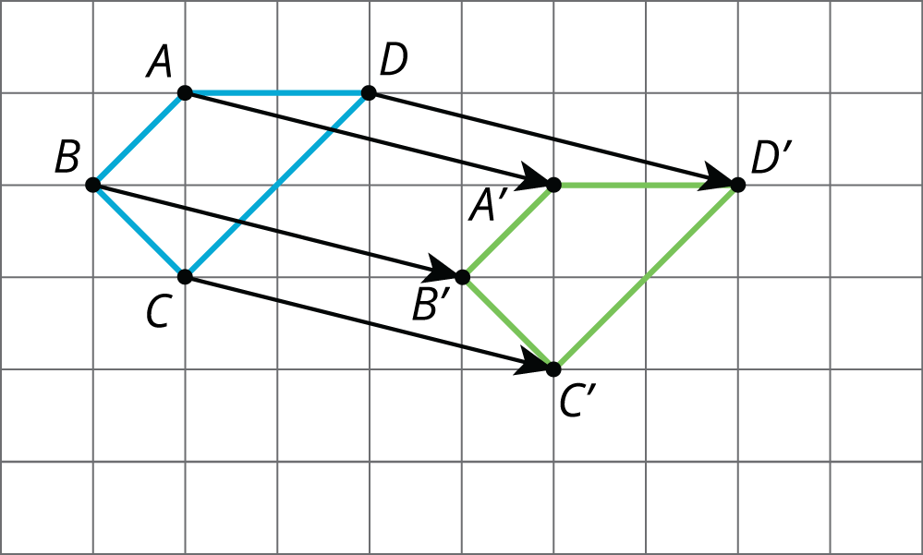
- A rotation can be described by an angle and a center. The direction of the angle can be clockwise or counterclockwise.
- For example, quadrilateral $KLMN$ is rotated 60 degrees counterclockwise using center $P$. This type of grid is called an isometric grid. The isometric grid is made up of equilateral triangles. The angles in the triangles each measure 60 degrees, making the isometric grid convenient for showing rotations of 60 degrees.
- 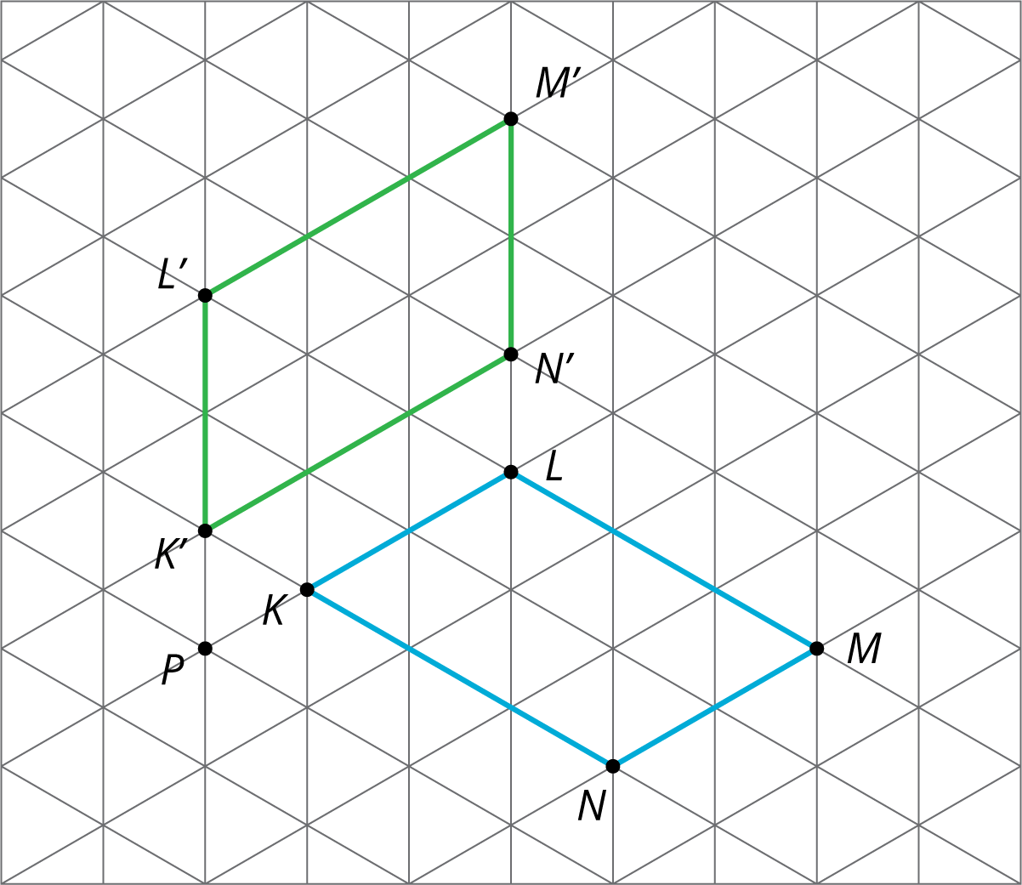
- A reflection can be described by a line of reflection (the “mirror”). Each point is reflected directly across the line so that it is just as far from the mirror line, but is on the opposite side.
- For example, pentagon $ABCDE$ is reflected across line $m$.
- 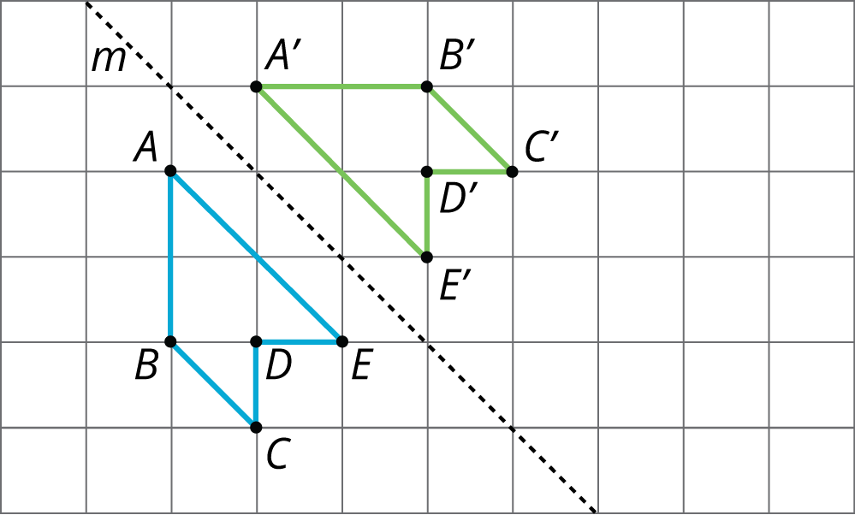
© CC BY Open Up Resources. Adaptations CC BY IM.

