Lesson 13: The Burj Khalifa
Let’s investigate the Burj Khalifa building.

13.1: Estimating Height
Use the picture to estimate the height of Hyperion, the tallest known tree.
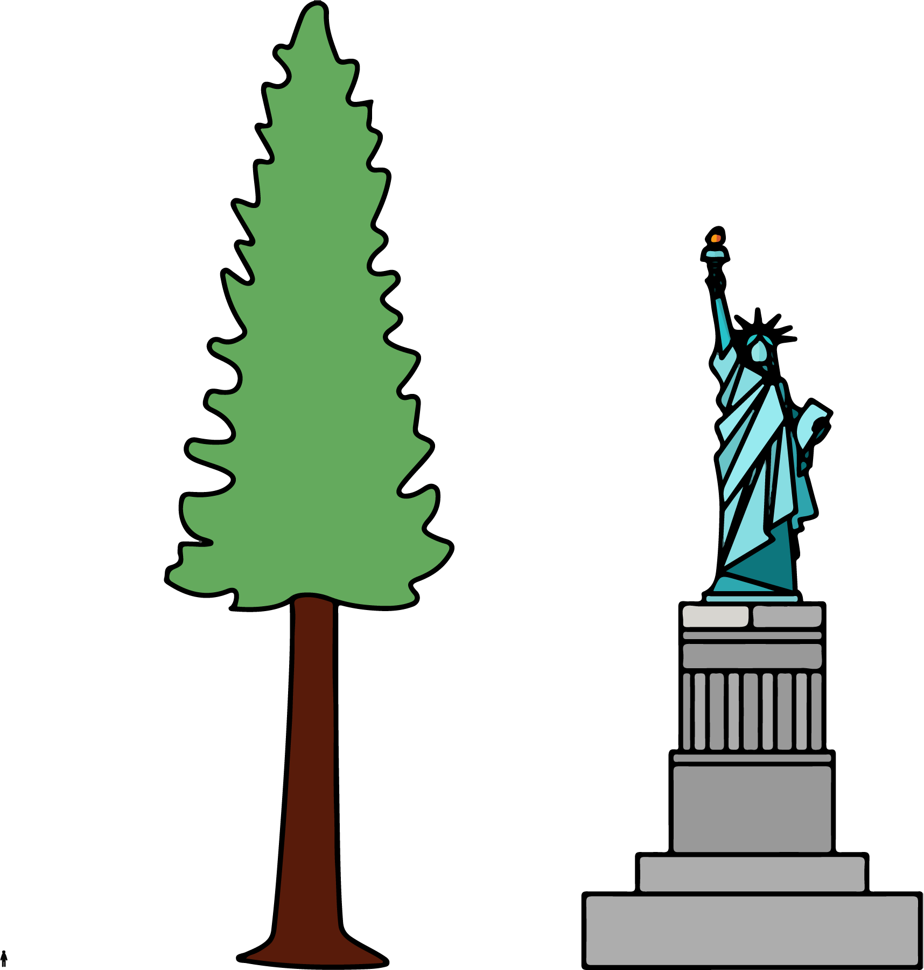

13.2: Window Washing
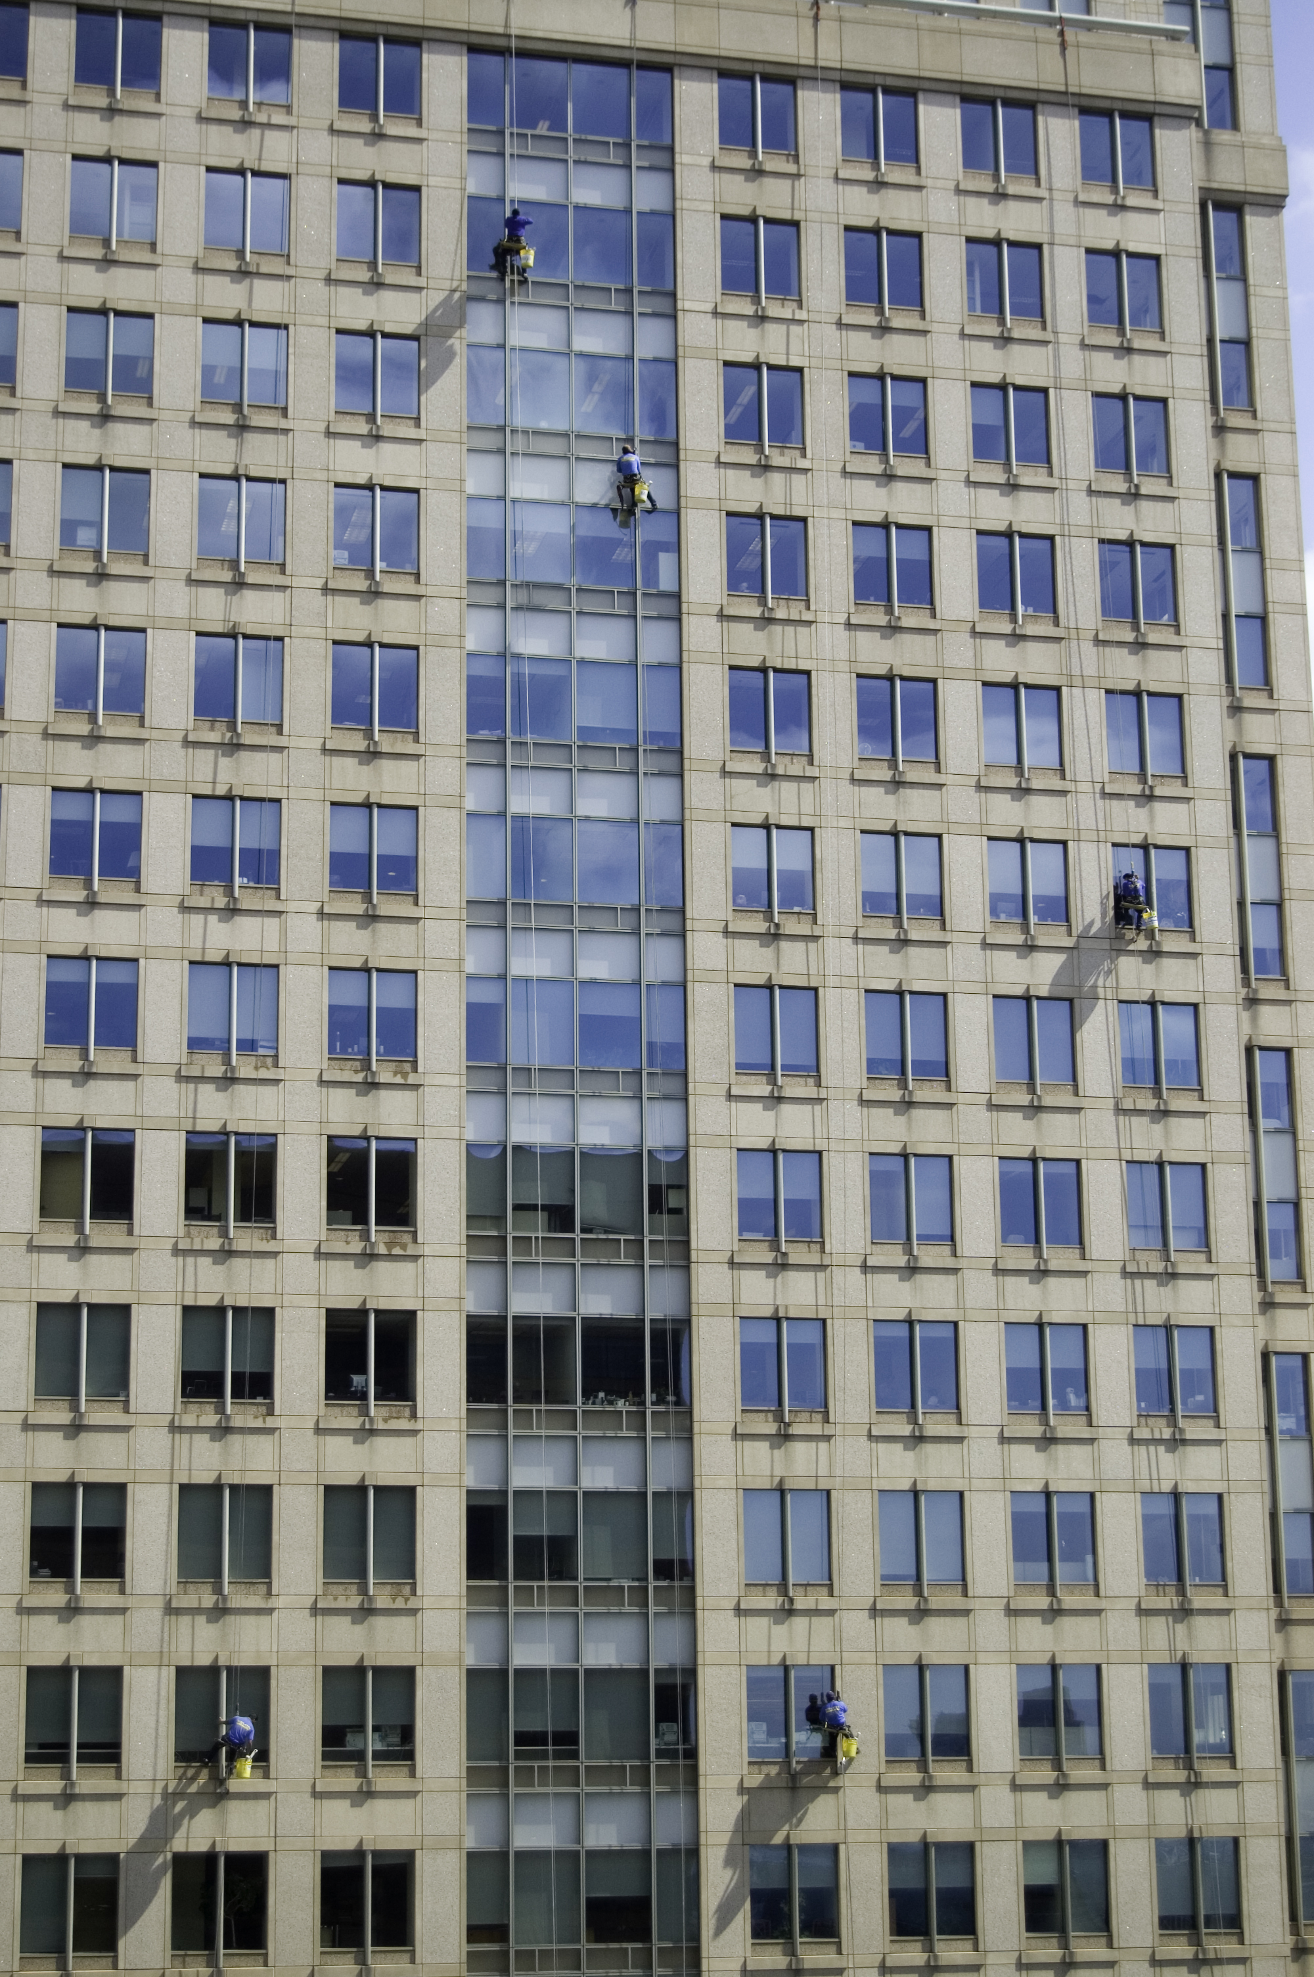
A window-washing crew can finish 15 windows in 18 minutes.
If this crew was assigned to wash all the windows on the outside of the Burj Khalifa, how long will the crew be washing at this rate?

13.3: Climbing the Burj Khalifa
In 2011, a professional climber scaled the outside of the Burj Khalifa, making it all the way to 828 meters (the highest point on which a person can stand) in 6 hours.
Assuming they climbed at the same rate the whole way:
- How far did they climb in the first 2 hours?
- How far did they climb in 5 hours?
- How far did they climb in the final 15 minutes?

Are you ready for more?
Have you ever seen videos of astronauts on the Moon jumping really high? An object on the Moon weighs less than it does on Earth because the Moon has much less mass than Earth.
- A person who weighs 100 pounds on Earth weighs 16.5 pounds on the Moon. If a boy weighs 60 pounds on Earth, how much does he weigh on the Moon?
- Every 100 pounds on Earth are the equivalent to 38 pounds on Mars. If the same boy travels to Mars, how much would he weigh there?

Lesson 13 Summary
There are many real-world situations in which something keeps happening at the same rate. For example:
- a bus stop that is serviced by 4 buses per hour
- a washing machine that takes 45 minutes per load of laundry
- a school cafeteria that serves 15 students per minute
In situations like these, we can use equivalent ratios to predict how long it will take for something to happen some number of times, or how many times it will happen in a particular length of time.
For example, how long will it take the school cafeteria to serve 600 students?
The table shows that it will take the cafeteria 40 minutes to serve 600 students.
number of students | time in minutes
15 | 1
60 | 4
600 | 40
How many students can the cafeteria serve in 1 hour?
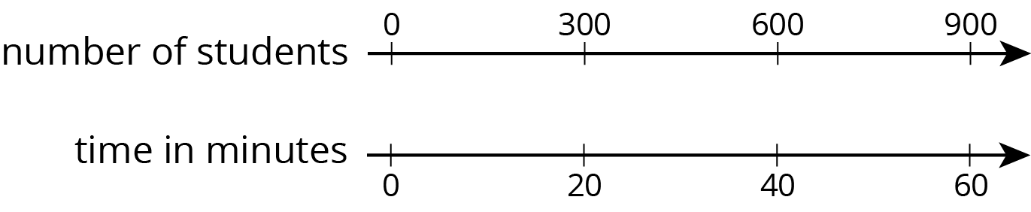
The double number line shows that the cafeteria can serve 900 students in 1 hour.
© CC BY Open Up Resources. Adaptations CC BY IM.

